What Do You Like?
Learning Goal:
- Students will examine what they want when they graduate from high school, how their current interests can relate to future careers, and how they can learn more about particular careers.
Introduction:
Directions Part 1:
1. Ask students to take about 10 minutes to fill in Part I of the “My Interests” form.
2. Talk with them about their responses.
Directions Part 2:
1. Have them complete Part II of the form.
2. Ask them to share the responses to Part II with a partner. Students should be encouraged to give each other feedback about career ideas.
Directions Part 3:
1. Give students access to the following website:
https://www.careeronestop.org/toolkit/careers/interest-assessment.aspx
2. Allow them time to take a short quiz, explore careers that they matched with, and fill in the chart with the information.
Extension Activity:
Career Exploration Worksheet
Have students answer questions about a career they find interesting based on their quiz and research.
Have students design business cards based on the career they think would be most interesting.
- Example:
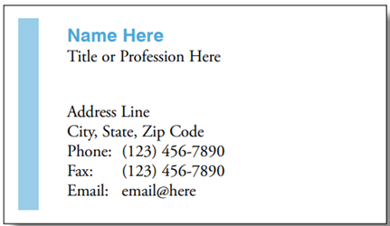

My Interests
Directions Part 1: Look at the table below.
On the left list the classes you like the best and tell why. On the right, list the activities you enjoy most and tell why.
Classes | Activities

Directions Part 2—Answer the following questions based on your responses to and discussions about Part I.
- How are the classes you like and the activities you like the same or different?

- What classes and activities do you think you will want to continue in high school?

- What classes and activities do you look forward to adding in high school?

- What jobs can you think of that could grow out of any of the classes or activities that you like?

Directions Part 3: Go to the following website: https://www.careeronestop.org/toolkit/careers/interest-assessment.aspx
Answer thirty quick questions about your interests and what you like to do.
After taking the quiz, explore the different careers that you matched with. Choose three to five careers you found the most interesting. Fill out the following chart with information regarding the careers. Please note that you can click on the career names on the website to find additional information. Record anything you find interesting about the career under additional information.

Career | Hourly Wages | Education Required | Additional information

Career Exploration Sheet
- I would like to know more about a career in:

- I think this could be a good career for me because:

- To learn more about this career, I should talk to:

- I can also learn more about this career from the following places:

- This is what my business card would look like if I worked in this career

Example Draw your card here

