Find the College For You
Learning Goal:
- Students will explore the many characteristics of colleges and universities that should be considered as they look at higher education options.
Introduction:
- Give every student a “treasure map.”
- Review with students each of the bolded sections on the map.
College Exploration:
Part 1
- Ask students to complete their own treasure maps.
- Bring students back together as an entire group and invite them to share which “map points” were the most important and why.
Part 2
- Divide students into groups of two or three. These groups could be based on the information gathered on their maps. Have students with similar interests work together. Ask them to use the following website: https://wsac.wa.gov/colleges-and-institutions-washington
to find information that would help them dig up information on their treasure map. Have them use the chart to record information.
Conclusion
Ask each group to share what kind of information they were able to locate and where it was found.

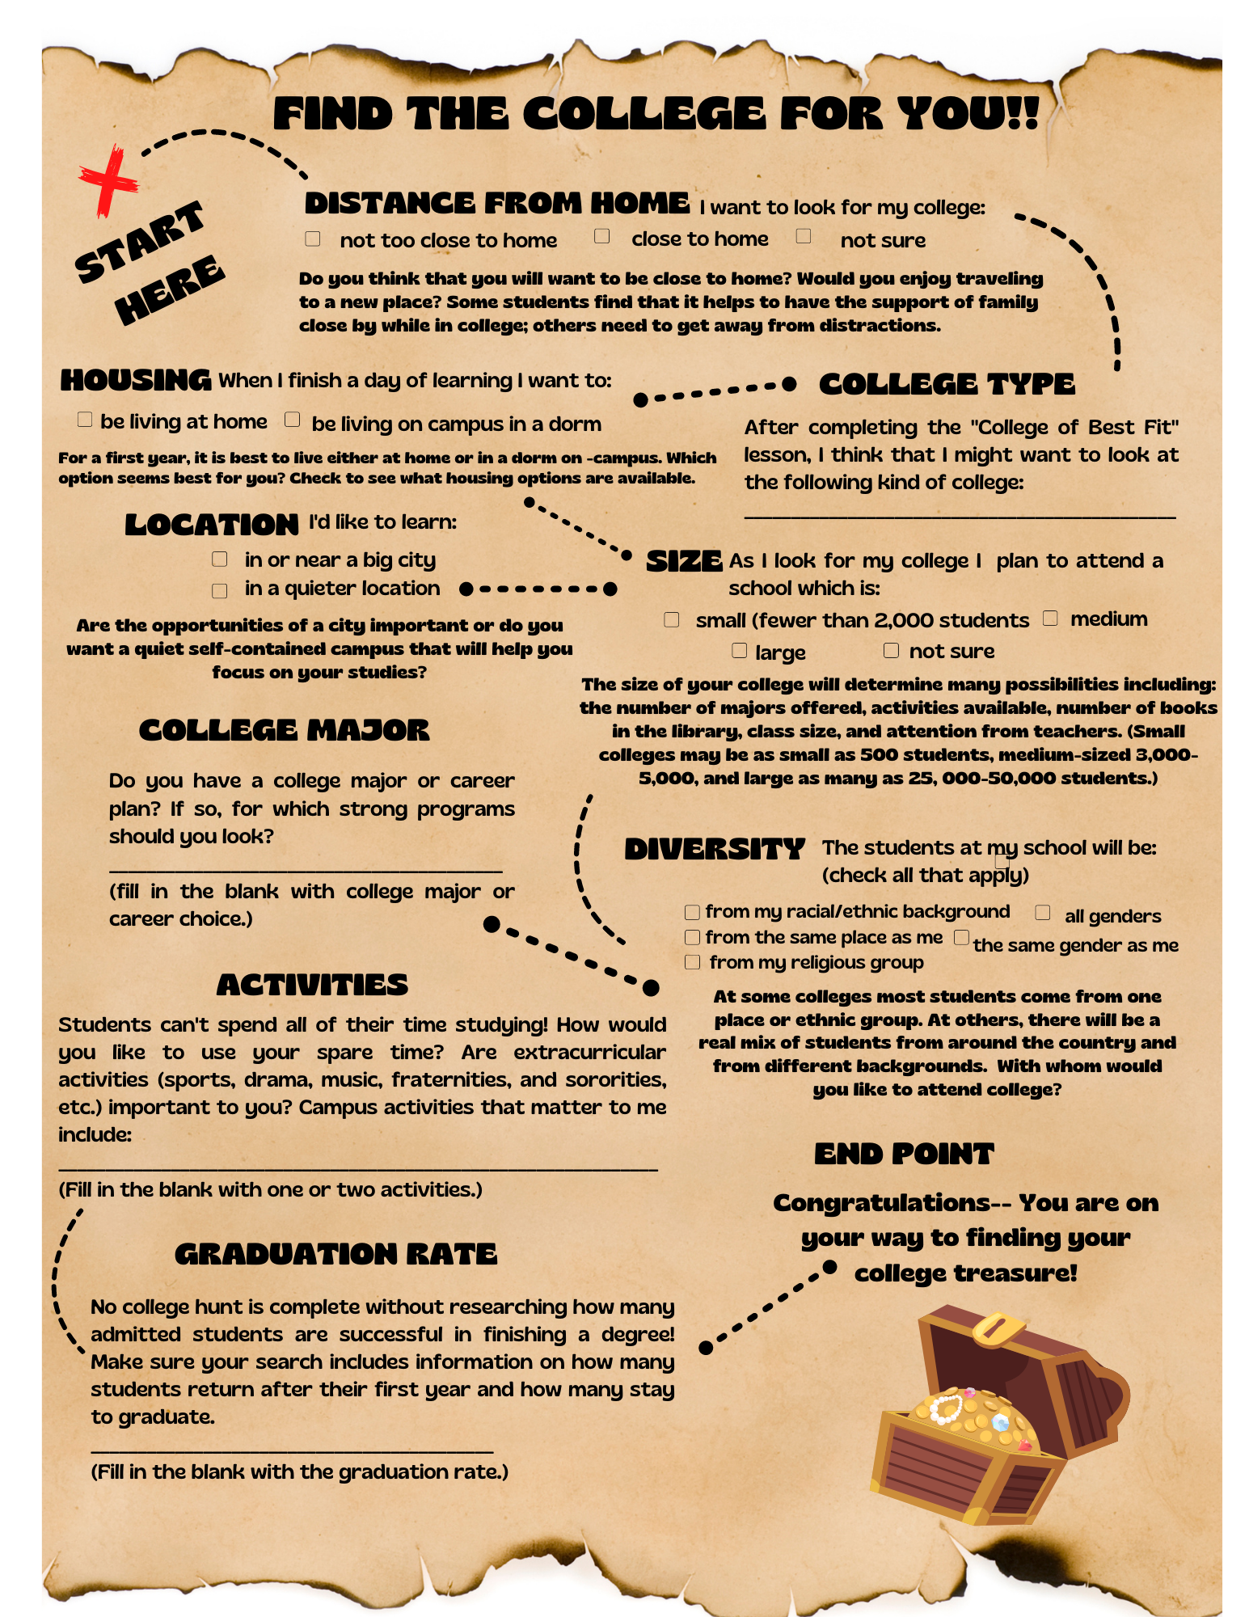

Use the following website: https://wsac.wa.gov/colleges-and-institutions-washington
Explore different colleges and record the information below to help you decide if this is a school you would like to attend in your future.
College Name

Distance from home

College Type

Housing

Location

Diversity

Majors

Activities

Graduation Rate

