GENERAL

Click the Help button 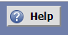located in the upper right corner of the webpage to view all Help topics. The Help icon will display help for the current view.

GETTING STARTED

- Enter www.tacoma.uw.edu/25live to access 25Live in your web browser. 25Live works best with Mozilla Firefox and Google Chrome.
- After entering your UW Net ID and password, you will be taken to the Dashboard.
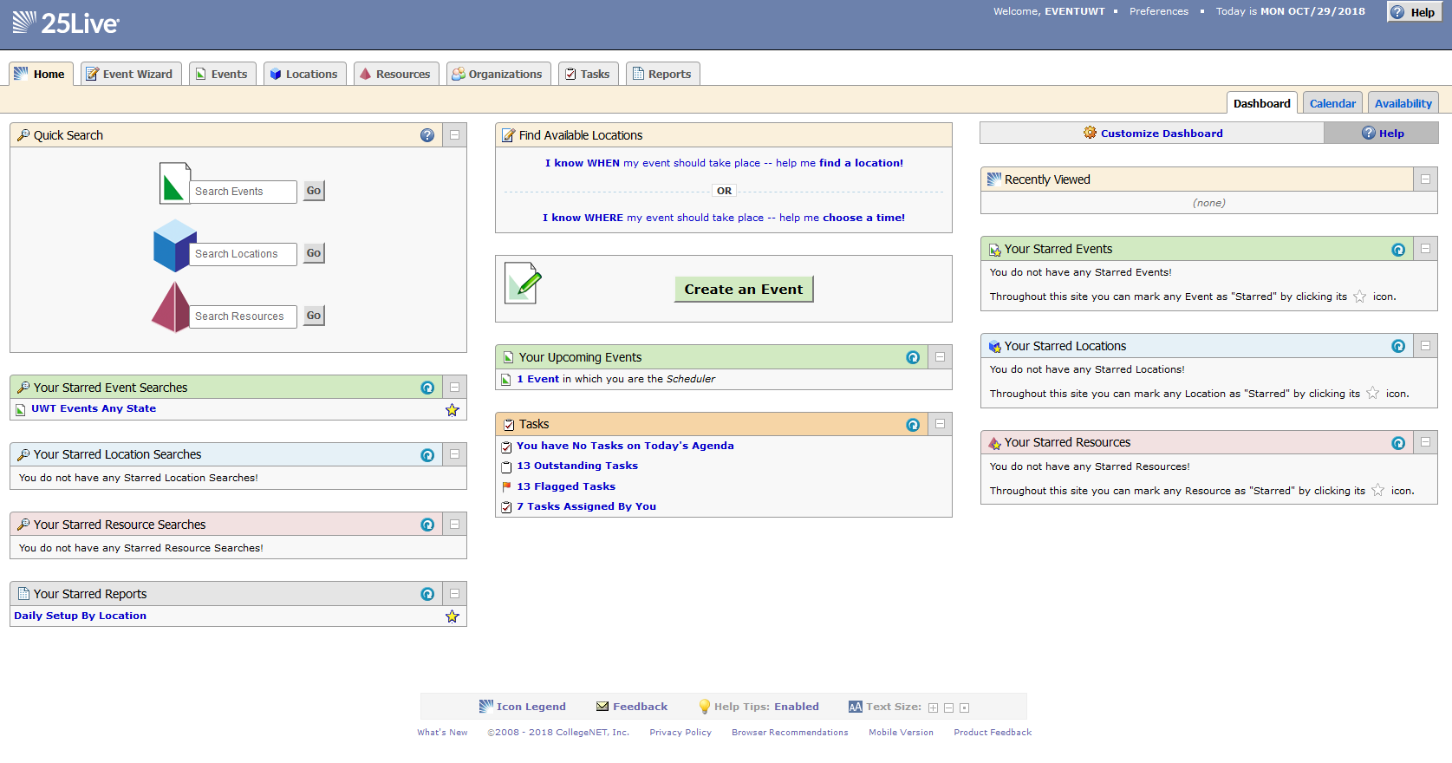
  - All UW Net IDs will have the ability to view space information and availability. For space requesting privileges, additional training is required.

EVENT WIZARD

- There are four ways to create a space reservation from the Dashboard: Event Wizard tab, Create an Event button, Find Available Locations options.
  - Users with requesting privileges will see the Event Wizard tab.

- Once in the event wizard, you will enter your reservation details. As you click through each field, instructions or hints will appear on the right side of your screen. All required fields (*) must be completed before you may advance to the next screen.
  - Event Name – How the event will appear within 25live (Be specific. Include year if it is an annual event).
  - Event Type – Selection will drive the questions that will be asked in the event wizard
  - Department – Make sure you are selecting a UW Tacoma department (Selecting a non-UW Tacoma organization may cause issues after submitting the event wizard)
  - Co-Sponsoring Department – If you are working with another unit on your event you can add them here.

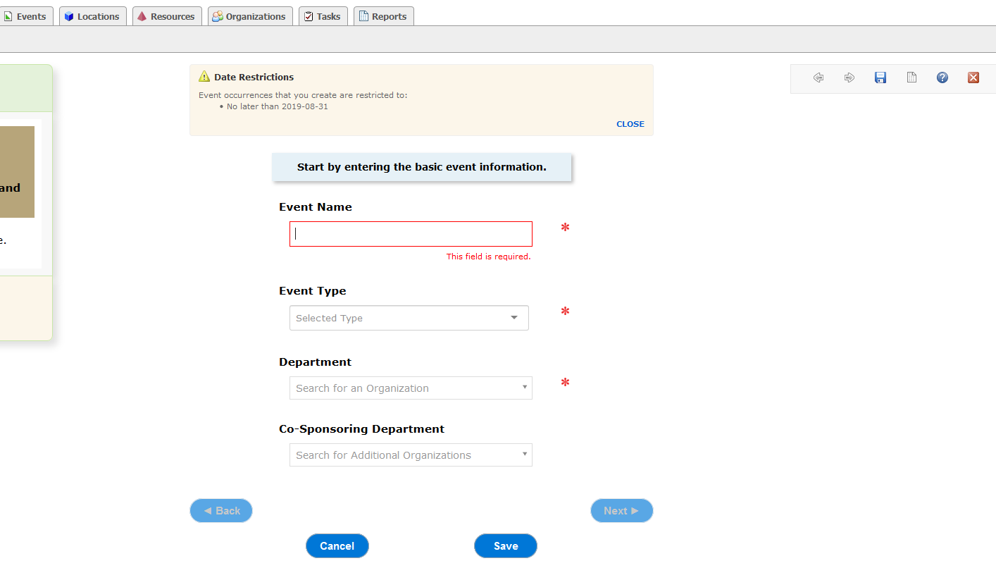

  - Expected Head Count – This field will help find locations for your meeting/event.
  - Event Description – Tell us about your event. Please be specific.

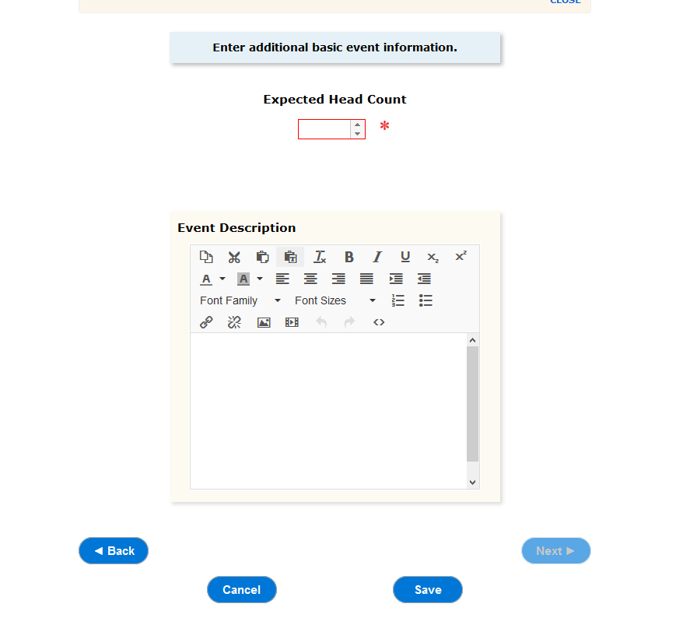

  - Is this a repeating event? – Select No if the meeting only has one occurrence or yes if it has multiple occurrences.

If your event has multiple occurrences with different times, you will need to create separate event wizards for the other times.

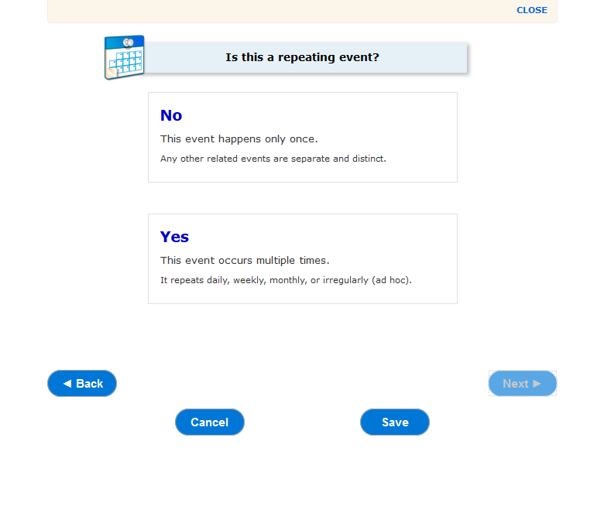

  - ENTER YOUR EVENT DATE AND TIMES:
Click the calendar icon to select the date of the first event occurrence. Select your start and end event times from the drop-down menus.
- If your event occurs on multiple date with the same times, you’ll describe how it repeats on the next page.
- If your meeting has multiple occurrences that happen at different times, you’ll need to create separate event wizards for each time.
- Please leave “The first occurrence beings and ends on the same day” box checked.
- Select “yes” in the Additional Time section if you need time before or after your event in the room. This will add pre- or post- time to your event reservation.
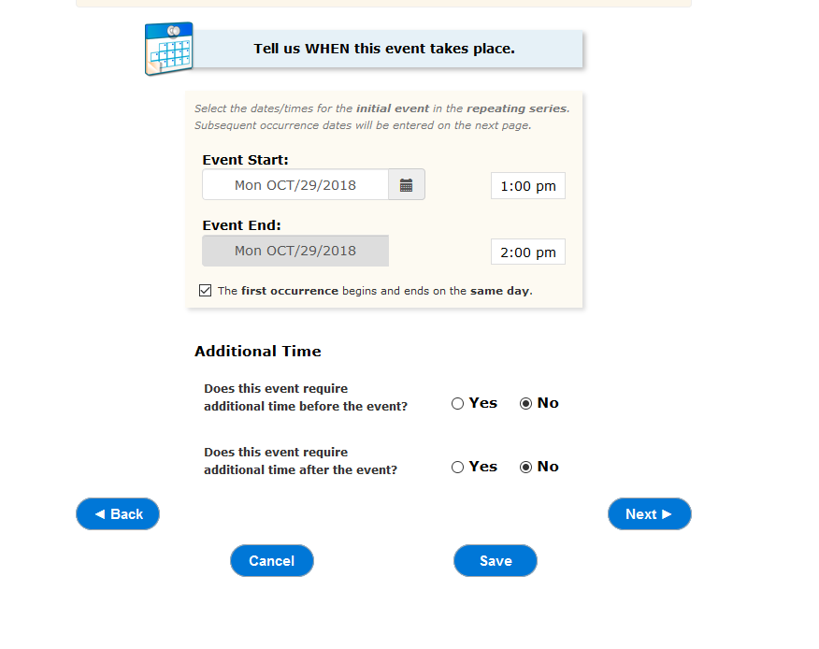

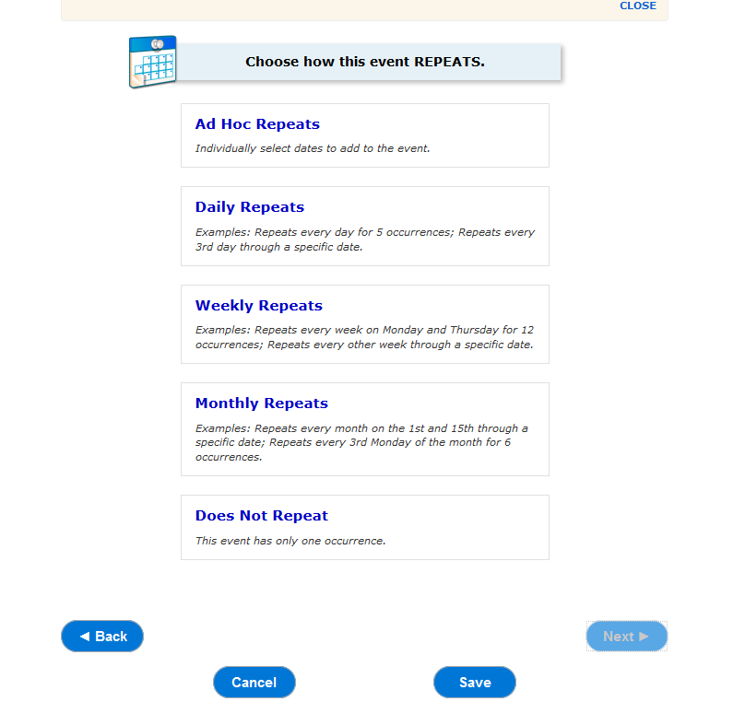
REPEATING EVENTS: You will see this part of the event
wizard if you have indicated previously that your event has multiple occurrences or when you are in Edit mode making changes to an existing reservation. Select from the following options:
- Ad hoc – event dates may be random and are selected from a calendar

- Daily

- Weekly

- Monthly

- Does not repeat

Please become familiar with the scheduling timelines for reservable spaces at UW Tacoma. For example, the system may allow you to submit a request for a classroom for the
year but those spaces are scheduled quarterly. The scheduling offices reserve the right to cancel or remove dates that fall outside the scheduling times.

- Locations – Click Saved Searches and select Public Searches. Select the UWT location search on the right to generate a list of spaces. Check Show only my authorized locations that have no time conflicts to see available spaces. Check Enforce head count.
    - Available spaces will have a green check mark icon
    - The red triangle icon indicates conflicts with your meeting/event date and times.
    - Spaces with the red brick icon are not avialable for Simple Meeting use.

    - The selected location(s) will populate on the right of the webpage. You may select multiple locations per reservation.

    - If you have marked a location as a favorite, they will always appear at the top of the page. You may also search by location name if you know those details.

    - The selected location(s) will populate on the right column of the webpage.

    - It is possible to select multiple locations per reservation.

    - To remove a selected location, click the red X to the right of the location name.

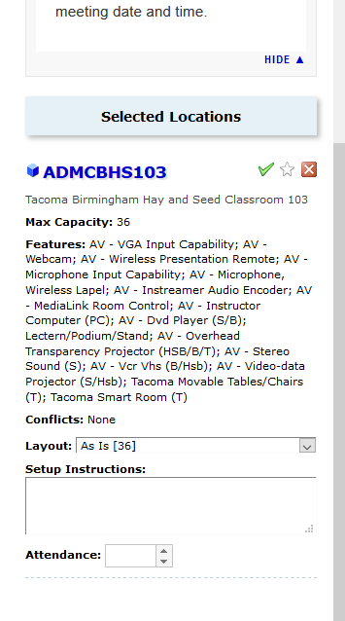
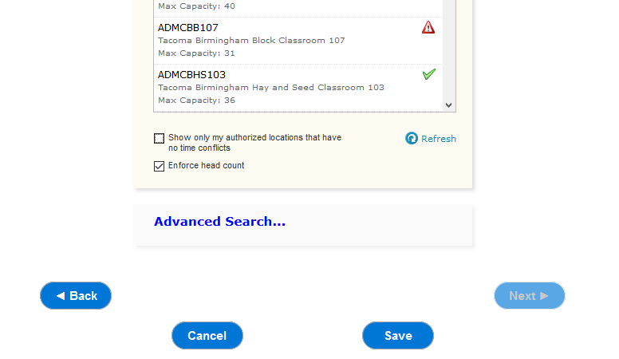

SELECTING LOCATIONS FOR MULTIPLE OCCURRENCES

If you have multiple event dates on your reservation, each selected location will have a View and Modify Occurrences link. Click the link to see reservations in greater detail.

If you want to assign a room on certain dates that do not have conflicts, uncheck the “Assign?” box accordingly.

Details of each conflict will appear at the bottom of this window if you hover your mouse over the conflict icon. A black square means that the room is either offline or closed; the paper icon means that the room is assigned to another reservation.

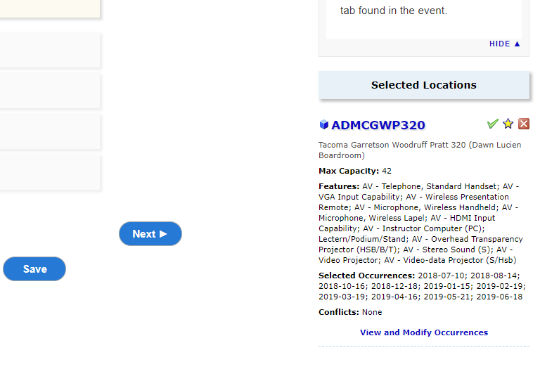
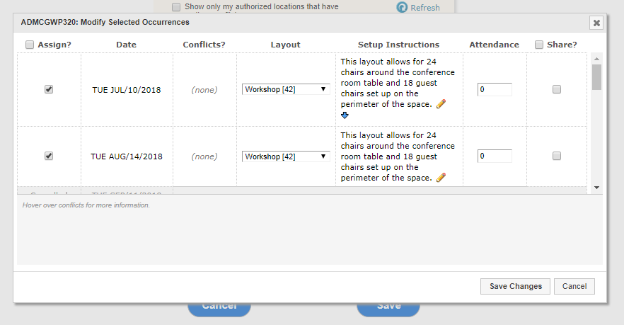

REMOVING A LOCATION
- In the Event Wizard on the right column, click on the red X button next to the space that you do not want to select. See attached image for reference. You will notice that your selected locations will also populate in the left column (the left column provides you with a summary

- After making your location selections, click Next until you complete the form.
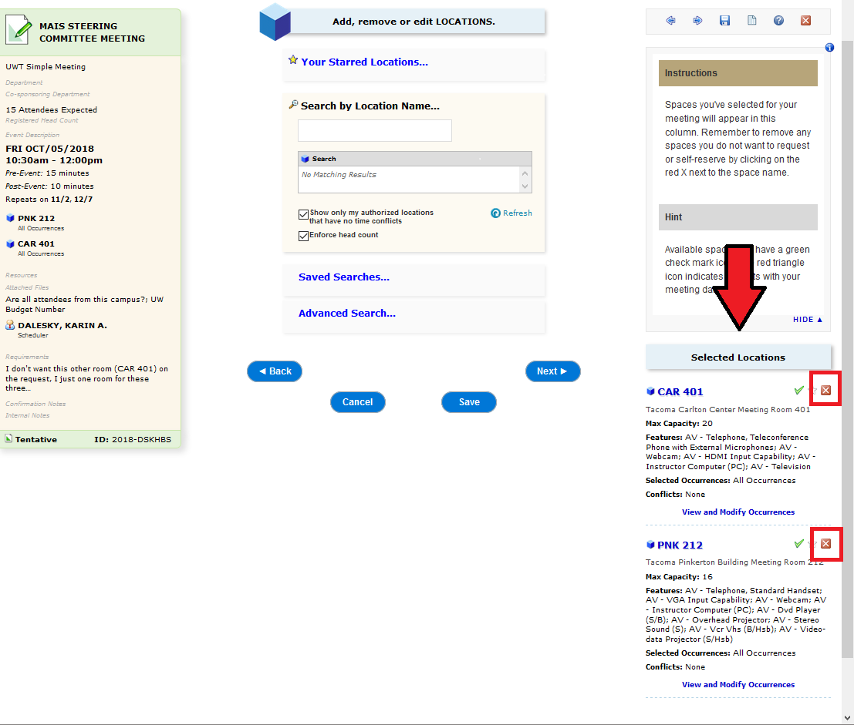

- Add Setup Information – Once you have selected your location you can select your setup option and provide additional details about your setup needs. If you select a custom setup you can attach your custom diagram on the next page of the request form.

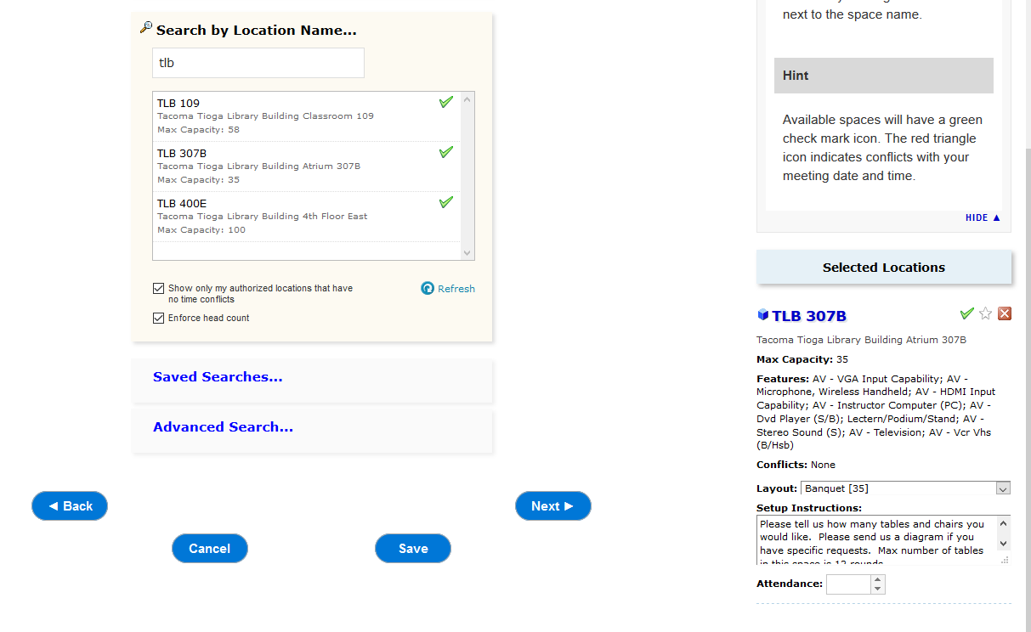

If you have multiple spaces you will need to select your setup and provide details for each space you are reserving.

If you are requesting multiple dates you will need to click on View and Modify Occurrences to request your setup option and provide details about your setup needs.

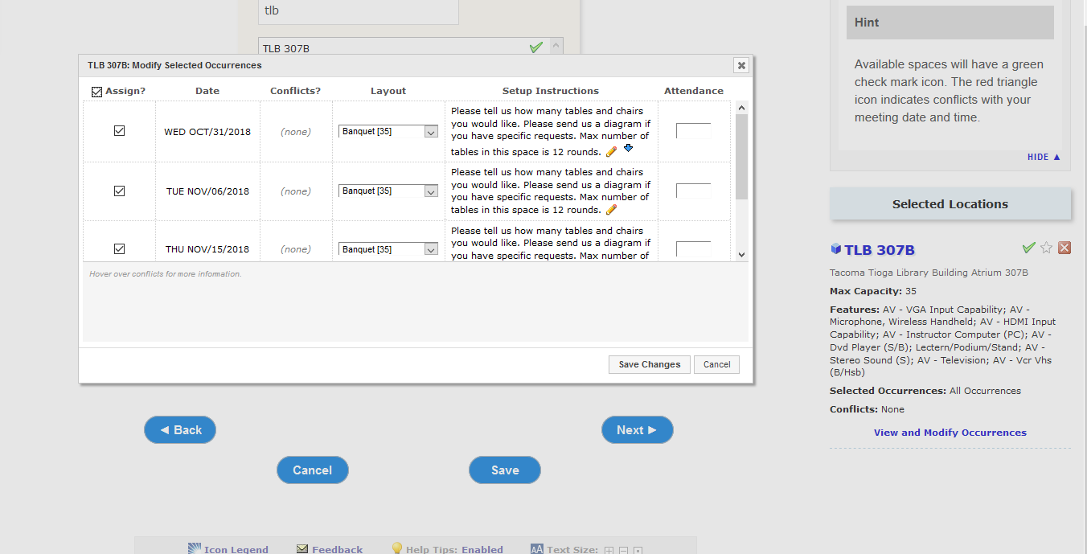

- Add or remove ATTACHED FILES – You can attach up to five files per reservation. If you are requesting a custom setup for your event please attach your diagram here.
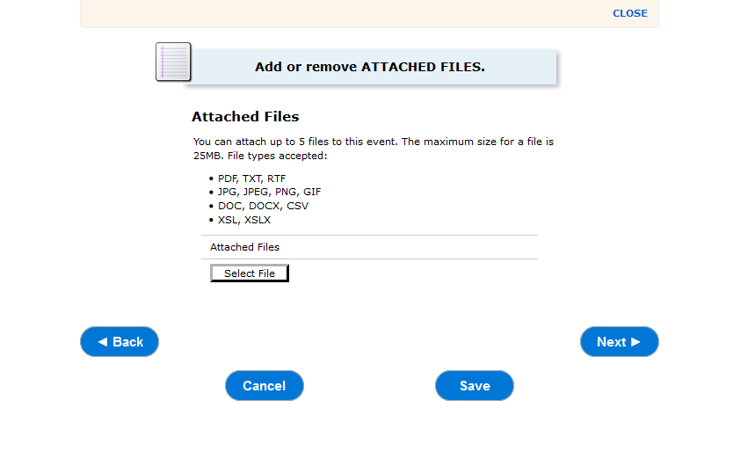
Custom Setup Diagrams:

Download your blank setup diagram for spaces that allow custom setup diagrams online at: http://www.tacoma.uw.edu/uuf/setups

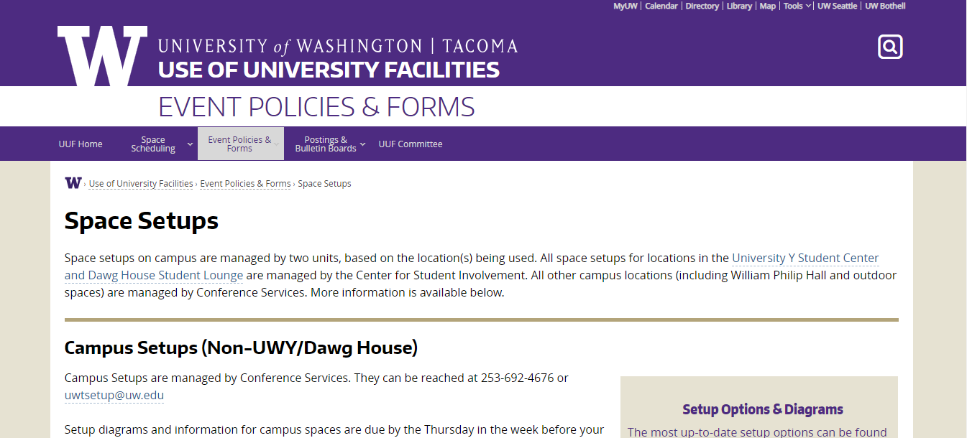

- Additional information – Answer the required questions
  - Are all your attendees for this campus? This question notifies Campus Safety that there will be individuals who are not UW Tacoma Faculty, Staff or Students if you answer no.

  - UW Budget Number: This budget # is charged for all support costs associated with your event including your budget # authorizes Support Departments to charge this budget.
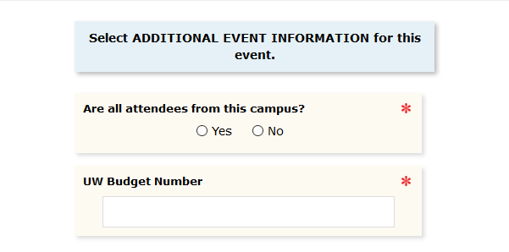

  - Day-of-Event Contact Information: If you would like support departments to reach out to someone other than you as the scheduler about the specifics of this event please include their name and contact information.
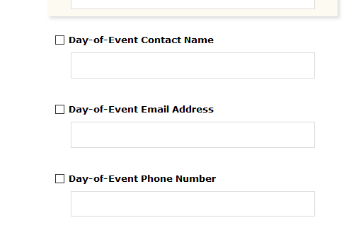

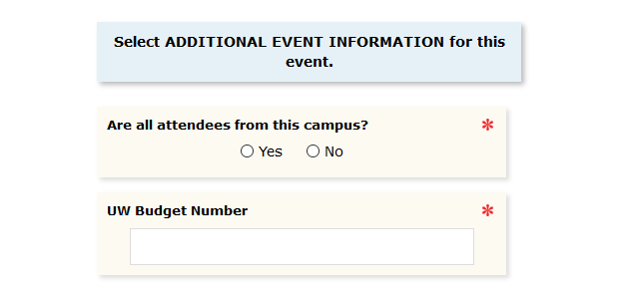

- Requirements – Include the specific information about your event. This notifies support departments about your support needs and information required to collect about each event hosted at UW Tacoma. You can either check the box or start typing in the comments box.

For more information about requirements please visit: www.tacoma.uw.edu/uuf/25live/requirements

If you don’t need any support or your answer to all questions is no please check the This event requires none of the services listed above.

  - CS: ALCOHOL WILL BE SERVED AT THIS EVENT.
Notifies: Campus Alcohol Approver and Campus Safety
Reservations in which alcohol will be served are required to follow the campus alcohol policies and receive approval to serve. Events with alcohol are required to request support from Campus Safety. Charges may apply.

  - CS: CASH WILL BE CHANGING HANDS AT THE EVENT.
Notifies: Campus Safety
Reservations that have cash present may be required to have an officer from Campus Safety be present. This is determined on a case-by-case basis and will result in a charge to the event. Charges may apply.

  - CS: EVENT WILL INVOLVE POLITICAL ACTIVITY.
Notifies: Campus Safety

Reservations that are political-in-nature or include political activities must notify Campus Safety. An officer may be required to be scheduled for the event. Charges may apply.

  - CS: PLEASE PROVIDE ADDITIONAL REQUESTS OR COMMENTS FOR CAMPUS SAFETY.
Notifies: Campus Safety
This space can be used to request additional services from or ask questions to Campus Safety. This includes asking for doors to be unlocked to spaces/buildings.
*please note that you do not need to request buildings or rooms to be open (with the exception of computer classrooms) if your event takes place during regular campus open hours

  - FS: FOOD AND/OR NON-ALCOHOLIC BEVERAGES WILL BE SERVED. PLEASE PROVIDE DETAILS.
Notifies: Facilities Services

If your reservation will have food served, please provide details regarding what is being served. Please be detailed. Post-event custodial support is scheduled for events based on what is answered here. Failure to complete this question and serving food, or providing inaccurate information, can result in emergency cleaning charges. Please be advised that in 25Live 1 resource for custodial is equivalent to 15 mins of custodian time. Click here to learn more about custodial
Helpful links: UW Tacoma Food Policy Food and Beverages Approval Form

  - FS: PLEASE LIST THE NAME OF THE CATERER YOU PLAN TO USE.
Notifies: Events Office

If your reservation is serving food, please provide the name of the caterer and/or location where the food will be purchased. Click here to learn more about the campus food policies

  - FS: PLEASE PROVIDE ADDITIONAL REQUESTS OR COMMENTS FOR FACILITIES SERVICES.
Notifies: Facilities Services

This space can be used to request additional services from Facilities Services. This includes asking for access to electrical and water, assessing special event needs, use of grass spaces, and more.
For the TPS Garage Doors to be opened during your event please include your request here. For additional questions or concerns, please contact Facilities Services directly at facility@uw.edu.
Please note that if you are requesting space in the University Y Student Center, all facilities requests will be handled by the UWY staff. Please email uwyevent@uw.edu for more information or questions.

  - MS: WE WOULD LIKE A MEDIA TECHNICIAN TO SUPPORT THIS EVENT. PROVIDE DETAILS.
Notifies: Media Services

If your reservation would like assistance from a media technician, provide details in this box regarding the level of support you are requesting. This includes setup of equipment prior to an event, support throughout an event, special media needs, specific type and/or quantity of equipment, etc. A technician will reach out to you at least one week prior to the event. Charges may apply. Expect an email from a media technician.

  - MS: WE WOULD LIKE THIS EVENT TO BE VIDEO RECORDED.
Notifies: Media Services

If your reservation would like your event to be video recorded by Media Services, please check this box and note any important details. This service comes at a cost to the event. Expect an email from a media technician.

  - TS: WE WOULD LIKE GENERAL PARKING FOR THIS EVENT.
Notifies: Transportation Services

If your reservation would like to request general parking permits for an event, please mark this box and request the number of permits needed.

Please note that parking permits cannot be purchased for use by faculty, staff or students.

  - TS: WE WOULD LIKE RESERVED PARKING FOR THIS EVENT.
Notifies: Transportation Services

If your reservation would like to request reserved parking spaces for an event, please mark this box and request the number of spaces needed.

Please note that parking permits cannot be purchased for use by faculty, staff or students.

  - UUF: THIS EVENT INVOLVES AN EXTERNAL ORGANIZATION.
Notifies: Events Office

If your reservation will include, partner with, support, or promote a non-UW, external organization(s), please check this box. Please also include the name of the external organization(s).

  - UUF: THIS EVENT WILL CHARGE A REGISTRATION/ADMISSION FEE.
Notifies: Events Office

If your reservation will charge a fee for admission or registration, please mark this box. Please note that all events charging a registration fee are subject to review by the Conference Services Office. Events charging a registration fee may be required to run through Conference Services and room fees may apply.

  - UUF: THIS EVENT WILL INVOLVE FUNDRAISING/SOLICITATION OF CHARITABLE DONATIONS.
Notifies: Events Office

If your reservation will involve or contain fundraising or the solicitation of charitable donations, please mark this box.

  - UUF: THIS EVENT WILL INVOLVE PHYSICAL ACTIVITY.
Notifies: Events Office

If your reservation will involve any type of physical activity, please mark this box. Physical activities include, but are not limited to, sports/recreation, carnival rides, inflatables, etc.

  - Z: THIS EVENT REQUIRES NONE OF THE SERVICES LISTED ABOVE.
Notifies: n/a

If none of the questions on this page apply to your reservation, please mark this box. This means that your event will receive none of the support or services inquired about.

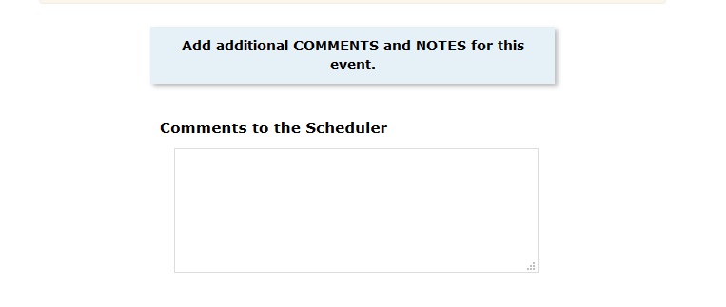
- Comments to the Scheduler – if you are requesting a space for your meeting/event that requires approval, you may include comments to the space approver.

- Affirmation – You must agree that you are hosting your meeting/event on behalf of UW Tacoma and agree to the policy statement before your reservation will be saved.

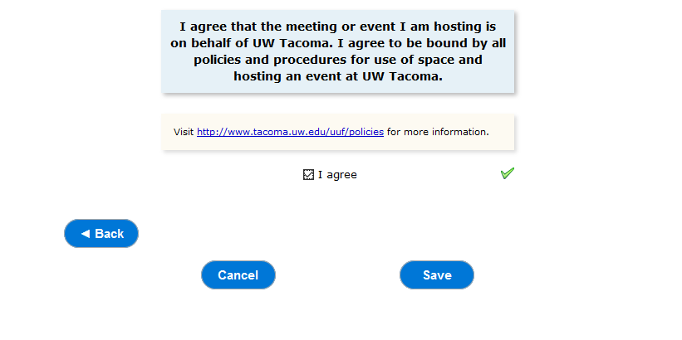
- After submission, you will see the Event Information page. Things to note:
  - ID: this is the unique ID for your reservation. It will be useful when communicating with a Scheduler or support department about your reservation.
  - If you selected a self-serve meeting room, the location will appear on the left column with a blue cube icon . The blue cube icon means that the space is assigned and needs no further approval.
  - If you selected a space that requires approval from a scheduler, the location will show that it is pending approval.
  - You may View Details, Edit, Copy or Email the reservation.
    - The Copy function is useful for creating a similar reservation with different times.

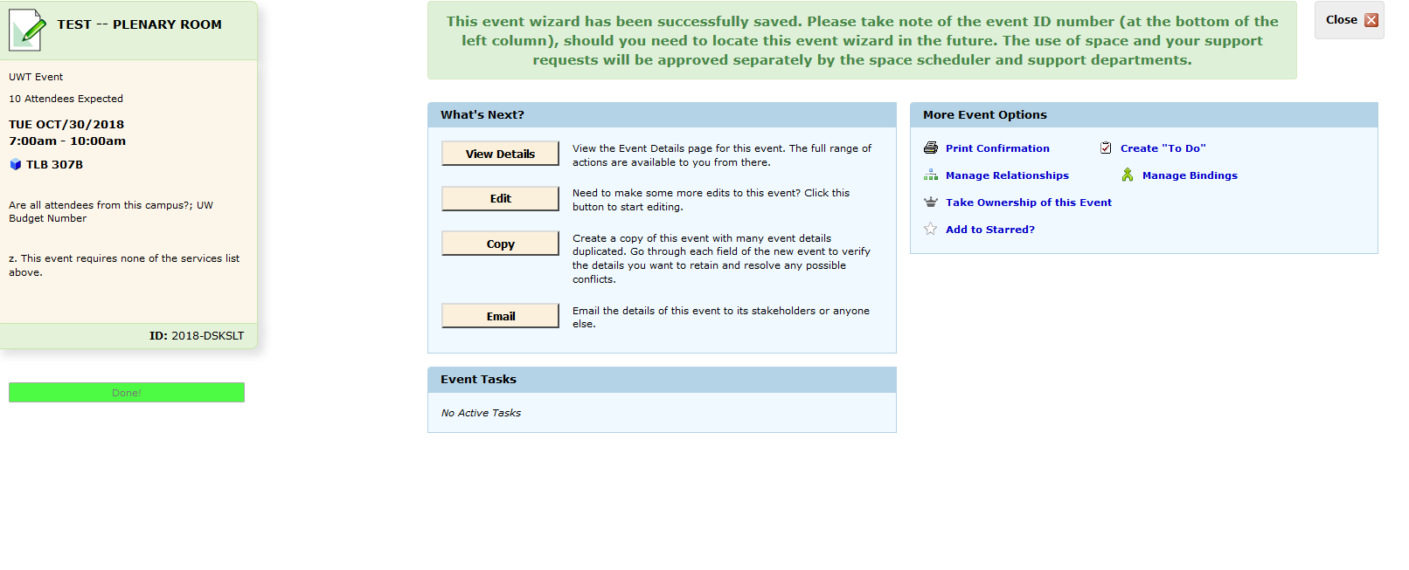

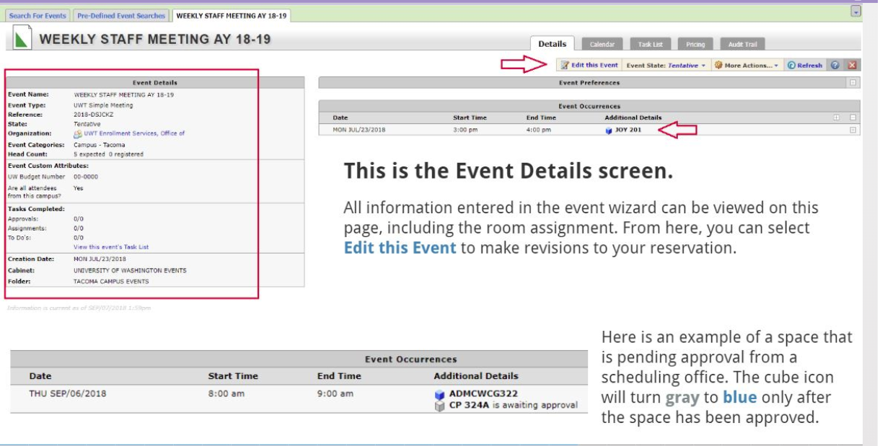

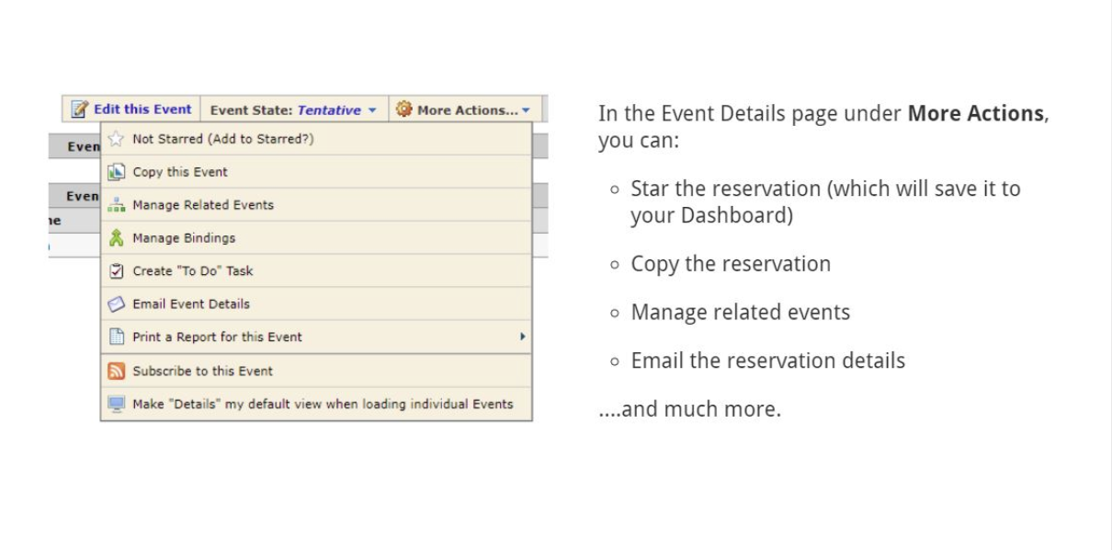

COPY A RESERVATION
This feature is useful when you have multiple occurrences of an event with different times. When you select “copy” from the Event Summary or Event Details pages, you will see the following prompt:
- Copy on this event: this choice will open an event wizard with some fields pre-populated from the originating reservation.
- Copy only this event and relate to existing set: this will open an event wizard with some fields pre-populated in addition to establishing a relationship with the originating reservation.

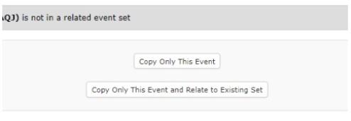

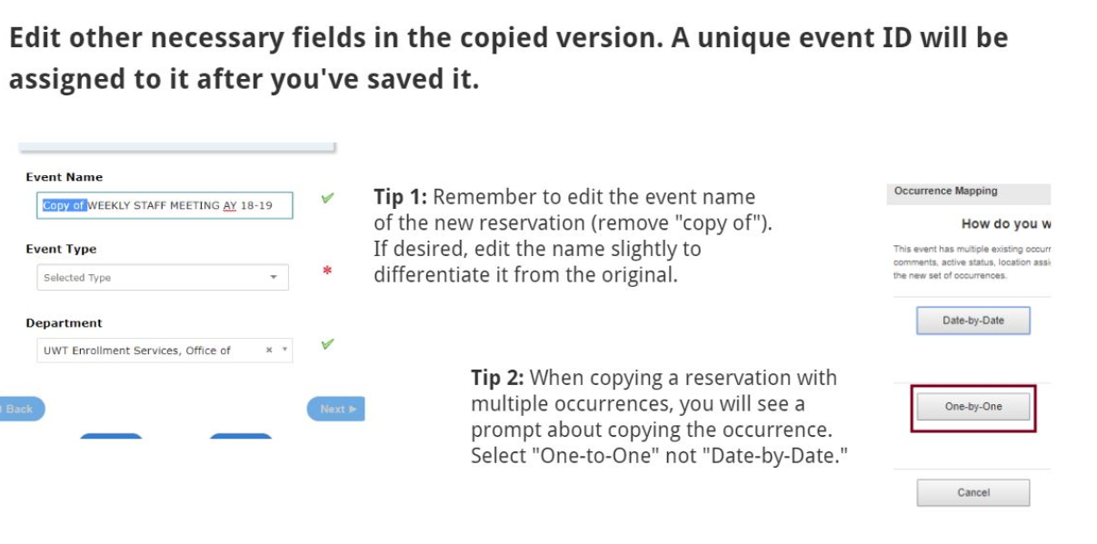
RELATING EVENTS
If you have an event that involves more than one reservation you can connect these reservations by relating them.

If you submit both reservations simultaneously you will see a Manage Relationships section pop-up after completing your second reservation. Click on Relate. This will connect your two reservations.

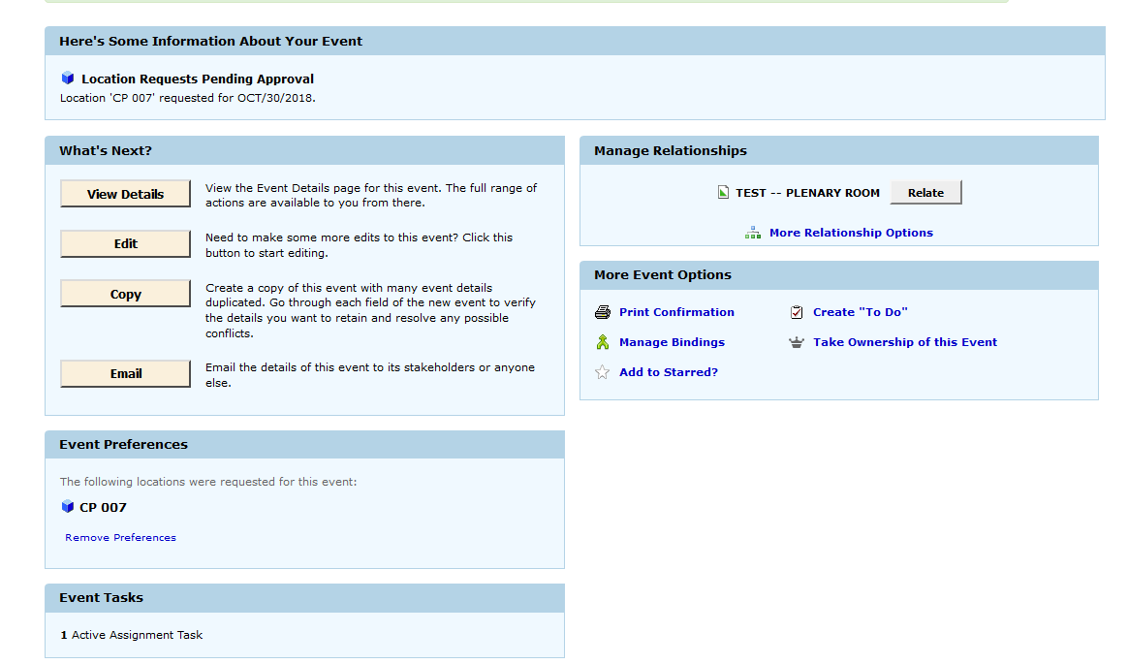

If you want to relate two reservations that you submit at different times open your first reservation that you want to relate and under More Actions select Manage Related Events.
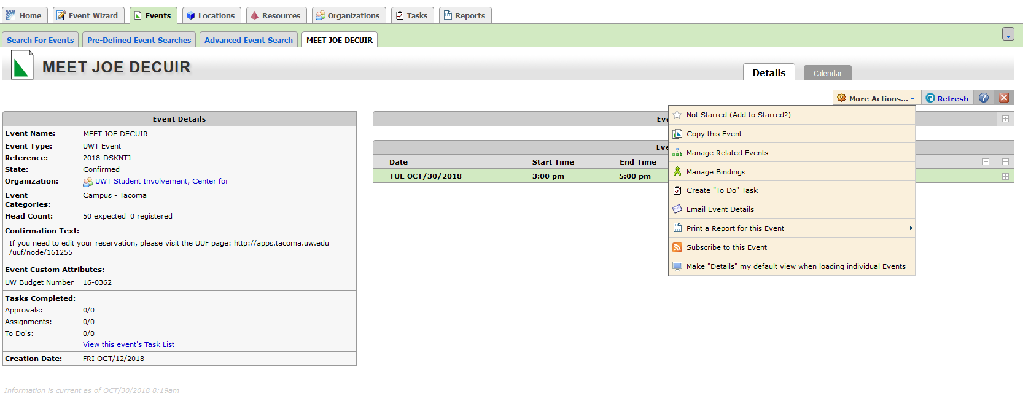

REVIEWING RESERVATIONS
- If you have upcoming reservations, you will see this on the Dashboard under “Your Upcoming Events” section. You will be taken to the Events tab > Pre-Defined Event Searches tab > Events You are Scheduling
- To view all dates or to specify a date range, select the Curren

Then click on Add Events to Set

Identify the event you would like to relate and click Add Selected. This will relate your two (or more reservations).

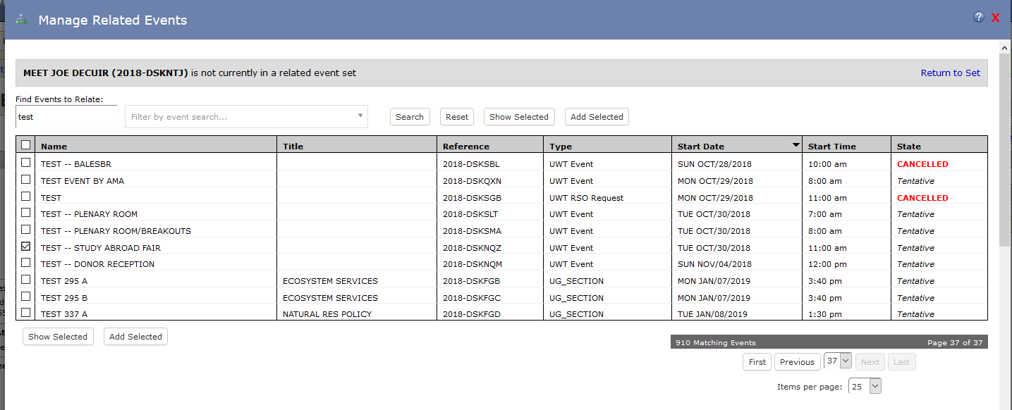

REVIEWING RESERVATIONS
- If you have upcoming reservations, you will see this on the Dashboard under “Your Upcoming Events” section. You will be taken to the Events tab > Pre-Defined Events Searches tab > Events You are Scheduling.
- To view all dates or to specify a date range, select the Current and Future Dates filter.
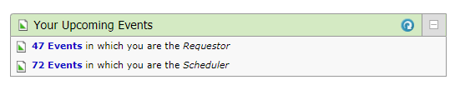

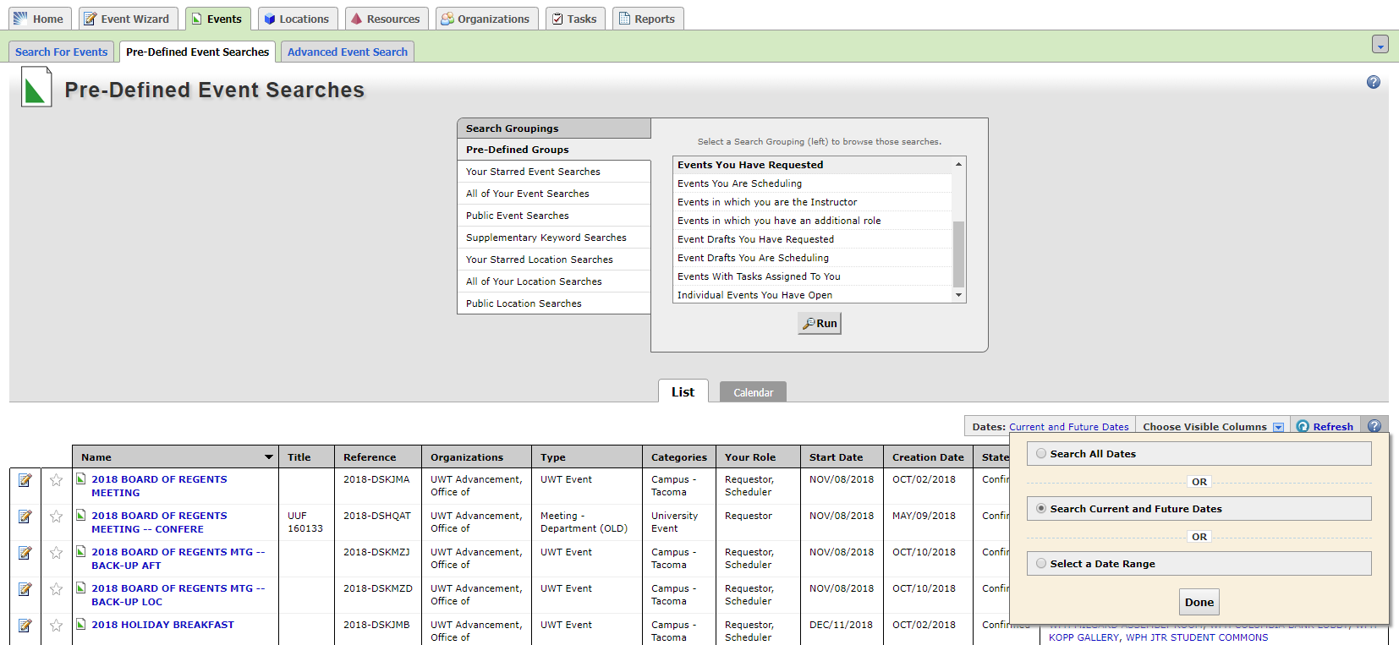

CANCELLING AN ENTIRE RESERVATION
- In the Event Details page, change the Event State to “Cancelled” from “Tentative” or “Confirmed.” Changing the event state will cancel all dates and locations within that reservation. See attached image for reference.

- After changing the Event State to “Cancelled,” you will see a pop-up asking that you confirm the cancellation. You cannot undo this action.
