How to Create a "To Do" Task
Purpose: Creating "To Do's" are a great way to set-up reminders for an event. They show up in your workflow but they also notify you by email and can be set-up and sent-out to other users.
Audience: All 25Live users
- Log into your 25Live user URL.
- You can set-up a To Do for an existing event or a new event:
  - Locate Event
  - Click on the Task List
  - Scroll down to the Create "To Do" Task
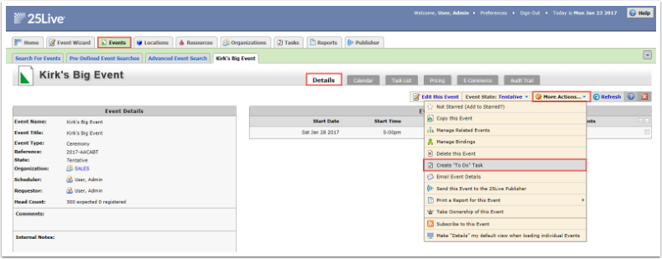
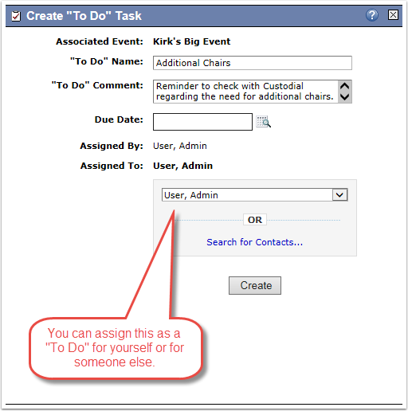
- The Create "To Do" Task will ask for a name of your task. It will also ask you for date and who the task was assigned to and by whom.

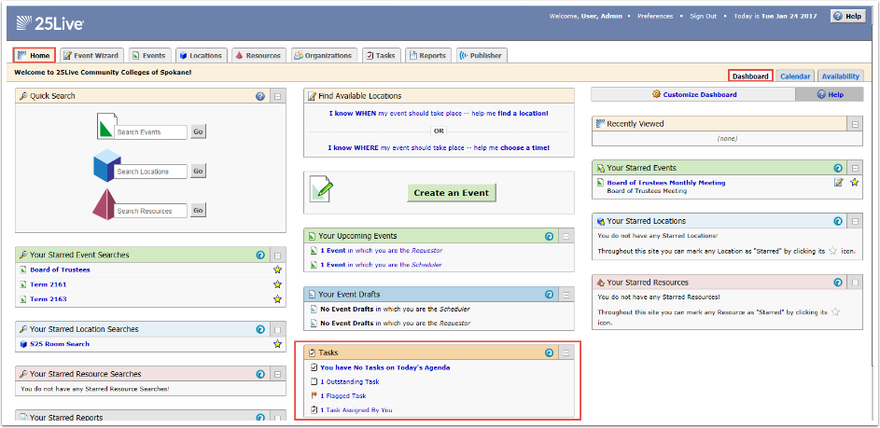
- When reviewing your tasks from from the Dashboard screen, you will see a list of tasks assigned by you and assigned to you.

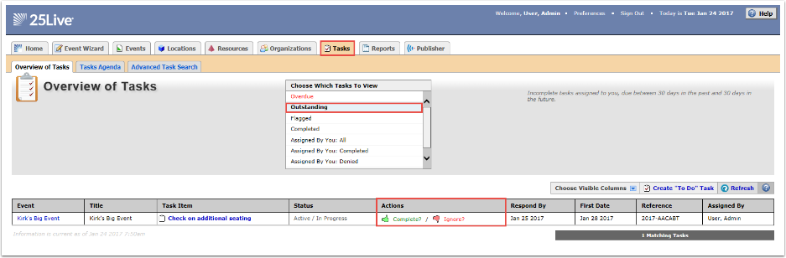
- When looking at the Tasks tab, you will see more details of your outstanding tasks. In addition, you will also receive an e-mail reminder if your e-mail notification functionality is turned on.

