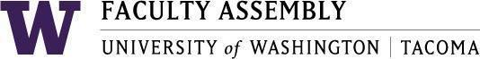

Academic Policy & Curriculum Committee
April 22, 2020, Zoom 12:30-2:00 am

Agenda
New course and Course Change’s only. No policy discussions. No 1503’s requiring Notice of Proposals

- New Course Proposals

*TLAW 200: Pre-Law Seminar
Returned February 2020 meeting. Returned for the following reasons: Syllabus is 2 paragraphs and does not form syllabi standards. Need to include at least one text. Missing Religious Accommodation. Include school of law as a potentially affected school. 20% Participation

TSOCW 554: Cognitive Behavioral Therapy for Advanced Social Work Practice

- Course Change Proposals:

T URB 110 (Diversity Designation Review)

T ACCT 330: Introduction to Accounting Information Systems

Join Zoom Meeting
https://washington.zoom.us/j/188312756

Dial by your location
+1 669 900 6833 US (San Jose)
+1 646 876 9923 US (New York)
Meeting ID: 188 312 756

