Faculty Assembly Executive Council (EC) Meeting Minutes
May 19, 2017 1:00-3:00pm CP 206 C

Present: Marcie Lazzari, Mark Pendras, Lauren Montgomery, Ka Yee Yeung-Rhee, Sushil Oswal, Katie Haerling, Julia Aguirre, Marion Eberly. Matt Kelley, Ji-Hyun Ahn, Marian Harris, Michelle Garner, Loly Alcaide Ramirez, Nicole Blair, Marion Eberly. Jennifer Harris, Jeff Cohen. Excused: Mark Pagano, Greg Rose, Charles Costarella, Jim Gawel, Melissa Lavitt, Ellen Moore, Jutta Heller, Lauren Pressley, Leighann Chaffee. Guests: Eric Bugyis (for Jutta Heller & Leighann Chaffee), Lisa Isozaki, Sarah Hampson.

- Consent Agenda & Recording Permission
The agenda was approved with the removal of Faculty Assembly Meeting Debrief and Honorary Degree Procedure due to time available. Permission was given to record for the minutes.
- Announcements
-Provost Search Advisory Committee UW Tacoma listening forum to be held on 5/30/17 from 9-11am in WPH.
-Faculty rep on the search committee for the VC of Finance and Administration, Katie Haerling, will email confirmation of the tentative candidate visit dates. EC members asked that she represent faculty by asking the candidates about faculty engagement in the budgeting process and for evidence of their experience around shared governance with faculty.
- Approval of Minutes
The April 26, 2017 Executive Council meeting minutes were approved.
- Chair’s Report and Discussion Items
- Past Chair on Strategic Planning Coordinating Committee (SPCC)
Past chair, Marcie Lazzari, has served as faculty liaison to the Strategic Plan while sitting on the SPCC. It has been recommended that this become a role of the past chair. The goal of this recommendation is for a clear communication pathway to be established. Mark Pendras, FA current chair, has agreed to attend SPCC as the faculty liaison/rep for 2017-2018. This arrangement will be reevaluated spring next year to see if it should be added in formally to the past chair’s role description. It was noted that the FA chair sits on the Executive Budget Committee and that this experience will be helpful when sitting on SPCC since SPCC forwards its proposal recommendations to EBC.
- Salary Planning Exercise from Provost Slides DATA
RECAP: The Provost has tasked deans and chancellors with a salary planning exercise due to the budget crunch-time and slowed growth. This ask is also in conjunction with Executive Order 64, the Faculty Salary Policy. Provost Baldasty’s letter is in Appendix A. He wants units to use this process to plan for three+ years and look at salary equity, compression, and conversions. [Note: the UW Tacoma Chancellor is considered a dean within the UW governance structure, the EC is considered the elected faculty council, and UW Tacoma is considered a school.] Within the task of a salary audit, the following should be considered: regular merit, additional merit, promotion raises, unit adjustments, retention raises, etc. In regards to “peer institutions,” (similar demographics) UW Tacoma faculty salaries are decent.
FA leadership circulated data by categories (for every academic unit) to EC members.
Response:
- Data that showed salaries by race, gender, and ethnicity were unavailable from Seattle.
- The data highlighted that this is a unit-level issue/decision making task.
- The same treatment across units would not work well since units vary widely.
- Can we identify meaningful patterns across all units or only within units?
- The spreadsheet was frustrating in general and mainly showed the disparities across units
- The spreadsheet was inaccessible to some members; FA Admin will follow up with them
Are there principles that should apply across all units?
- Recognize our campus as a community of people – there is a bottom line of what it takes to live here and makes ends meet
- Need to be conscious about the impact of percentages at the higher end and compression via cost of living in this area
- Different disciplines are compensated very differently; it would be difficult to get a general agreement
- Could we link to median incomes for the area and make thresholds or minimums, below which we don’t want to to fall because it would undermine our community?
The Salary Planning task is being carried out at the unit level in coordination with deans/directors and their elected faculty councils. Thus, should EC also do it at the campus level? Proposed: have units do this task and EC members check in with the elected faculty councils in the fall for accountability in how this task is being carried out. Perhaps even ask faculty how they feel about their faculty councils because if the faculty councils aren’t working well, everything built upon them won’t work either.
- Q: Would we develop guidelines on how to evaluate unit processes or feel out the process as we go?
- A: Figure it out as we go because this is a new process on campus.
- Generally, EC members agreed with the proposal, but there was also concern that there needs to be a shared-governance big picture conversation.
- Unit discrepancies is a big conversation; how and when to take it up?
- Some members felt strongly about working on articulating a minimum threshold.
- Is there a cost benefit to the university to put more resources in one place than another? Will two leaders be making these resource decisions or will there be wider input?
- Some units have more compression – should we direct campus funds there, or to the unit with less compression?
- Within unit compression happens within units who have larger salaries.
- Look at deviation from median with peer institutions. Develop a floor/minimum and a (flexible) ceiling in reference to median of peer institutions
  - Minimum salaries and maximum deviations from the mean
- There are a range of ideas/concepts appropriate for EC to explore and then there are unit-level decisions
The idea behind this exercise is manage our salaries better in order to have more knowledge to make decisions with; know what the salaries are, what the patterns are, where they’re going. We need good information to do good planning. The amount of money available doesn’t negate that planning is good.

- Principle Investigator Policy – Lisa Isozaki, Research Administrator Appendix A
Lisa Isozaki, Research Administrator in the UW Tacoma Office of Research, highlighted the aspects of this proposed policy that elevated in from its previous form as a memo (written by Joel Baker when I was in the Office of Research):
-addition of a time-limited exemption
-addition of roles that need pre-approval
-addition of non-eligible due to contract length
-one can petition within their academic unit to be a PI
-addition that academic units can develop their own PI policy that could be stricter, if needed to serve that academic unit’s particular needs
Q: Could this policy include allowing a post-doctorate student to be a PI?
A: No, there is a UW-wide policy that limits what a post-doctorate student can submit. UW wants to make sure that they don’t have people applying for grants that would outlive the PI’s contract length.
EC discussed the limitations that the proposed policy places around PI eligibility related to faculty category and contract length. As a larger reaching issue, EC members brought up the need to consider how the faculty composition is/can be shaped by policies. As a potential solution to limiting which faculty categories can be a PI, EC members suggested having the option of a co-PI so that there would be assurance that the work would be finished regardless of contract length. They expressed that it is a good goal to protect people’s work so that unhealthy expectations are not set. Putting limits around who can be a PI should not be restrictive, but protective.
EC asked about timeline for feedback. Since the Office of Research would like to have a policy in place before Fall 2017 (which is the next opportunity that EC would get to discuss this policy at length), the Office of Research will have this proposed policy be provisional until EC has time to deliver more substantial feedback in Fall 2017. Lisa Isozaki will take current feedback to the Office of Research and remain in contact with EC about continuing this discussion during the next academic year.
- Campus Climate Survey – Marian Harris and Sarah Hampson, Faculty Affairs Committee
Campus Climate Survey Project Proposal
In keeping with the Faculty Affairs Committee ongoing charge on issues of race and equity, FAC determined that UW Tacoma needs a campus climate survey to address ongoing issues around race and climate. FAC reviewed several surveys and the most comprehensive survey was by Rankin & Associates. They have done climate surveys for over 170 institutions, large and small, local and across the country. FAC acknowledges that there is now a tri-campus climate survey in the works, but wants to advocate for UW Tacoma to have a separate survey because of our unique issues and needs. FAC asked the EC would support their proposal for a campus climate survey to be conducted by Rankin & Associates.
The tri-campus climate survey group is also looking into having Rankin & Associates conduct the tri-campus survey. There is to be a meeting later in May between Rankin & Associates and the tri-campus climate survey group at UW Seattle. Others from UW Tacoma would be welcome to attend, but the meeting date/time was unknown.
EC members asked how this survey would be different from the COACHE survey that was undertaken a couple of years ago. The biggest difference is that the campus climate survey would include all faculty, staff, and students, where the COACHE survey was only for faculty.
EC members asked about exploring what kind of influence UW Tacoma could have in the design of the tri-campus climate survey. They suggested that perhaps the tri-campus climate survey could be molded to meet some of our needs, and then UW Tacoma could follow up with a more specific survey as well. All agreed that UW Tacoma needs a campus climate survey, but that we need to be strategic in terms of timing and resources. EC supports FAC working with the group planning the tri-campus climate survey at UWS and advocating for the survey to include aspects that are specific to UW Tacoma. Deirdre Raynor and Anthony Falit-Baiamonte are UW Tacoma reps on the Diversity Council in UW Seattle. EC encouraged collaboration with them.
- Equitable Teaching Policy Appendix B
EC passed this policy on March 31, 2017, but brought it back to add this language:
“Mitigating factors that might exempt individual faculty members from time to time from these
guidelines include:
• Teaching specialty courses such as service learning, labs or field work, that require
scheduling commensurate with community organizations and activities or daylight
hours. The programs should, however, try to share such workload by providing
opportunities to other faculty to develop expertise in such specialty areas.
• Care-giving responsibilities.
• Health or disability related needs.”
VOTE: 13 in favor; 1 abstain; 6 absent.
- Leadership for Office of Equity & Inclusion
EC discussed the following questions prepared by member, Julia Aguirre, who is serving on the committee to gather feedback about the leadership position for the Office of Equity & Inclusion:

Goal: Gather Executive Council feedback on questions related to the Associate Chancellor of Equity & Inclusion. This position will be similar to other leadership positions and most likely have a faculty appointment (this is strong recommendation given the nature of the position). The phase 1 search committee is meeting early next week (of 5/22) to consider all feedback and start working on the job description. EC feedback will be timely.
During the EC meeting: 5 minute reflection on the three questions via survey or on a half sheet of paper.

1) What specific skill sets and areas of knowledge would you like the ACEI ideal candidate to have?
2) What areas of need would you like the ideal ACEI candidate to address, specifically in relation to working with Faculty Assembly?
3) How do you envision the future ACEI leading UWT forward with our mission and commitment to equity and inclusion?

EC discussed the potential benefits of this leadership position having a faculty appointment, i.e. being able to identify with faculty as well as students and staff and being on par with other top administration who have faculty appointments. EC members would like to see this person help faculty with pedagogical equity and help faculty make courses inclusive so that every student can find belonging in each course. EC also discussed the official title of the position (Assistant Chancellor) and asked that it be reviewed so that it aligns more clearly with the other top administrative leadership roles (i.e. vice chancellors). It will be important for this person’s role to be clearly defined and elevated to the level of other campus leadership.
- Tri-Campus Reporting Structure Memo Appendix C
There has been frustration and ambiguity around the tri-campus structure/relationship. This memo, coming from the faculty as UW Tacoma and UW Bothell, requests that the President and Provost review the current reporting and organizational structure, as well as, makes recommendations to better align the UW Tacoma and UW Bothell leadership with the UW Seattle leadership. The chair of the UW Senate, Zoe Barsness, and the Faculty Council on Tri-Campus Policy have encouraged FA leaders and the UW Bothell General Faculty Organization to send this memo to the President and Provost. FCTCP also intends to include the memo in their final report. One of the main recommendations in the memo is to establish a Board of Chancellors in which the UW Tacoma Chancellor and UW Bothell Chancellor have a meeting with the Provost, instead of them only being including on the Board of Deans. Additionally recommended is that the UWT and UWB vice chancellors meet with the vice chancellors of UWS, the faculty leadership of UWT and UWB also report to the Provost. EC members agreed with this effort and suggested adding an amended org. chart that depicts the recommendations.
- Adjourn

Appendix A
Principal Investigator (PI) Status Policy at UW Tacoma

The purpose of this policy is to specify who at UW Tacoma can serve as a Principal Investigator or Project Director on extramural proposals and outlines a process for individuals in specific positions that may request an exemption.

A Principal Investigator (PI) is an individual who has primary responsibility for the design, execution, and management of a research project and who will be involved in the project in a significant manner. A Project Director (PD) is an individual who has primary responsibility for the design, execution, and management of a training or public service project and who will be involved in the project in a significant manner.

The ‘primary responsibility’ held by PIs and PDs may not be delegated explicitly or implicitly to individuals who are not eligible in their own right to serve as Principal Investigator or Project Director. The current UW Tacoma eligibility requirements for Co-PIs and co-PDs are the same as those for PIs and PDs.

Academic units at UW Tacoma can have unit-specific more restrictive PI policy that the campus level policy.

Eligible without no further action
All UW Tacoma faculty with the rank of Assistant Professor, Research Assistant Professor, Associate Professor, Research Associate Professor, Professor, Research Professor, and Research Scientists grade 10 or higher are eligible to serve as Principal Investigators, co-Principal Investigators and Principal Directors on extramurally supported projects.

Time-limited Exemption
Senior or Principal Lecturers - exemption will be provided on a continuing basis effective for up to 5 years. Exemption requests, addressed to the Associate Vice Chancellor for Research, must include:

• A letter of support from the academic unit dean or director that includes a confirmation that a positive vote of the academic unit faculty, above the rank of the candidate, was received. The letter should include the expiration date of eligibility.
• A copy of the recommended individual's current curriculum vitae

Project-limited Exemption
Affiliated Faculty,² Competitively Hired Lecturers, Research Scientists at grade 9 - this eligibility is limited to a specific project. Exemption requests, addressed to the Associate Vice-Chancellor for Research, must include:
- A letter of support from the academic unit dean or director explaining how the proposed project or program will significantly contribute to the educational, research or public service goals of the petitioner’s unit; and (2) that the nominated individual adds unique knowledge, experience and competence to the project.
- A copy of the recommended individual's current curriculum vitae
- One-page project description of project

Non-eligible
Non-competitively hired lecturers or Research Scientists below a grade 9, and Post Doctoral Research Associates (PDRA) are not eligible to serve as PI or PD or petition his/her Dean/Director for an exemption.

Other titles
UW Tacoma faculty and other employees holding other than one specified here and seeking exemption from this policy may petition their Dean/Director to be considered for eligibility to serve in a PI or PD capacity. If the Dean/Director approves this initial petition and decide in consultation with Associate Vice Chancellor of Research if the exemption request should be time-or project-limited and then submit the request.

Appendix B

Guidelines for Equitable Teaching for UW Tacoma

Faculty Assembly Executive Council

Approved March 31st, 2017

The growing size of our campus now necessitates the creation of policy guidelines to ensure the equitable distribution of teaching responsibilities across all faculty ranks. This includes both a distribution of course level (upper and lower division), and of teaching times throughout the day and evening time slots. This is important because classroom space is limited and greater utilization of outlying time slots is required. Sharing the responsibility of these outlying time slots across faculty rank is best practice both in terms of student experience and equitable labor practices. Similarly, students benefit when faculty of all ranks teach lower division courses, and faculty also benefit from exposure to students at earlier stages in their academic careers. Thus, both of these principles are best practices in terms of pedagogy and equitable labor practice.

Toward this goal, Faculty Assembly recommends the following guidelines:

- Each full-time faculty member makes themselves available to teach at least one class in the early morning (8:00am) or evening (beginning after 5:00pm) each year.
- No faculty member shall be required to teach more than two such courses (8am or beginning after 5:00pm) each year, unless they request so.
- Each full-time faculty member makes themselves available to teach at least two lower division courses in their unit or service courses each year. (A service course is one that is required for other majors.)

Mitigating factors that might exempt individual faculty members from time to time from these guidelines include:

- Teaching specialty courses such as service learning, labs or field work, that require scheduling commensurate with community organizations and activities or daylight hours. The programs should, however, try to share such workload by providing opportunities to other faculty to develop expertise in such specialty areas.
- Care-giving responsibilities
- Health or disability related needs

According to these guidelines, teaching specialty courses in the upper division is not a mitigating factor.
Appendix C

To: Ana Marie Cauce, President, Jerry Baldasty, Provost, University of Washington, Seattle

From: Lauren Montgomery, Vice Chair, Mark Pendras, Chair, Faculty Assembly, UW Tacoma,
Casey Mann, Chair, Linda Watts, Vice Chair, General Faculty Organization, UW Bothell

RE: Request for review of the governance structure in the upper administration of the University of Washington tri-campus system.

Date: May 13, 2017
The faculties of the UW Tacoma and the UW Bothell campuses are requesting a review of the governance structure of the upper administration of our tri-campus system. We do not wish to change anything essential about our relationship to the Seattle campus, but think that a review of the governance structure could be beneficial to the whole system. In the current configuration, our two chancellors are members of the Board of Deans & Chancellors on the Seattle campus, and report to the Provost through that body. This structure was established 27 years ago when the two campuses were created, and made sense at the time due to their small size and the desired close relationship to UW Seattle. In the quarter of a century since then, both the Bothell and Tacoma campuses have grown and matured considerably. We both now have multiple schools and deans of our own, as well as more differentiated upper administrative structures with multiple vice chancellors. In developing this request, we consulted with the Chancellors of Tacoma and Bothell, and the Senate Executive Council Chair, all of whom endorse our request. But we emphasize that the initiative originated with faculty leadership on the Tacoma and Bothell campuses. Our reasons for making this request are:
1) Clarity of communication and processes: With the current configuration, there is persistent ambiguity and confusion around the nature of the relationship between the campuses. The governance structure views Bothell and Tacoma as schools of the Seattle campus, but in fact, these campuses are more differentiated than schools, and function differently. The resulting ambiguity of process and confusion in communication interferes with the smooth execution of directives and the flow of information back and forth between faculty and administration across campuses. These problems have a subtle but distinct demoralizing effect on faculty working in shared governance, hindering our ability to maintain enthusiasm and initiative for improvement.
2) Need for more points of formal intersection to promote tri-campus system efficiency - Currently, the only formal administrative contact points are the Chancellors’ membership on the Board of Deans and Chancellors. Given the functional differences between Chancellors and Deans, the system may benefit from an additional, separate reporting structure directly to the Provost and President. Similarly, the system may benefit if Vice Chancellors from Bothell and Tacoma are members of the reporting group to the Provost with the Vice Provosts in Seattle. Finally, while the tri-campus faculty are already interconnected on committees, councils and steering and task forces, the system may also benefit from a formal reporting relationship between faculty leaders and the Provost and President.
3) Aligning structure with function - An articulation of the governance relationships where the structure better follows the function of the various parts may enhance our system-wide collaboration, promoting communication and the flow of information back and forth between the right people, in the right places, at the opportune time. This could also facilitate the creative experimentation that tends to happen on the smaller campuses and the sharing of feedback from those initiatives with Seattle.
4) Agreement with UW organizational chart - Finally, the review and possible changes we are requesting could bring the governance and reporting structure into better agreement with University of Washington organizational chart, approved by the President and Board of Regents in December, 2016 (see below).
We understand that the nature of a revised governance structure will be the result of a collaborative process involving all stakeholders over time, but here are some new structures we have thought of to serve as examples:
Current Tri-campus Upper Administrative Reporting Structure
Board of Deans, Chancellors and (E)VCAA – Reporting to Provost
Seattle Deans of Schools
Chancellor, UW Bothell
Chancellor, UWTacoma

Proposed Additional Structures

Board of Chancellors – Reporting to Provost
UW Tacoma Chancellor
UW Bothell Chancellor

Vice Provosts and Vice Chancellors – Reporting to the Provost
Vice Provosts on Seattle Campus
Vice Chancellors on Bothell Campus
Vice Chancellors on Tacoma Campus

Faculty Leadership – Reporting to Provost
Chair & Vice Chair, Senate Executive Council, Seattle
Chair & Vice Chair, Faculty Assembly, Tacoma
Chair & Vice Chair, General Faculty Organization, Bothell

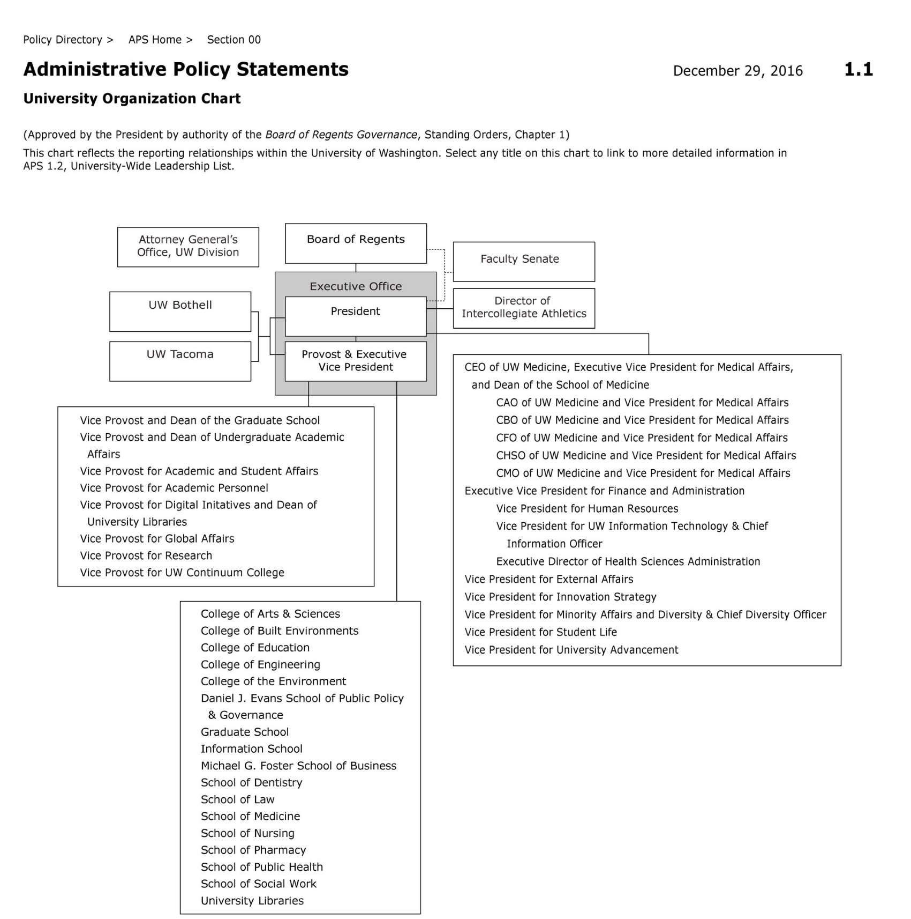
-

UW Tacoma Executive Council
Faculty Salary Planning Priorities

The Executive Council of the Faculty Assembly of the University of Washington Tacoma has the opportunity to provide guidance to our campus administration regarding campus salary planning. Individual units are engaging in long-term salary planning for their units, but Chancellor Pagano and EVCAA Lavitt are also making available centrally 1% of salary from this year's pool to address campus level salary concerns, and they want guidance from the EC about how to prioritize use of those funds (equity, compression, inversion, starting salaries, etc.).

Below is a list of priorities for EC members to vote on. Please place a rank number (1 being the highest priority, four being the lowest priority) in front of each of the below priority groupings:

______ Faculty who have been the most compressed for the longest period of time.

______ Faculty who face the most pronounced compression, regardless of years in rank.

______ Faculty who have spent the most time in their rank, though their levels of compression may be less pronounced.

______ Faculty who have spent the least amount of time in rank, facing the lowest levels of compression.

Recognizing that making salary decisions according quantitative factors alone, while relying on limited data criteria, may be undesirable, please also indicate whether you would like to see the following language included in the guidelines provided by the EC to the campus administration (write ‘yes’ or ‘no’ in the space provided):

______ The recommendations provided here are based on set of criteria limited by the availability of data. While we appreciate this opportunity to offer guidance, the EC would also like express a desire to expand the criteria in the future to include additional demographic categories, specifically data on race and gender, so as to assess and correct any additional patterns of inequity.
______ In providing this guidance regarding faculty salary priorities, the EC would like to emphasize the importance of simultaneous qualitative review of the salary data to ensure that the salary decisions made will effectively target the identified salary concerns.

“Faculty holding this title [Research Associate] may not be principal investigators on grants or contracts.” (http://www.washington.edu/admin/acadpers/job_descriptions/Research_Associate.html). 2 Modeled after PI policy within College of Engineering and College of Environment

