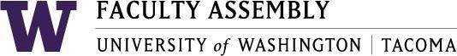

FACULTY ASSEMBLY WINTER
MEETING & WORKSHOP

January 27, 2017 – 1:00 p.m. – 3:00 p.m.
William Philip Hall

1:00 Welcome and Introductions – Mark Pendras, Faculty Assembly Chair and Associate Professor, Urban Studies, & Lauren Montgomery, Faculty Assembly Vice Chair and Senior Lecturer,
School of Interdisciplinary Arts and Sciences

1:02 Faculty Memorial – Jill Purdy, Associate Vice Chancellor for Undergraduate Affairs, Associate Professor, Milgard, School of Business

1:08 Opening Remarks – Mark Pagano, Chancellor & Melissa Lavitt, Executive Vice Chancellor for Academic Affairs

1:22 Brief Sketch of Diversity at the UW Tacoma – Mark Pendras, Faculty Assembly Chair and Associate Professor, Urban Studies

1:30 Going Upstream Workshop with the Faculty Assembly – Yves Labissiere, PhD. Portland State University

3:00 Adjourn

