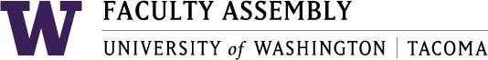

FACULTY ASSEMBLY FALL RETREAT Agenda
September 25, 2017 10:00 a.m. – 12:30p.m.
William Philip Hall

10:00-10:10 Welcome & Introductions
Lauren Montgomery, FA Chair and Senior Lecturer, SIAS
Ka Yee Yeung-Rhee, FA Vice Chair and Associate Professor, Institute of Technology
Mark Pendras, FA Past Chair and Associate Professor, Urban Studies

10:10-10:20 Chancellor’s Remarks
Mark Pagano, Chancellor

10:20-10:30 Strategic Plan & DACA Update
Kathleen Farrell, Director, Student Planning and Administration
Mentha Hynes-Wilson, Vice Chancellor, Student & Enrollment Services

10:30 – 10:45 Faculty Assembly – Shared Governance and Priorities for the year.

10:45- 11:15 –- Administrator Jeopardy
~Break ~

11:30 – 12:00 - Academic Planning – Rationale, goals, implementation
Jill Purdy, Interim Executive Vice Chancellor Academic Affairs
Tye Minckler, Vice Chancellor, Finance and Administration
Ali Modarres, Chair, Council of Deans and Directors

12:00 – 12:30 – Faculty conversation on Academic Plan

Refreshments Provided by Faculty Assembly Excellence Fund, with donations from faculty.
Thank you!

