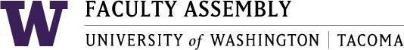

Agenda
Faculty Affairs Committee Meeting
October 18, 2018 / 12:30pm-2:00pm SCI 104

- Consent Agenda & Recording Permission
- Approval of Minutes from 9/20/18
- Open Public Meeting Act
https://www.youtube.com/watch?v=9yTtVGToW1A
(Members will be required to sign documentation of completion)

- Executive Council Charges to Standing Committees review
- Parking
- Childcare
- Teaching Evaluation Policy
- Changes to UW Faculty Code
- Non-Competitive Hiring Policy
  - FAC Development of General Search Policies
- Confidentiality
- Internal Candidates
- Search Firms
- Other Considerations?
- Sound Transit
- Adjournment

