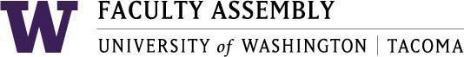

Agenda
Faculty Affairs Committee Meeting
November 15, 2018 / 12:30pm-1:30pm SCI 104

- Consent Agenda & Recording Permission
- Approval of Minutes from 10/18/18
- Parking
  - 15 allocated minutes for discussion and brainstorming
Bring ideas… All options considered.
- Childcare (no news yet)
- Teaching Evaluation Policy (Prepare for December discussion and vote)
- Non-Competitive Hiring Policy (Review of existing proposed policy) (Changes?)
  - FAC Development of General Search Policies
- Confidentiality
- Internal Candidates
- Search Firms
- Other Considerations?
- Sound Transit (Prepare for December visit from Sound Transit staff)
- Adjournment

