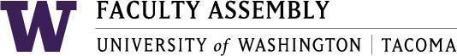

Agenda
Faculty Affairs Committee Meeting
December 6, 2018 / 12:30pm-1:30 p.m. SCI 104

- Consent Agenda & Recording Permission
- Approval of Minutes from 11/15/18
- Parking
UWT Administration Parking Proposal (Grant)
Draft expected for the January meeting
Possible transportation survey review (Berry)
- Childcare
Follow up (Grant)
Draft expected for the January meeting
- Teaching Evaluation Policy
Prepare for discussion and vote (FAC all)
- Non-Competitive Hiring Policy
Policy draft review, discussion and vote (Laing)
- Social Activities
(FAC all)
- Transportation (Sound Transit)
ST has decided not to meet with us. Brainstorm other approaches.
- Adjournment

