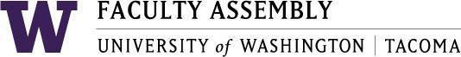

Agenda
Faculty Affairs Committee Meeting
June 7, 2018 12:30pm-2:00pm SCI 104

- Consent Agenda & Approval of Minutes
  - Meeting materials: May 10, 2018 Faculty Affairs Committee Minutes
- FAC 2018 Final Report
  - Review Draft and Prepare Final Version
- Non-competitive Hiring Policy Draft
- Next Year
- Teaching Evaluation Policy Draft
- Changes to UW Faculty Code

- Adjourn

Tabled items:

Climate Survey
Parking
Childcare
Sound Transit

