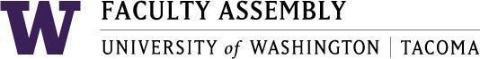

Agenda
Faculty Affairs Committee Meeting
September 20, 2018 / 12:30pm-2:00pm SCI 104

- Consent Agenda & Recording Permission
- Approval of Minutes from 6/7/18
- Open Public Meeting Act
Please watch the following video
https://www.youtube.com/watch?v=9yTtVGToW1A
(Required signature documentation of completion at next meeting)

- New Member Need – Nursing & Healthcare Leadership
- Parking
- Childcare
- Teaching Evaluation Policy
- Changes to UW Faculty Code
- Non-Competitive Hiring Policy
  - FAC Development of General Search Policies
- Confidentiality
- Internal Candidates
- Search Firms
- Other Considerations?
- Climate Survey
- Sound Transit
- Adjournment

