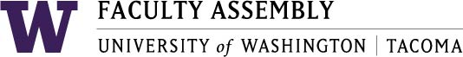

Agenda
Faculty Affairs Committee Meeting
November 13, 2017 11:30-12:30pm CP 206 C

- Consent Agenda
  - Meeting material: October 16, 2017 Faculty Affairs Committee Meeting Minutes
- Chair’s Report and Discussion Items:
  - Childcare and Early Childhood Education
  - Diversity and Inclusion in Hiring Processes
  - Non-competitive Hiring Policy – Latest Draft
  - Parking for Faculty – Feedback and Ideas
  - UW Express Bus (#586) – Sound Transit / Pierce Transit
  - Teaching Evaluations
  - Adjourn

