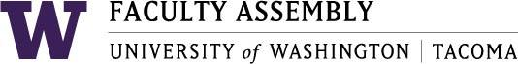

Agenda
Faculty Affairs Committee Meeting
May 10th, 2018 12:30pm-1:30pm Location SCI 104

- Consent Agenda & Approval of Minutes
  - Meeting materials: April 12, 2018 Faculty Affairs Committee Minutes – pending

- Non-competitive Hiring Policy – Discussion
- Teaching Evaluation Policy Draft & Faculty Code Language
- Climate Survey Update – No news to discuss
- Parking – Discuss next steps in new plan to collaborate with students.
- Childcare – Discuss next steps in new plan to collaborate with students.
- Sound Transit – Still need to form a plan – may also be best to collaborate with students.
- FAC 2018 Final Report
- Adjourn

