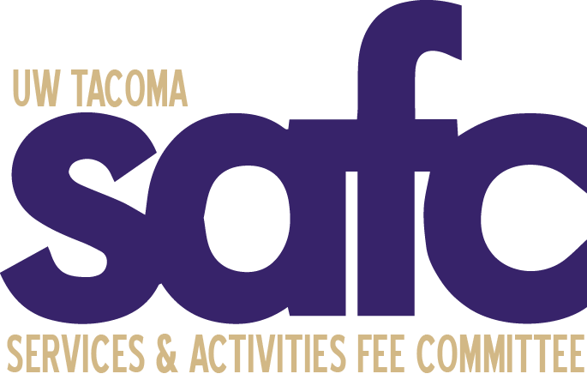
Services and Activities Fee Committee (SAFC)
Friday, 4th June, 2021
12:00pm – 1:00pm
Join Zoom Meeting
https://washington.zoom.us/j/97606414543
Meeting ID: 976 0641 4543
One tap mobile
+12532158782,,97606414543# US (Tacoma)
+12063379723,,97606414543# US (Seattle)

MEETING AGENDA
CALL TO ORDER:

ROLL CALL

Voting Members
Julisia Brock
Sabrina Bui
An Le Dang
Emily Flavin, Vice-Chair
Sarah Kim
Amy Rhee, Chair
Kylee Zehnder

Ex Officio Members
Bernard Anderson, Associate Vice Chancellor for Student Life
Drew Dunston, ASUWT Director of Finance
Jan Rutledge, Finance & Administration Representative
Ronald San Nicolas, Lecturer; Simon Family Endowment MSW Autism Field Unit Coordinator
Sean Schmidt, Student Affairs, Associate Director of Student Planning & Administration (Compliance Officer)

OPEN PUBLIC FORUM

APPROVAL OF AGENDA

APPROVAL OF MINUTES

UNFINISHED BUSINESS
- 2021-2022 Committee Member Search

NEW BUSINESS

ANNOUNCEMENTS

ADJOURNMENT

