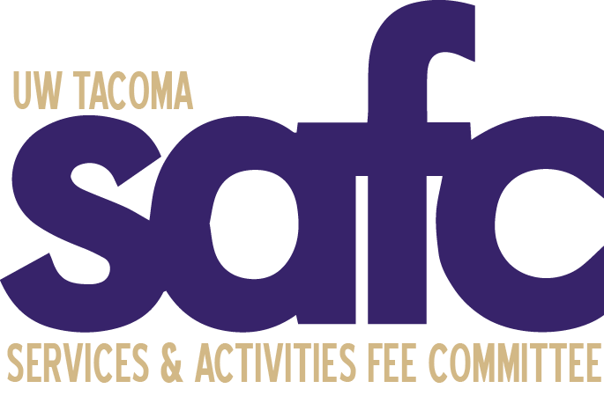
Services and Activities Fee Committee
Friday, May 21st, 2021 - 2pm
Zoom: https://washington.zoom.us/j/97606414543
Zoom Telephone: (253) 215-8782
Meeting ID: 976 0641 4543

MEETING MINUTES 19

CALL TO ORDER: 2:00pm

ATTENDANCE (1 minute)

Voting Members
Julisia Brock - Present
Sabrina Bui – Absent
An Le Dang- Present
Emily Flavin, Vice-Chair - Present
Amy Rhee, Chair - Present
Kylee Zehnder - Present
Sarah Kim - Present

Ex-Officio Members
Bernard Anderson, Associate Vice Chancellor for Student Life – Absent
Jan Rutledge, Finance & Administration Representative – Present
Ronald San Nicolas, Lecturer, Simon Family Endowment MSW Autism Field Unit Coordinator - Present
Sean Schmidt, Student Affairs, Associate Director of Administration, Finance, and HR (Compliance Officer) - Present

Guests
Kelly Tyrell – Present

- Introductions & Icebreaker

- OPEN PUBLIC FORUM

- APPROVAL OF AGENDA (1 minute)
  - An moved to approve the May 21st, 2021 agenda. Kylee seconded. Motion passed unanimously.
- APPROVAL OF MINUTES (1 minute)
  - Minor correction made to the May 7th minutes – changed “Student Advisory Board” to “Student Activities Board” on Page 3.
  - Emily moved to approve the minutes of the May 7th, 2021 meeting. Julisia seconded. Motion passed unanimously.
- UNFINISHED BUSINESS (40 minutes)
  - Board of Regents Materials
    - YMCA Agreement:
      - Discussion held regarding the current YMCA Agreement and if next year’s SAFC (2021-2022) will bring up the issue of part-time students paying part-time YMCA fees.
      - The current SAFC Board displayed support for the 2021-2022 SAFC Board reviewing the YMCA agreement for part-time students to finalize the issue.
    - Reviewed more general materials being sent to the Board of Regents.
  - 2021-2022 Committee Member Search
    - Discussion held regarding searching for new committee members for next year’s SAFC Board. The Board wants to allow an opportunity for word-of-mouth recruitment posts to Handshake/recruiting alternatives.
    - The bylaws state that there should be roughly five committee members hired prior to SAFC’s start in Fall of 2021, which will be the current committee’s goal.
  - Spring Special Allocations – Giving Garden
    - Discussion surrounding the inability of the current committee’s authorization to approve funds for next year, meaning the Giving Garden will have to get and spend necessary funds for this school year by June 30th, 2021.
    - Giving Garden would also need to work with UWT IT as well as UWT Facilities to approve the wireless communications and underground irrigation system respectively, something SAFC can’t approve.
    - SAFC official approval will include stipulations to the Giving Garden regarding above points (i) and (ii).
    - Sarah moved to approve the Spring Allocation for the Giving Garden under the stipulation they spend the requested funds by June 30th, 2021. Kylee seconded. Motion passed unanimously.

- NEW BUSINESS (10 minutes)
  - Preemptive Food Request Approval for 2021-2022
    - Jan wanted to do a quick look at reviewing a preemptive food approval for 2021-2022. Will be discussed during the June 4th meeting.

- ANNOUNCEMENTS (5 minutes)

- ADJOURNMENT
- Emily moved to adjourn the meeting at 2:53pm. Kylee seconded. Motion passed unanimously.

