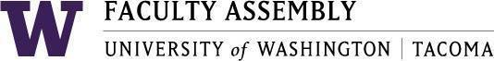

Agenda
Faculty Affairs Committee Meeting
May 17th, 2021 / 12:30pm-1:30 p.m. Zoom

- Recording Permissions/Consent
- Approval of Minutes-
  - Minutes from 4/19/2021
- Report from Faculty Affairs Co-Chairs
  - May 10 EC Meeting
- Updates from Non-Tenure Track Faculty Forum
- Workload Problem Statement and Solution Discussion
- Findings from School-Level Surveys, FGs, SIAS Analysis (Sharon and Alex)
- Topics/Areas of Interest for FAC, 2021-2022
  - iTech Fellows concern (Two-tiered system, disproportionate impact)
  - Post COVID-19 Concerns
  - Parking/Transportation
  - Junior Faculty: Conferences/Professional Development
- Adjournment
  - Next Meeting: June 14, 2021
    - Election of FAC Chair(s)

Join Zoom Meeting
https://washington.zoom.us/j/95419519317

Dial by your location
+1 253 215 8782 US (Tacoma)
+1 206 337 9723 US (Seattle)
Meeting ID: 954 1951 9317

