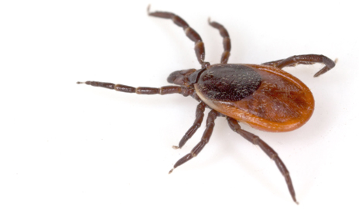
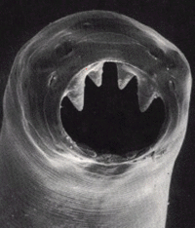
TCORE 122. Introduction to Science
Parasites, Pests, and Society
Dr. Jeremy M. Davis
jerdavis@uw.edu SCI 102B (253) 692-4907

Class Sessions: Tuesdays and Thursdays, 10:15-12:20 IN GWP 101
Office hours: Tuesdays, 1:30-2:30, Fridays, 11:00-12:00 or by appointment
Reading Material:
Student Purchase: Zimmer C. 2011. Parasite Rex: Inside the bizarre world of nature’s most dangerous creatures. New York (NY): Simon & Schuster, Inc. 306 p.
Selections provided by instructor: Lee JA. 2010, The Scientific endeavor: A primer on scientific principles and practice. San Francisco (CA): Addison Wesley Longman. 186 p.
News and Primary Research Articles provided by the instructor.

The UW-Tacoma Core Program:
The Core program consists of a coordinated series of courses that represent the various disciplines in the university. This course, along with the others in your cohort, fulfills one of the university’s general education requirements in each of the areas of knowledge plus composition. The courses are designed to both support and challenge you to develop the critical thinking, writing, research, and analytical skills you’ll need at UWT while introducing you to relevant topics in the social sciences, humanities, and sciences.
Parasites, Pest, and Society
This course explores the cultural and biological impacts of organisms that compete with, feed off, and otherwise interact with human societies. Through case studies, students will learn how scientists study the origins and success of these species and how best to control them.

Date | Day | Topic | Reading
Mar 29 | T | Introduction to the course, parasites, and pests | Syllabus
Mar 31 | Th | A scientific approach to parasites | Lee Ch. 1  Zimmer Ch. 1
Apr 5 | T | Developing hypotheses | Lee Ch. 2
Apr 7 | Th | Life as a parasite | Zimmer Ch. 2
Apr 12 | T | How research works | Lee Ch. 3
Apr 14 | Th | Finding scientific evidence | Lee Ch. 4
Apr 19 | T | How parasites manipulate behavior | Zimmer pp. 79 -100  PRA
Apr 21 | Th | The role of parasites in ecological communities | Zimmer pp. 100-117  PRA
Apr 26 | T | Midterm Exam
Apr 28 | Th | Tracing the history of parasites | Zimmer 118-147
May 3 | T | Predicting the virulence of parasites | Zimmer 147-156
May 5 | Th | Parasites and Sex | Zimmer 157-176
May 10 | T | Avoiding parasites | Zimmer 176-189
May 12 | Th | Humans and parasites | Zimmer Ch. 7
May 17 | T | Skepticism and Pseudoscience | Lee Ch. 6 & 7
May 19 | Th | Using parasites for good | Zimmer pp. 216-234
May 24 | T | Do we care about parasite biodiversity? | Zimmer pp. 234 - 253
May 26 | Th | Should I get a hookworm? | Lee Ch. 8
May 31 | T
Jun 2 | Th

Graded work:
Chapter Summaries:
We will read 7 of the 8 chapters in Parasite Rex. For each one, you will write a summary of the chapter, that describes in your own words the main concepts of the chapter and briefly reviews an example or two that highlights that theme.
Clicker Questions:
We will be using poll response software in this class. You will use your phone or laptop to respond to prompts embedded in my presentations.
Reading Answers
Exams
Project???

