Office of Undergraduate Education

TCORE 101- Introduction to Academic Writing
OMG! Language & Social Media
M/W/F 11:00 – 12:20 (SCI 105)
Riki Thompson
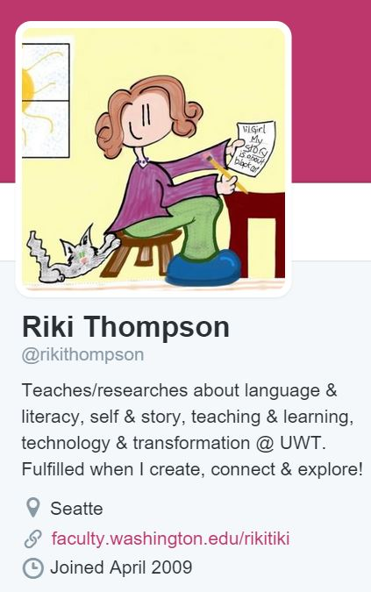
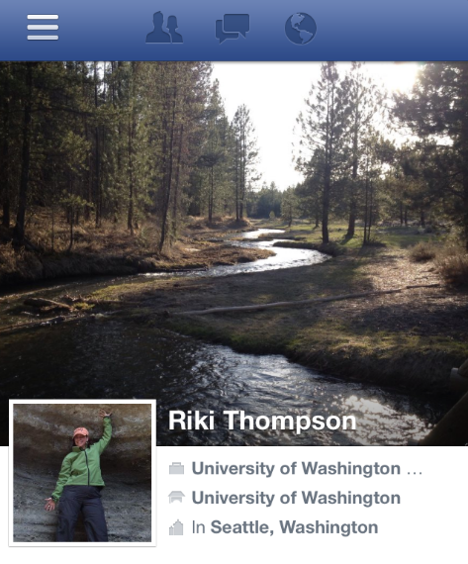
Office Hours
M/W ~ 12:30-1:00 or by appt GWP 403 f2f
Phone & online available
We will spend the quarter exploring the question, “How do people use language in social media?” We will read academic and mainstream articles that are discussing this issue from various angles, and examine examples of language use in social media to see what we think of this issue. Finally, we will do lots of writing to try and make some sense of the question, hopefully, coming to some conclusions by the end of the quarter.

Email: rikitiki@uw.edu
Skype: rikithompson
Twitter: @rikithompson

Course Description
This course introduces you to the principles of argument, including critical thinking, analytical reading skills, and writing skills needed for academic writing—all vital skills for success in college. In this course, you will learn to write through a process that involves analyzing texts, developing formal written arguments, participating in writing groups, creating digital compositions, presenting your research findings, and substantially revising your work in response to feedback.
Participation and close collaboration at each stage of the processes of reading and writing, from the critical reading of texts through the planning, drafting, and revising of compositions, is necessary for success in this course. You will be composing and sharing all quarter, with small assignments intended to help you build toward larger projects. Hands-on activities, research, lectures, discussions, reading, writing, readers reviews will be the primary tools to engage you in learning.
Core
The Core program consists of a coordinated series of courses that represent the various disciplines in the university. This course, along with the others in your cohort, fulfills one of the university’s general education requirements in each of the areas of knowledge plus composition. The courses are designed to both support and challenge you to develop the critical thinking, writing, research, and analytical skills you’ll need at UWT while introducing you to relevant topics in the social sciences, humanities, and sciences.

Student Learning Goals
Through the study of language and social media, this course will introduce you to and train you in skills critical for success at UWT. By the end of this course, it is my hope that you will have a sense of how to operate within the various learning goals.

UWT Core

Inquiry and Critical Thinking
- inquiry & problem solving: collect, evaluate, and analyze information and resources to solve problems or answer questions.
- research methods & application: approach complex issues by taking a large question and breaking it down into manageable pieces.
- synthesis & context: make meaningful connections among assignments and readings in order to develop a sense of the ‘big picture.’

Communication/Self-Expression
- argumentation: formulate an original thesis-driven argument and sustain it in both written and verbal communication.
- analysis: identify, analyze, and summarize/represent the key elements of a text.
- disciplinary awareness: enter/place themselves into an existing dialogue (intellectual, political, etc.).
- expression of ideas: express ideas clearly in writing and speaking in order to synthesize and evaluate information before presenting it.

Global Perspective-Diversity-Civic Engagement
- disciplinary perspective: understand events and processes as ‘disciplinarily’ situated.
- global perspective: interact with concepts, ideas, and processes related to the interdependences between personal, local, and global relationships.
- diversity: think outside of cultural norms and values, including their own perspectives, to critically engage the larger world.
- civic engagement: interact with concepts, ideas, and processes related to civic engagement.

Quantitative Literacy
- Use quantitative evidence (including statistics, graphs, etc.) in support of an argument.
- Analyze and evaluate a chart or graph and interpret it (through discussion, a written assignment, etc.)
- Find quantitative data to support an argument.

First Year Writing Learning Goals
At the completion of his/her course of study, a successful student in FYW will have practiced and demonstrated a degree of proficiency in the areas listed.

READ RHETORICALLY THROUGH PROCESSES OF MEANING-MAKING, LEARNING, AND COMMUNICATING PURPOSEFULLY AND TO VARIOUS AUDIENCES

REVISE IN RECURSIVE PROCESSES THAT CONTINUALLY RE-SEE, RETHINK, AND RESEARCH IDEAS, QUESTIONS, AND NEW INFORMATION

REFLECT AS A WAY TO UNDERSTAND ONE’S OWN READING PRACTICES, AND PRODUCING UNDERSTANDING (OR THEORY) THAT HELPS THE WRITER CULTIVATE FLEXIBLE AND RHETORICALLY-BASED PRACTICES FOR FUTURE USE

PROOF AND EDIT ONE’S DRAFTS IN SELF-CONSCIOUS WAYS, WAYS THAT ALLOW THE WRITER TO CONSIDER FUTURE PROOFING AND EDITING PRACTICES AS RHETORICAL IN NATURE AND AS A PART OF THE WRITING PROCESS

ENGAGE IN ACADEMIC RESEARCH AS A PROCESS THAT INCLUDES RECOGNIZING WHEN INFORMATION IS NEEDED TO SUPPORT WRITING, AND HAVING THE ABILITY TO LOCATE, EVALUATE, INCORPORATE, AND ACKNOWLEDGE APPROPRIATE SOURCE

PROBLEMATIZE ONE’S EXISTENTIAL WRITING SITUATION, OR POSE PROBLEMS THAT THE WRITER’S OWN LANGUAGE PRACTICES MAY CREATE WHEN THEY ARE SET NEXT TO THE DOMINANT ACADEMIC DISCOURSE, OR WHEN OTHERS READ AND JUDGE ONE’S WRITING

Required Texts

• Page, R., Barton, D., Unger, J. W., & Zappavigna, M. (2014). Researching Language and Social Media: A Student Guide (Student edition). Routledge.
• A Writer’s Reference (custom, 8th ed., 2013), Hacker & Sommers.
Writing Spaces: Readings on Writing. (http://writingspaces.org/essays ).
Additional readings will be posted via the course website. You will be required to print off the articles and bring a hard copy to class.

Digital Tools

• Computer and Internet access each day (preferred that you have a laptop for class)
• Canvas access each day (preferred that you access in class)
• Course blog: Meta-Writing @ http://digiriki.wordpress.com/
• Various social media sites & apps (TBD)

Course Requirements

Readings
Readings will be assigned for most days and will relate to the focus of the week. Readings will address research and writing for academic environments as well as the course theme of social media.

Coursework
There will be a number of short assignments to help you practice certain types of academic writing. Writing will be used to build to the big assignments, and you will get and give feedback along the way along the way.

Participation
This class is a seminar, not a lecture course, which means you’ll have reading and/or writing homework for every class session and be expected to participate actively in every session. By enrolling in the course, you agree to arrive on time to our class meetings, and to prepare for each class by completing readings and other assignments. As explained in our course grading contract, you must participate fully in at least 83.3% of all activities during our class sessions. Additionally, please know the university policies on attending all courses at UWT, which can be found out: http://www.tacoma.uw.edu/uwt/enrollment-services/class-attendance

Presentations
We will do presentations to give you a chance to present your research, get feedback, and practice public speaking. At the end of the quarter, you will have a chance to share your research findings with the UWT community at the Student Showcase.

Essay
You will write one academic essay using a collaborative writing and reviewing process to improve your work. As this course emphasizes the process of revision, not merely the written product, is important to your learning as a continuously evolving writer. You will have a chance to significantly revise your writing using feedback from me, your fellow writers, and Writing Center consultants.

Grading
Your overall course grade is calculated using a grading contract (see the Grading Contract for specifics). Your portfolio will be assessed (not graded) by several colleagues, you, and me.

Note: this course counts as fulfilling the composition requirement for graduation from UWT if the student achieves a 2.0 in the course. If you do not achieve a 2.0, you will need to take TWRT 112. http://www.tacoma.uw.edu/enrollment-services/grading-policies

Late work
Because assignments build upon each other, turning work in late seriously impedes your ability to complete the required work of the course and negatively impacts your ability to contribute to your writing group. It is your responsibility to be aware of deadlines and turn your work in a timely manner. All assignments and essays are due at the beginning of class on scheduled due dates in the required form (be it paper or electronic) and details can always be found on the course website. If you miss class, it is your responsibility to get the assignments from a classmate or from the course website. See the Grading Contract for specifics about the impact of late work on your final grade.
http://www.tacoma.washington.edu/enrollmentservices/grading.cfm

Teaching and Learning Center
The TLC provides a wide variety of instructional resources and support for teaching and learning at UW Tacoma. Teaching and learning are ongoing processes that take practice, commitment, and time. We are here to assist you in achieving your goals and provide math/quantitative, writing, science, and other tutoring services.
http://www.tacoma.washington.edu/tlc/

Library
The UWT Library provides resources and services to support students at all levels of expertise. We guide students through the research process, helping them learn how to develop effective research strategies and find and evaluate appropriate resources. For more information about the Library and its services, see:
http://www.tacoma.washington.edu/library/

Academic Standards/Plagiarism
All student work must be free of plagiarism. Plagiarism is defined in the University catalog and in the Student Handbook. Consult your professor if you have any questions.

A major part of your experience in the class will be reading, synthesizing, and using the knowledge and ideas of others. It is the responsibility of the faculty to help you in this process and to be certain you learn to credit the work of others upon which you draw. To plagiarize is to appropriate and to pass off, as one's own ideas, writing or works of another. Plagiarism is no less of a misconduct violation than vandalism or assault. Ignorance of proper documentation procedures is the usual cause of plagiarism. This ignorance does not excuse the act. Students are responsible for learning how and when to document and attribute resources used in preparing a written or oral presentation.

For more information, please refer to the “Student Academic Responsibility” document prepared by the Committee on Academic Conduct in the College of Arts and Sciences, UW Seattle: http://depts.washington.edu/grading/pdf/AcademicResponsibility.pdf

Library
The UWT Library provides resources and services to support students at all levels of expertise. We guide students through the research process, helping them learn how to develop effective research strategies and find and evaluate appropriate resources. For more information about the Library and its services, see: http://www.tacoma.washington.edu/library/

Electronic Devices
Electronic devices (including, but not limited to, cell phones, pagers, laptops, and personal digital assistants) may only be used in the classroom with the permission of the instructor. Activities that are non-relevant to the course, such as checking/sending email, playing games, and surfing the web, are considered disruptive activities when class is in session.

E-mail Policy
http://www.tacoma.washington.edu/policies_procedures/E-mail_Policy.pdf

Disability Support Services
The University of Washington Tacoma is committed to making physical facilities and instructional programs accessible to students with disabilities. Disability Support Services (DSS) functions as the focal point for coordination of services for students with disabilities. In compliance with Title II of the Americans with Disabilities Act, any enrolled student at UW Tacoma who has an appropriately documented physical, emotional, or mental disability that "substantially limits one or more major life activities [including walking, seeing, hearing, speaking, breathing, learning and working]," is eligible for services from DSS. If you are wondering if you may be eligible for accommodations on our campus, please contact the DSS reception desk at 692-4522
http://www.tacoma.washington.edu/studentaffairs/SHW/dss_about.cfm/

Student Health Services
Student Health Services (SHS) is committed to providing compassionate, convenient, and affordable health care for University of Washington Tacoma students, from care for illness and minor injury to women’s health and preventative medicine, including vaccination services. Insurance is not required. Funded by UW Tacoma student fees, office visits are provided free of charge. Treatment plans may incur costs, such as medications, labs, or vaccines, most of which are offered at discounted rates. For more information, please visit www.tacoma.uw.edu/shs or email at uwtshs@uw.edu. If you have questions or would like to schedule an appointment, please call (253) 692-5811 or stop by SHS at the Laborer’s Hall on Market Street.

Counseling Center (Student Success)
The Counseling Center offers short-term, problem-focused counseling to UW Tacoma students who may feel overwhelmed by the responsibilities of college, work, family, and relationships. Counselors are available to help students cope with stresses and personal issues that may interfere with their ability to perform in school. The service is provided confidentially and without additional charge to currently enrolled undergraduate and graduate students. To schedule an appointment, please call 692-4522 or stop by the Student Counseling Center (SCC), located in MAT 354.
http://www.tacoma.washington.edu/studentaffairs/SHW/scc_about.cfm/

Campus Safety Information
http://www.tacoma.washington.edu/safety/emergency/Emergency_plan.pdf

Safety Escort Program
For your safety, UW Tacoma encourages students, faculty, staff and visitors to use the Safety Escort Program. Campus Safety Officers are available to walk you to your car or other campus destinations during the following hours: Monday - Thursday — 6 a.m. to 11 p.m.; Friday — 6 a.m. to 10 p.m. The service is free of charge. During busy periods, the Campus Safety Officer may ask you to meet in a common location as to facilitate escorting.

In case of a fire alarm
Take your valuables and leave the building. Plan to return to class once the alarm has stopped. Do not return until you have received an all clear from somebody "official," the web or email.

In case of an earthquake
DROP, COVER, and HOLD. Once the shaking stops, take your valuables and leave the building. Do not plan to return for the rest of the day. Do not return to the building until you have received an all clear from somebody "official," the web‚ or email.

Inclement Weather
Call (253) 383-INFO to determine whether campus operations have been suspended. If not, but driving conditions remain problematic, call the professor's office number. This number should provide information on whether a particular class will be held or not, and/or the status of pending assignments. If the first two numbers have been contacted and the student is still unable to determine whether a class will be held, or the student has a part-time instructor who does not have an office phone or contact number, call the program office number for updated information.
This class is all about figuring out your process and working through it.
It will be messy & we will make course corrections as needed.
Be curious!
Ask questions!
Embrace uncertainty!

