Office of Undergraduate Education

TCORE 113 C: Introduction to Social Sciences
Communities and the Common Good:
Find It, Fix It! Campus Parking - Agents of Change

Professor Linda Hurley Ishem
Winter 2018
Class Times  Location | 10:15-12:20PM Tuesdays  TLB 115 | 10:15-12:20PM Thursdays  TLB 115
Office Hours  Location | 3:30-5:30PM Tuesdays  PNK 312 | (or by appointment)
Contact | lishem@uw.edu | 253/692-4761 (o)  253/861-6222 (c)

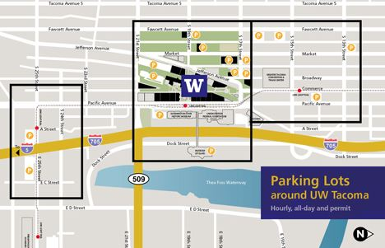

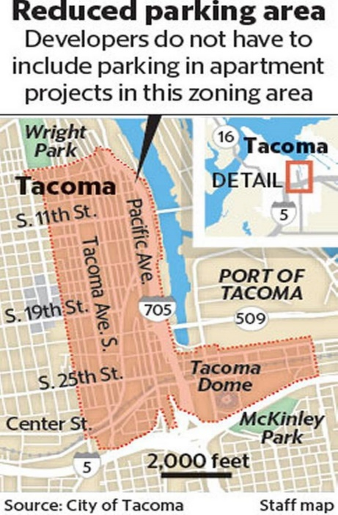

Course Description
Communities and the Common Good is an experiential, self-reflection and service-learning social science course. This quarter we will focus our attention on the challenging issue of parking on our centrally located, Urban Serving, commuter campus. As members of the UW Tacoma community, acting as agents of change, we will adopt elements of the municipal Find It Fix It model to conduct a comprehensive SWOT analysis of campus parking and prepare a set of recommended changes. The analysis will include regulations, policies and practices especially as they intersect with the campus culture and students’ learning experience. Central questions include what institutional actors are involved and what are their interests and motives? How is policy established? How can we, as key stakeholders and agents of change, influence policy decisions? And most importantly what changes would be most practical and beneficial for the common good?

These questions about policy change in general bring us back to questions related to our individual rights, roles and responsibilities as members of communities. Based on interdisciplinary assumptions, theories, and methods of the social sciences, this course will explore various definitions and configurations of community, civic engagement, and the common good. The course will examine tensions between individualism and communalism; individual rights and social responsibilities; and special interests in relation to the common good.

We live in an era of giving back, paying it forward, and random acts of kindness. Contrast that to growing income inequality, rampant individualism, sexism, racism, xenophobia, greed and excess. Accordingly, this course examines questions such as: What are the limits of our individual responsibilities for establishing and maintaining the common good? How do physical, relational, and cultural identities affect our sense of belonging and responsibility to the community? We will draw from a strengths perspective in which agency, resilience, empowerment, and the primacy of human relationships inform our understanding of individual and social responsibility and civic engagement.

In the past numerous UW Tacoma students and faculty members have provided detailed descriptions of how parking policies and enforcement impact their lives and learning experience. We will take it a step further to examine why and how these policies came about and how they might be changed to better serve the common good.

Course Learning Objectives

At the conclusion of this class, you will understand:
- The role of civic engagement in policy making and community change;
- How informed individuals, and strategically mobilized alliances can effect change;
- The role and applications of community service learning;
- Recognize and evaluate your personal role and responsibilities in various civic and social communities;
- how to gather information and advocate for positions based on empirical evidence;
- and practice expressing ideas orally and in writing as a means of engagement with your communities.

Required Texts:
Stoecker, R. (2016). Liberating service learning and the rest of higher education civic engagement. Philadelphia: Temple University Press.
All other required reading will be posted on Canvas or hard copies will be distributed in class.

Canvas and UWT Email Required
Check your UW email and the course Canvas website daily for updates. The announcement page will provide important information and guide you to other resources. Canvas and email will also be used for communication, announcements, assignments, lecture notes, exchange of ideas, and feedback.

Classroom Principles

The best way to learn is to be an active, informed learner and to push yourself to think in new ways, interact with your instructor, classroom guests, and other students, and practice expressing your thoughts orally and in writing. Silence all electronic devices before class begins. Internet surfing and side conversations are huge distractions that are generally prohibited during class. We will typically take a 10 minute break during each class. Please wait until that time to leave and re-enter the classroom. Turn assignments in on time otherwise they will be graded down. Challenge yourself to think critically, speak your mind, but be respectful of those who may not agree with you. Initial the daily attendance log and as a courtesy please notify me in advance if you plan to miss class. I am not interested in the reasons for your absence; you pay dearly for the privilege of attending college; presumably your absence is justified. Ask classmates for notes on missed material. Keep in mind that your absence impacts class activities, your learning, and possibly your grade. Attendance is particularly important on Thursdays when we will schedule most of our field experiences.

Formatting – Formal written assignments must be typed in 11-12-point font, double spaced with standard margins, using APA citation style and submitted electronically in a WORD compatible format via Canvas.

Teaching and Assessment Methods
The course will be based on lectures, films, guest speakers, field and community-service learning experiences, in-class exercises, discussion board reflections, papers and presentations.

“How Many Pages?” | “What Is The Assignment?” | “How Many Points May I Earn?” | Due Date
2 | Paper #1: Personal commute or parking related experience | 50 | Jan 11th
3 | Paper #2: Facts/data gathering related to Parking on 46 acre Campus Footprint | 100 | Feb 6th
 | 3 Minute Concept Sharing | 25 | Feb 6th
4-6 | Paper #3: Service Learning Recommendations/Insights | 150 | Mar 12th
 | 10 Minute Team Teaching Presentations | 50 | Mar 6 & 8
1-2 Paragraphs per Entry | Reflections Journal | 200 (20 per week)
Multi- dimensional | Active Participation | 100 (10 per week)

Grading (675 points total)
Course Requirements

Participation (-100 to +100 points)
In this course, we strive to create a learning community. Active participation is a necessary condition to that end. Failure to participate via absence, silence or other means diminishes the resources and expertise available to other members. Participation includes active involvement in peer review of assignments and active involvement in and meaningful contribution to class discussion and activities. Because participation can be either positive or negative and that negative participation has an effect on all other group members, it is possible to have a negative participation score for grading purposes.

Reflection Journal/Discussion Board
You will keep a journal of reflections on weekly course content (to include readings, discussion, films, visitors, etc.). Although this exercise requires only one or two paragraphs per week, it does require thoughtful consideration of the material. Please allow ample time to do this effectively. This exercise is meant to help you think about your relationship to the people, issues, social structures, and the world around you.

Consider preparing your reflection while the material is fresh either after class each Thursday or before you begin reading the next week’s assignments. Typically specific prompts will be provided however the following questions should be considered:
- How did you see your life experience reflected in this week’s content?
- How did the content reinforce or challenge your previous thoughts on this topic?
- Personally, not necessarily in class, what more would you like to explore about this topic?
- What can you do to bring about change where your experience deems that change is necessary for the common good?

Writing Requirement
Assignment #1 – Voluntary Lifestyle Community, January 11th
Length 2 pages (50 points)

You will write a brief personal essay describing your commute to campus. Describe how you get here, where you park and what challenges you encounter. Also describe how the experience makes you feel and its impact on your readiness to learn and to participate in campus activities. Include any aspirations you have related to your commute and parking. In other words, if you had a magic wand how would you change the commute and parking?

POLICIES AND EXPECTATIONS
Academic Calendar - Review course drop, withdrawal, instruction dates.
washington.edu/students/reg/calendar.html

Academic Honesty - Review Expectations, Policies, Consequences.
tacoma.uw.edu/node/38211
Bias Incident Reporting Website A resource for anyone who needs to report an incident of bias or wants to explore and better understand issues like bias and discrimination, and how to effectively respond. - tacoma.uw.edu/reportbias
Emergencies, Safety, and Evacuation Routes - tacoma.uw.edu/node/20236
Inclement Weather - always check the UWT Home Page tacoma.uw.edu. Official campus closures or delays will be announced there first. Course Announcements and Email regarding assignments and expectations during a closure will follow once the severity of the situation is known.
Safe Campus - preventing violence is a shared responsibility in which everyone at the UW plays apart. The SafeCampus website provides information on counseling and safety resources, University policies, and violence reporting requirements help us maintain a safe personal, work and learning environment. tacoma.uw.edu/safecampus/uwt

GETTING HELP
Academic Support
Numerous campus resources are available to support your academic success. Know your options and seek help and resources when needed.
Disability Resources for Students - resources and support for students with disabilities tacoma.uw.edu/dss
Library - Tioga Library Building / Snoqualmie Building
Research Support – get assistance starting a research project tacoma.uw.edu/node/21865
Subject Librarians - Make an appointment with a subject librarian to talk about library resources, research strategies, focusing a topic, evaluating information and more. tacoma.uw.edu/library/subject-librarians
Student Success Mentoring Program - Connect with a faculty or staff mentor tacoma.uw.edu/ssmp
Teaching and Learning Center - (TLC) 2nd floor of the Snoqualmie building
Writing & Spanish support: writing consultations, online tutoring, workshops & support tacoma.uw.edu/tlc
Quantitative skills support: peer tutoring available for math, science, statistics and more... tacoma.uw.edu/tlc
ESL Support - Help for students whose first language is not English tacoma.uw.edu/tlc
Technology Support - Labs, software, equipment checkout and help with Canvas, Google, email, logins, etc. tacoma.uw.edu/it
Online Support for Your Course Work - http://www.tacoma.uw.edu/online-learners/online-support-students

Self and Family Support
Everyone needs a little help sometimes. Here are a few campus resources on campus to help you get through those challenging times.
Bias Incident Reporting Website - A resource for anyone who needs to report an incident of bias or wants to explore and better understand issues like bias and discrimination, and how to effectively respond. tacoma.uw.edu/reportbias
Center for Equity & Inclusion (WCG 104) - Resources and support for students regarding diversity, equity, inclusion and social justice issues. tacoma.uw.edu/equity/home
Child Care Assistance Program (MAT 103) - Parenting students are encouraged to take advantage of the resources provided on campus. These resources include the Huskies and Pups RSO, the Childcare Assistance Program, on-campus Family-Friendly Spaces, priority access at the MUSE, and back-up/sick care at one of these locations Bright Horizons and KinderCare. On campus resources include lactation rooms and baby changing stations. For more detailed information, visit https://www.tacoma.uw.edu/childcare-family-support-services/childcare-family-support-services-0 or contact the Huskies and Pups RSO: huskiesandpups@gmail.com.
Counseling Center (Office of Student Success) - The Counseling Center offers short-term, problem-focused counseling to UW Tacoma students who may feel overwhelmed by the responsibilities of college, work, family, and relationships. Counselors are available to help students cope with stresses and personal issues that may interfere with their ability to perform in school. The service is provided confidentially and without additional charge to currently enrolled undergraduate and graduate students. To schedule an appointment, please call 253-692-4522, email uwtshaw@uw.edu, or stop by the Student Counseling Center (SCC), located in MAT 354. Additional information can also be found by visiting: tacoma.uw.edu/counseling.
Student Health Center - All UW Tacoma students who pay the Services and Activities Fee (SAF) now receive student health services at six Franciscan Prompt Care clinics: Bonney Lake, Burien, Gig Harbor, Lakewood, Puyallup, Tacoma. The “distributive care model” provides students more ways to access health care through six CHI Franciscan Health prompt care facilities throughout the Puget Sound, as well as access to Franciscan Virtual Urgent Care, at no additional cost. The Franciscan Prompt Care clinic located across the street from St. Joseph Medical Center, just up the hill from campus, is designated as the UW Tacoma clinic where students will receive priority treatment. The former Student Health Services clinic located in Laborer’s Hall on Market Street has closed. These changes do no affect which students can utilize Student Health Services. All current SAF-paying UW Tacoma students have access to Student Health Services, even those who have health insurance. All appointments are now scheduled by calling 253.428.2200.
Military-Connected Student Statement - If you are a student who is a veteran, on active duty, in the reserves or national guard, or a military spouse or dependent, then stay in contact with your instructor if any aspect of your present or prior service or family situation makes it difficult for you to fulfill the requirements of a course or creates disruption in your academic progress. It is important to make your instructor aware of any complication, then he/she will work with you and, if needed, put you in contact with university staff who are trained to assist you. Campus resource for veterans, service members and families are located in the Veteran and Military Resource Center, TLB 307A. The VMRC can be reached at uwtva@uw.ed, 253-692-4923
Oasis Center - Oasis transforms the lives of queer youth by creating a safe place to learn, connect, and thrive. Oasis envisions a world in which queer youth are valued in the community as strong, creative leaders. Oasis is the only drop-in and support center dedicated to the needs of LGBTQ youth ages 14-24 in Pierce County. We are a youth-adult partnership in which youth and adults come together for shared teaching learning and action! Office Phone: 253-671-2838 Emergency Cell Phone: (253) 988-2108

The Pantry - to provide supplemental, nutritional, and culturally relevant food as well as hygiene items to all UWT students and their families. Location and information can be found by visiting: tacoma.uw.edu/thepantry

Resources for low-income and people experiencing homelessness: http://mdc-hope.org

Shelter for Young Adults (close to campus) - Beacon Center - Shelter for young adults 18-24, Open daily 6:30 pm – 6:30 am. Doors close at 10 pm. Located at:
Beacon Senior Center 415 South 13th Street Tacoma, WA. The shelter has 40 beds and serves young people ages 18-24. Please call 253-256-3087 for more information. http://www.communityyouthservices.org/piercecounty.shtml
Short-term Loan Program - The Office of Student Financial Aid has funds available for short-term loans to assist students with temporary cash flow problems. Funds are generally available within one to four working days, only to students who are currently attending the university (loans cannot be processed between quarters). Repayment is due by the next quarter, or whenever additional funds such as financial aid arrive on account, whichever comes first. There is no interest on the short-term loans but there is a service charge added to the repayment amount. Students may apply online through MyUW under "Personal Services." Paper application forms are also available in the Financial Aid Office, but the processing time is longer. Learn more about short-term loans

