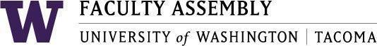

Agenda
Faculty Affairs Committee Meeting
January 10, 2022 / 12:30pm-1:30 p.m. Zoom

- Recording Permissions/Consent [2 min]
- Approval of Minutes [3 mins]
  - Minutes from 12/13/2021
- Update from Non-Tenure Track Faculty Forum [15 mins]
- Review of 2022 Action Items [5 minutes]
- Discussion of COVID-19 Impact Survey Final Report and Next Steps [15 minutes]
- Discussion of Faculty Workload Resolution and Next Steps [20 minutes]
- Adjournment
  - Next Meeting: February 7, 2022

Join Zoom Meeting
https://washington.zoom.us/j/91703164807

Dial by your location
+1 253 215 8782 US (Tacoma)
+1 206 337 9723 US (Seattle)
Meeting ID: 917 0316 4807

