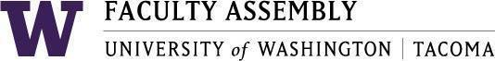

Agenda
Faculty Affairs Committee Meeting
March 14, 2022 / 12:30pm-1:30 p.m. Zoom

- Recording Permissions/Consent [2 min]

- Approval of Minutes [3 mins]
  - Minutes from 2/7/2022

- Update from Non-Tenure Track Faculty Forum [15 mins]

- Discussion of Faculty Workload Resolution [20 minutes]
  - Status update
  - Collated comments from all Schools to be sent out to all FAC members by Sunday (3/13)
  - Discussion

- Discussion of International Faculty Support charge from Faculty Assembly [15 minutes]
  - Questions for survey instrument
  - Next Steps

  - Next Meeting: April 18, 2022

Join Zoom Meeting
https://washington.zoom.us/j/91703164807

Dial by your location
+1 253 215 8782 US (Tacoma)
+1 206 337 9723 US (Seattle)
Meeting ID: 917 0316 4807

