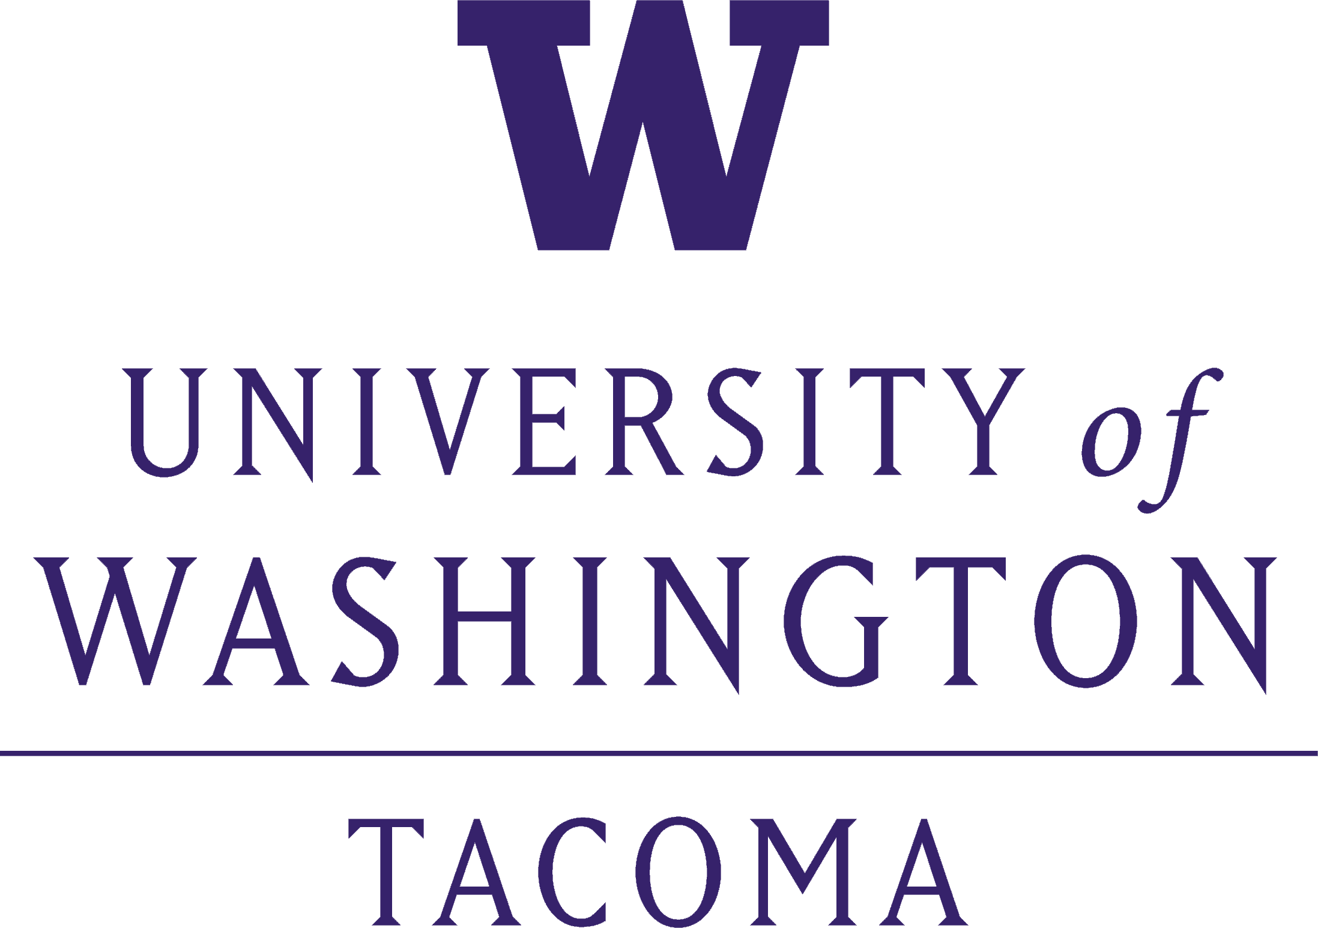

Dean, School of Interdisciplinary Arts & Sciences
Position Profile

The University of Washington Tacoma (UW Tacoma) invites nominations, expressions of interest, and applications for the position of Dean of the School of Interdisciplinary Arts and Sciences (SIAS).

The School of Interdisciplinary Arts and Sciences
As the largest academic program at UW Tacoma, SIAS prepares a diverse student body to contribute to a complex multicultural society and encourages engaged citizenship at the local, national, and global levels. Using an interdisciplinary approach to knowledge, inquiry, and problem-solving, students learn to create, analyze, and express themselves in ways that enhance their own development, their sense of community within human and natural environments, their ability to deal with problems of injustice and inequality, and their dedication to positive change. The School prepares students to be adaptable outstanding leaders, professionals, and citizens. SIAS brings innovative approaches to build a dynamic learning community as it responds to student needs and serves as the liberal arts and sciences cornerstone of UW Tacoma. The School promotes academic excellence by encouraging students to understand the interconnectedness of world problems and solutions and to become responsible citizens. Faculty engage in inquiry and research that is both socially and culturally relevant and promote a holistic understanding of the natural world and environmental issues.

Currently, the School has 15 full professors, 41 associate professors, 20 assistant professors, 2 teaching professors, 25 associate teaching professors, 20 assistant teaching professors, 6 full-time lecturers, over 30 part-time lecturers, 26 affiliate faculty, and 21 staff who serve approximately 1,200 majors and 1,500 pre-major students with an annual budget of approximately $13.4 million. There are five divisions offering 18 undergraduate majors, and 24 minors or certificates. These degrees are offered through the following academic divisions in SIAS:

- Division of Culture, Arts, and Communication
- Division of Politics, Philosophy, and Public Affairs
- Division of Sciences and Mathematics
- Division of Social, Behavioral, and Human Sciences
- Division of Social and Historical Studies

Divisions within SIAS offer several allied majors that are grouped based on their disciplinary affiliations but remain un-departmentalized to promote interdisciplinarity. In addition, the School is in the process of developing new master’s degree programs.

SIAS’ values and guiding principles are:

- Academic Distinction and Student Success
- Interdisciplinary Teaching and Scholarship
- Engaged Inquiry
- Diversity and Inclusivity
- Community and Social Responsibility

For more information about SIAS, please visit https://www.tacoma.uw.edu/sias.

University of Washington Tacoma
The University of Washington Tacoma is one of three campuses of the University of Washington. The mission of UW Tacoma is to educate diverse learners and transform communities by expanding the boundaries of knowledge and discovery. Guided by the core values of access, excellence, community, diversity and innovation, the University has evolved and grown into a distinctive academic institution that responds to the needs of the region in exceptional ways.

UW Tacoma’s distinctiveness and identity are defined by its urban-serving mission of access, economic development, use-inspired research and community partnerships. Since its founding in 1990, the UW Tacoma has been first and foremost a change agent for the region, providing access to students in a way that transforms families and communities. As an urban-serving university, UW Tacoma impacts and informs economic development through community-engaged students and faculty who seek to be connected and relevant to community ambitions and needs, and through the revitalization of downtown Tacoma as a retail shopping and dining destination as well as a unique place for learning and discovery.

The University first opened its doors in 1990 as an upper division and master’s level institution and later welcomed lower division students in 2006 and Educational Leadership doctoral students in 2013. Today, UW Tacoma offers 40 undergraduate degrees, 18 graduate degrees, and a PhD in Computer Science and Systems through its seven academic units and serves 5,040 students, 83% of whom attend full-time. Approximately 86% of students are undergraduates and 14% are graduate students. UW Tacoma has been designated as an Asian American and Native American Pacific Islander-serving (AANAPISI) institution, a Veteran Supportive Campus by the Washington State Department of Veterans Affairs, recognized nationally as a Military Friendly Campus; just over 20% of students receive VA benefits. 59% identify as students of color and 4.2% are international students. The average age of students is approximately 21-34 years. 54% of our students are first generation students – either first to college or first to degree in their families.

The Campus is accredited as a unit of the University of Washington by the Northwest Commission on Colleges and Universities; however, UW Tacoma holds separate accreditation from the Association for the Advancement of Colleges and Schools of Business (AACSB) and the Accreditation Board for Engineering and Technology (ABET). Since its inception, UW Tacoma has awarded more than 28,146 degrees and certificates.

UW Tacoma has 362 faculty members and lecturers. Among full-time faculty, two-thirds hold professorial rank and terminal degrees. The student faculty ratio is 16:1, and class size averages about 25 students. Research expenditures have grown every year and are currently approaching $2.7M. The Faculty Assembly at UW Tacoma is led by an elected Executive Council that concerns itself with all domains of faculty professional and personnel issues. The three standing committees of the Executive Council are Academic Policy and Curriculum, Appointment Promotion and Tenure, and Faculty Affairs.

UW Tacoma is the anchor tenant and landowner of Tacoma’s historic warehouse district and the cornerstone of downtown Tacoma’s cultural and educational epicenter. The campus consists of 23 buildings on 46 acres. The campus is rejuvenating the city core. On-campus housing is offered to 300 students at the University’s Court 17 apartments.

UW Tacoma Land Acknowledgement
The UW Tacoma community acknowledges that we learn, teach, work and live on the ancestral land of the Coast Salish people. In particular, our campus is situated on traditional lands of the Puyallup Tribe of Indians.

We recognize that this is a difficult and painful history, and we understand we must play an active role in remembering, not just what happened to Indigenous communities’ post settlement, but also the rich history that existed long before colonization. This land acknowledgement is one small act in an ongoing process of honoring the past while working together with local Tribes to build a more inclusive and thoughtful community.

For more information about UW Tacoma, please visit: http://www.tacoma.uw.edu/.

Location and Community
Tacoma, Washington, a midsized urban port city known as the “City of Destiny” is an attractive city, which offers affordable city life and a Mediterranean climate. Located just 45 minutes outside of Seattle, Tacoma offers top-notch restaurants, museums, art galleries, performing arts centers and a wide variety of outdoor activities with over fifty parks and open spaces in Tacoma. Point Defiance Park, one of the largest urban parks in the country (at 700 acres), is in Tacoma. With Mount Rainier as a backdrop, Tacoma is an ideal place for families to grow and businesses to expand. As Washington’s third-largest city, Tacoma boasts an abundance of cultural events and activities, six major museums, beautiful parks, and waterfront walking trails. Tacoma provides easy access to all the outdoor activities for which the Pacific Northwest is famous.

The Tacoma community was instrumental in the founding of UW Tacoma, aggressively advocating for a campus specifically in the downtown core. The community intended that UW Tacoma increase the educational attainment of the region and improve the economic health of the city. The University has enjoyed an exceptional level of support from and engagement with the region that has evolved over time through proactive alliances, tribal partnerships, and initiatives. Collaborations that build community and economic capacity are a core element of the campus mission.

Position Summary
The Dean will serve as the chief academic officer for the School of Interdisciplinary Arts and Sciences with responsibility for developing a comprehensive, ambitious, and dynamic vision for its future. UW Tacoma is on an upward trajectory in pursuit of academic excellence, student success, creativity and community service and the Dean must serve as a passionate advocate for these ideals—working in collaboration with faculty and staff from all SIAS’ academic disciplines and other stakeholders to create a unified vision for the School’s future. In so doing, the Dean will have the unique opportunity to showcase the School and UW Tacoma as a contributor to the development of the local community in alignment with the University’s community outreach mission.

In leading the School during this important period of institutional growth and transition, the new Dean will play a critical role in effectively aligning the divisions that now comprise SIAS, developing and implementing a new strategic plan, and guiding the School through a reorganization process. The Dean will be responsible for the academic, research, creative and outreach leadership of the School, as well as the management of its human and financial resources. The Dean has responsibility for leading the faculty and staff to work cohesively to advance the School as a whole and represents SIAS on campus and to the outside world, including alumni, donors, and other external stakeholders.

The Dean of SIAS will provide transformative leadership for the School. The successful candidate will work closely with Associate Deans, Division Chairs, elected SIAS Faculty Council, staff, and others in the University as they collectively seek research and teaching excellence, as well as national and international prominence through the pursuit of scholarly and creative work. The Dean will report to Executive Vice Chancellor for Academic Affairs and serve as a member of the University’s leadership team.

Opportunities and Challenges
UW Tacoma is a dynamic and aspirational institution. Building on the existing momentum, the future holds significant potential for growth, increased excellence, and the opportunity to propel the University into the ranks of the premier urban-serving institutions in the country. The next Dean will join a fiscally and operationally healthy institution that is deeply committed to its mission. It is an institution with strong community and legislative support. The Dean will provide leadership in a number of critical areas including but not limited to:

- Advancing Inclusive Excellence – The next Dean will serve as a key leader in supporting and strengthening the School’s efforts toward upholding the University of Washington's Race & Equity Initiative, which suggests that "in order to support and sustain diversity and equity...we must directly confront bias and racism at the individual, institutional and systemic levels." The Dean must be a passionate advocate and strong champion dedicated to fostering a culture where members of the SIAS community, including faculty, staff, students, and community members, are active partners in a collaborative and supportive learning environment.

- Creating a Unified Strategic Vision – The new Dean will partner with the SIAS faculty, staff, and students to create a bold new vision for the School’s future focused on promoting interdisciplinary collaboration while respecting the unique attributes of each academic discipline housed within the School. The new vision will also enhance student success, create an innovative and dynamic learning environment, inspire research and scholarly activity, and further the impact the School has on the campus and in the local community. As is the case for many other institutions of higher education, UW Tacoma has persevered through a time of significant societal and institutional change and the Dean must be prepared to bring together diverse stakeholder groups to chart a unifying path into the future. As the School continues on its upward trajectory toward increased growth and heightened impact, the new Dean will bring stability, clarity, and forward-thinking to SIAS as its champion in these endeavors.

- Establishing a New Organizational Structure for SIAS – The Dean will lead in the discussion and development of an organizational structure that embraces efficiency and collaboration, clarifies budgetary processes, streamlines decision-making processes, supports an equitable distribution of resources, and better leverages the intellectual capacity and distinct identity of each academic unit housed within SIAS. A careful examination of the School’s organizational structure and relationships amongst SIAS units will be necessary in order to ensure that the School safeguards its inherent interdisciplinary strength. Above all, the Dean must strive to create an environment that enhances the cross-divisional and interpersonal relationships that have established SIAS as a collaborative team focused on student success and academic excellence.

- Supporting the Professional Development of Faculty and Staff– The School’s dedicated faculty and staff are among its greatest strengths as they bring energy, innovation, intellectual curiosity, and a passion for supporting students to their respective roles. The Dean will work closely with faculty and staff across all SIAS units to foster an environment that promotes mentorship and professional development while also securing and investing the resources necessary to support the further development of faculty and staff, both individually and as a community.

- Enhancing Communication and Transparency – The Dean will be expected to foster a culture that is committed to effectively and proactively communicating with the wide-range of internal and external constituents SIAS serves. Moreover, the Dean will be in a position to take advantage of the full breadth of disciplines within the School, and the perspectives provided by faculty within these areas, in creating an environment that recognizes and appreciates its unique blend of programs and opportunities for impact. Therefore, the Dean must possess strong listening skills, the ability to engage stakeholders in meaningful discussions, and an openness in providing information about the decision-making process and how decisions will affect SIAS stakeholders as it strives to fulfill its mission and achieve its goals.

Qualities and Characteristics
Additionally, the successful candidate will have many of the following personal qualities and characteristics:

- Openness in dealings with others and acceptance of diverging perspectives;
- Ability to formulate and inspire others with a clear vision;
- A commitment to fostering and sustaining a culturally diverse academic environment and disrupting norms related to racially hostile campus climates;
- A demonstrated ability to relate effectively to a wide variety of people of diverse backgrounds through an equity lens, including an understanding and respect for cultural, racial/ethnic, gender, sexuality, and individual differences and fostering such respect across SIAS leadership teams, faculty, staff, and students;
- Skills and the capacity to bring individuals and groups with diverse views to consensus and common action;
- A commitment to academic freedom;
- A commitment to a student-centered learning environment and appreciation for serving students from varied backgrounds and age groups;
- Knowledge of budgeting and financial management processes in a complex academic environment;
- Respect for a variety of approaches to scholarship and a commitment to interdisciplinarity;
- A collegial administrative style that promotes a sense of academic respect and collaboration with faculty, staff, and students in an interdisciplinary environment;
- Effective leadership skills that demonstrate support for the full spectrum of academic and research programs found at SIAS;
- Ability to support the academic endeavors of first-generation and urban college students and enhance the visibility of UW Tacoma’s distinctive educational programs;
- The ability to think strategically and bring together diverse groups of interests to coalesce in a shared vision for the institution;
- A collaborative, creative mindset that extends Tacoma's unique urban environment in ways that promote engagement and partnership opportunities with community stakeholders and regional Tribal communities;
- A willingness to actively and enthusiastically partner with an engaged undergraduate student body;
- A deep commitment to academic excellence, demonstrated ability for creative leadership and management, and the energy and vigor to translate ideas into action;
- An innovative, interdisciplinary, and entrepreneurial approach to the Dean position that will serve as a catalyst for new and compelling academic, creative, and research initiatives in the School with the potential to expand on existing strengths;
- A keen awareness about the cultural, institutional and systemic barriers that historically underrepresented people experience in higher education and a desire to eradicate such systems and practices;
- Demonstrated evidence of having developed and consistently applied an anti-racist approach to leadership and decision making based in principles of equity and inclusion;
- Excitement to serve as an engaging advocate on behalf of SIAS with internal and external stakeholders; ability to stimulate productive partnerships with external constituencies; and
- A deep resonance with UW Tacoma’s commitment to excellence and diversity, to the personal and educational enrichment of its faculty, staff and students, and a passion for SIAS’ role in ensuring student graduation and post-graduate job success.

Qualifications
The Dean of SIAS will be a transparent leader with exceptional communication skills and the ability to make decisions following an open and collaborative consultation process. The next Dean must possess an understanding, commitment, and passion for UW Tacoma’s students and the challenges they face as first-generation, new majority students. Moreover, the Dean must have a strong commitment to shared governance and the ability to reconcile differing opinions and develop solutions within an open environment. The Dean must also be a strong manager with a proven record of creating and enhancing academic programs and a history of improving and promoting academic excellence.

To be appointed Dean of SIAS, the candidate must have an earned doctorate or other terminal degree and academic credentials that foster respect and qualifications for appointments as a full professor with tenure. Specifically, it is desired that the Dean will possess the following:

Required Qualifications
- Demonstrated Leadership: An understanding of the importance of academic leadership in promoting excellence in a University environment, supported by a record of effective leadership in higher education.
- Commitment to Diversity: A strong commitment to the principles and practices of diversity, equity and inclusion as evidenced by a record of success supporting diversity and equitable outcomes at all levels, including faculty, staff, and student recruitment and retention.
- Support for Teaching and Research: A record of success in promoting, supporting and facilitating teaching and all conventions of research to include: multidisciplinary, cross-disciplinary and community-engaged research.
- Budget Experience: Experience with budget management. Specifically, the ability to harness, steward and strategically manage financial resources and generate new resources. Ability to make difficult decisions concerning finances. Understanding national dynamics in higher education funding.

Preferred Qualifications
- Supporting First-Generation Students: A deep knowledge of how to structure educational systems from an asset-based approach that supports first-generation students and their learning experiences.
- Institutional Knowledge: An understanding of the nature of urban-serving universities.
- Advocacy Skills: Experience advocating on behalf of faculty, academic programs, staff, and students, both internally and externally.
- Vision: The ability to lead in developing and articulating an ambitious vision for the School—ensuring that SIAS plays a critical role in realizing the University’s strategic plan.
- Community Engagement: Experience in fostering strong connections between internal and external constituencies and creating meaningful connections with urban communities.
- Internal Collaboration: Have the capacity to collaborate with the Chancellors, Deans, and faculty across the UW campuses to support and strengthen its visions and values.
- Fundraising: A history of external fundraising to support program initiatives, faculty scholarship, and student success.

Application / Nomination Process
The Search Committee will begin reviewing applications immediately and will continue to accept applications and nominations until the position is filled. Complete applications must include a current curriculum vitae, and a letter of interest describing relevant experience and interest in the position. Nomination letters should include the contact information of the nominee. Applications and letters of nomination should be submitted by email to:

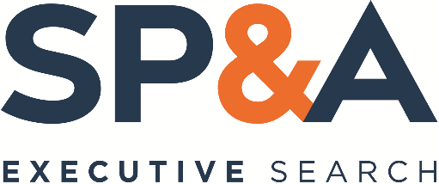 | Alberto Pimentel, Managing Partner  Robin Reyes, Senior Associate  SP&A Executive Search  6512 Painter Avenue, Whittier, CA 90601  Email: apsearch@spaexec.com  Refer to code “UWTacoma-SIAS” in subject line

University of Washington is an affirmative action and equal opportunity employer. All qualified applicants will receive consideration for employment without regard to race, color, religion, sex, sexual orientation, gender identity, national origin, age, protected veteran or disabled status, or genetic information. All University of Washington faculty engage in teaching, research and service.

