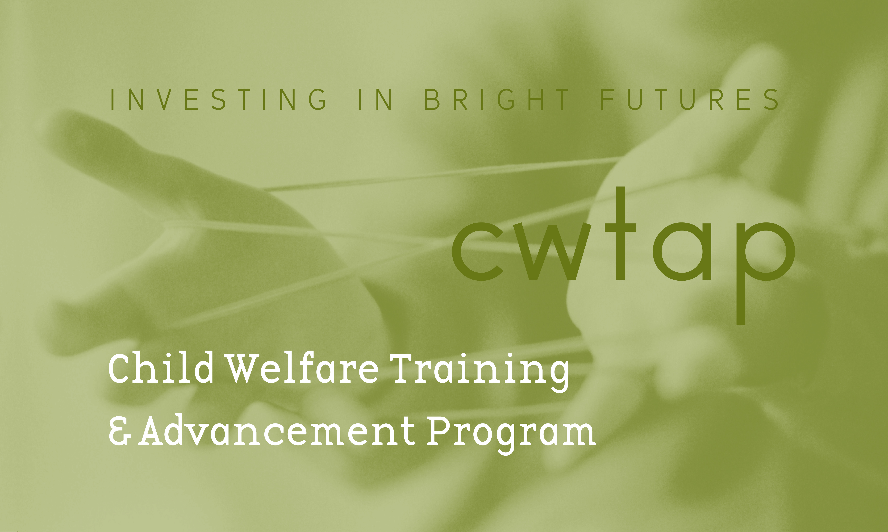

May 12, 2022

Dear Prospective Applicant,

This letter is to introduce you to the Child Welfare Training and Advancement Program (CWTAP). It is an exciting program for Master of Social Work (MSW) students considering or already working in a career in public child welfare. Please join us at our Information meeting (details below) to learn more.
CWTAP offers quarterly financial assistance, educational seminars and a wonderful opportunity to enhance or develop specialized practice skills while earning an advanced degree. Participants who are not current Social Service Specialists with the Department of Children, Youth and Families (DCYF) must complete their Generalist and Specialization practicums in a specialized DCYF field unit. Current DCYF employees are assisted in developing a work place field experience that broadens and deepens their knowledge and skills.

In preparation for the Information meeting, we strongly encourage applicants to learn more about the CWTAP program, including the CWTAP practicum experience, review the FAQ’s (Frequently Asked Questions) and testimonials from CWTAP Alumni and watch video interviews featuring DCYF staff in various jobs around the state – learn more here. Along with the meeting, this will help in deciding if being in the CWTAP program and ultimately working for DCYF is right for you.

The financial assistance available for the 2022-2023 academic year is based on in-state tuition costs. This assistance is calculated annually, and the amount may change during the course of the agreement, depending upon the availability of federal and state funds. At this time the financial assistance for tuition is covered at 100%. In return, all participants agree to apply for Social Service Specialist II or III positions within DCYF statewide upon graduation. Participants agree to work for an amount of time equivalent to the period of time for which they received financial assistance.

Applicants must attend the mandatory information meeting scheduled for Tuesday, May 24, 2022 from 3:30 to 5:00 PM. This meeting will be held via Zoom and will cover pertinent details about the program and the application packet. Please email Susan Welk if you’re interested in joining us. The completed CWTAP application deadline is Tuesday, June 7th by 5pm. We will send you a follow-up email to confirm the receipt of your application. Interviews will take place on June 23rd and 24th.

Please Note: Only students with COMPLETED APPLICATIONS submitted by the deadline will be interviewed.

Out of state applicants who are not able to attend the Informational meeting on May 24th must contact CWTAP Program Coordinator, Susan Welk, to make alternate arrangements.

Please direct your questions to:

Rick Butt, MSW Susan Welk
Director of CWTAP Program Coordinator, CWTAP
(206) 940-8384 (206) 856-2209
rickbutt@uw.edu susanw22@uw.edu

We wish you the best in your application process and if you have questions, please don’t hesitate to reach out.

Sincerely,
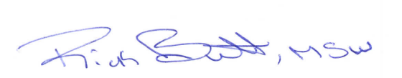

Rick Butt, MSW
Director, CWTAP
University of Washington, Tacoma
School of Social Work and Criminal Justice

