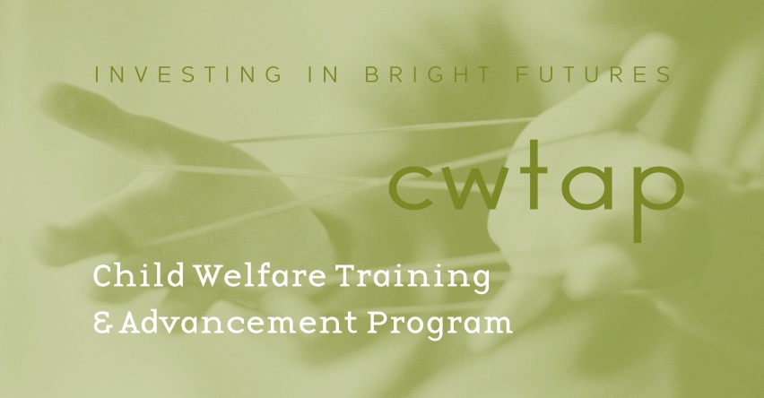

LETTER OF REFERENCE

______________________________________________________________________________

Name of Applicant

______________________________________________________________________________

Name of Person Providing This Reference and Relationship to the Applicant

This letter of reference is for the Child Welfare Training and Advancement Program (CWTAP). This applicant will have submitted other letters of reference for general admission to a School of Social Work.

For the purposes of helping determine this applicant’s suitability for the CWTAP, please discuss the following:

1) The applicant’s experience working with children and families.
2) The applicant’s experience with and capacity for culturally competent practice with diverse individuals and families.
3) The applicant’s commitment and potential contribution to the field of working with families and children at risk.

***Please be sure to sign your letter, attach this coversheet and send the original sealed in an envelope with the applicant or mail it to the address below***

Child Welfare Training and Advancement Program (CWTAP)
Attn: Susan Welk, Program Coordinator
1900 Commerce Street
Tacoma, WA 98402

