Course Evaluation Administration Template

Please feel free to use this template freely and adapt to your course

Script for students
- Thank you for taking the time to complete a course evaluation
- The instructor won’t get to see the completed evaluations until after the quarter is over and grades have been submitted
- Please provide constructive feedback to help with improving the course content or the instructor’s teaching

How to administer an online evaluation

IASystem is at https://uwt.iasystem.org/faculty/list_all_evals
- Treat them like paper evaluations by setting aside class time
- Warn students ahead of time that you will be doing this in class and ask them to bring their laptops or any other web enabled devices
- If you are teaching a two hour or 80-minute class, administer in the middle of the lecture
- Step out while the students are completing the evaluation
- Ask for a student volunteer to come get you after the evaluations are completed
- Use the RESPONSES to track the percentage of students that completed. You can navigate to this site and show the students what the percentage currently is and challenge them to improve it

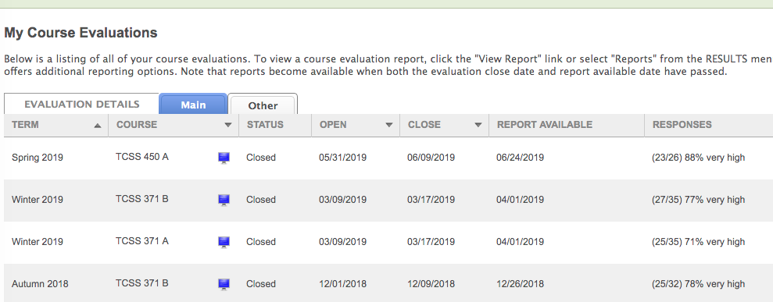

Other incentives to try
- Create an assignment in Canvas with 0 points but with a due date
- Give the entire class 1 or 2 points when 80 to 85% response rate is reached as a whole (Don’t recommend doing this for individual students)

Some references
https://teaching.berkeley.edu/how-can-instructors-encourage-students-complete-course-evaluations-and-provide-informative-responses
https://teaching.cornell.edu/resource/how-increase-response-rates-online-evaluations

