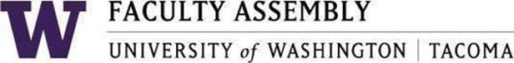

Executive Council Special Meeting

Tuesday, October 18, 2022
12:15 p.m. – 1:20 p.m.
Zoom only

Zoom link: https://washington.zoom.us/j/94375842044
+1 206 337 9723 US (Seattle)
+1 253 215 8782 US (Tacoma)
Meeting ID: 943 7584 2044

Agenda

11:00-11:05: Land Acknowledgement, Consent to Agenda, Permission to Record

11:05-12:00 Faculty Assembly Bylaws Revisions regarding APT (Guest: Mike Townsend, Secretary of the Faculty)

