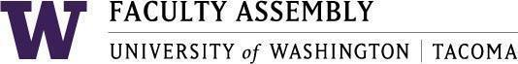

Agenda
Faculty Affairs Committee Meeting
December 12, 2022 / 12:30pm-1:20 p.m.
Dawn Lucien Boardroom GWP 320

- Recording Permissions/Consent [2 mins]
- Approval of minutes from last month [3 mins]
  - Minutes from 11/14/2022
- Update from Non-Tenure Track Faculty Forum [15 mins]
- Faculty Workload Resolution Update, Status and Next Steps [15 mins]
- International Faculty Support [15 mins]
  - Process for acquiring data on experiences of international faculty
    - Who should we be outreaching to
    - What type of information are we seeking
    - How will the information be used to support international faculty at UWT
    - Other steps to take?
  - Timeline for data acquisition and report writing

Optional zoom connection:
Join Zoom Meeting
Join Zoom Meeting
https://washington.zoom.us/j/99011957851 [washington.zoom.us]

Dial by your location
+1 253 215 8782 US (Tacoma)
+1 206 337 9723 US (Seattle)
Meeting ID: 990 1195 7851

