Guide to MLA 9th Edition

MLA, the style of the Modern Language Association, is commonly used by writers in the humanities, including in literature and languages, and emphasizies the author’s unique subjectivity and language. Much more information, including numerous examples, is available at style.mla.org.

Formatting Your Paper

The following guidelines are provided by MLA. Always follow your instructor’s instructions.
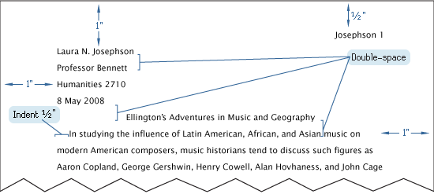
-One-inch margins
-Readable font (such as Times New Roman), 11-13 points
-Running head: Your last name and page number, including on first page
-Heading: Your name, instructor’s name, course name and number, date
-Title centered
-Paragraphs left-aligned and with first lines indented
-Double-spaced throughout the document (including block quotations and Works Cited)

Headings are acceptable in MLA style but are often not necessary in shorter essays. Headings should be styled consistently within the document; built-in heading styles are often acceptable.
In-text Citations
Generally, an in-text citation will include the author’s last name and a page number (or line number or time stamp) if you have included a direct quotation or paraphrase. You can omit the page number for webpages and other online sources that do not have page numbers.

You may cite sources in the text in either prose or parenthetical citations:

Prose: According to Naomi Baron, reading is “just half of literacy. The other half is writing” (194).

Parenthetical: According to one author, reading is “just half of literacy. The other half is writing” (Baron 194).

Prose, no named author: Reading at Risk notes that despite an apparent decline in the number of people reading over the past twenty years, more people than ever are writing creatively (3).

In-text Citations with Multiple Authors
If your source has multiple authors, use the following guidance.
One and Two Authors
Name both authors each time you refer to them:

Jay Lemery and Paul Auerbach note that doctors have not yet adequately explained the effects climate change will have on human health (4-5).

Three or More Authors
Name the first author and follow with “and colleagues” for a prose citation and “et al.” for a parenthetical citation:

Raymond Nickerson and colleagues argue that the truth value of statements determines how persuasive they are (135).

One factor that determines the persuasiveness of arguments is their truth value (Nickerson et al. 135).

Citing Secondary Sources (Indirect Sources)

If you quote an author’s quotation of a source you did not consult, use the abbreviation qtd. in your parenthetical citation:

Samuel Johnson admitted that Edmund Burke was an “extraordinary man” (qtd. in Boswell 289).

The Container Template
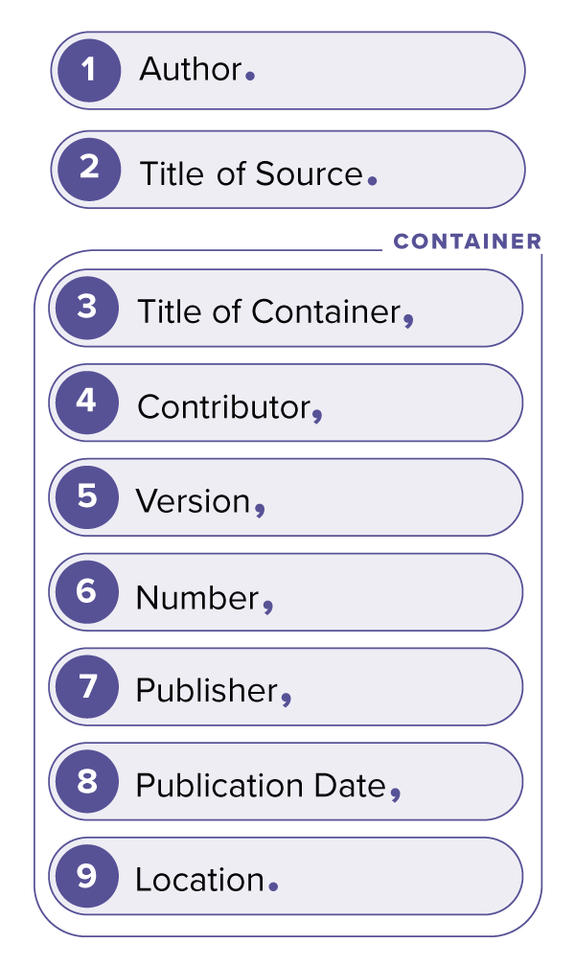
The 9th edition of MLA uses a “container” template for Works Cited citations that is intended to be flexible enough to accommodate many types of sources, including those found online. For this reason, there may be multiple ways to cite a source depending on how you accessed it. The container includes elements that will not be used in every citation. Simply omit elements that are not relevant to your source.

Author: Use the name of the person, people, or group who created the material you are citing. Many reports will name a “corporate author,” or the name of an organization; in videos, the author may be the person who appears on screen or a writer. For some collections, the editor may be the main author. If there is no named author, skip the Author element and begin the citation with the title.

Title: Use the work’s given title. For works that lack a title, provide a short description of the work. Generally, titles of longer works (such as books, journals, and films) are italicized and titles of shorter works (such as articles, poems, and songs) are put in quotation marks.

Container: Examples of containers include a journal (containing an article), a book (containing a chapter, story, or poem), a website or database (containing a post, file, video, or data), and a series (containing an episode). Some works may have multiple containers (for instance, an article in a book published online would be contained by both the book and the website it’s published on). Keep in mind that your purpose in using MLA citation is to allow the reader to easily locate your sources; include container information that will help the reader find your original information.

Contributor: List people and organizations who contributed to a work including translators, editors, and directors, when relevant.

Version: You should note the version of the work, including an edition or translation, when multiple versions exist.

Number: Numbers are commonly included for volume and issue numbers of journals and periodicals, season and episode numbers for many media series, and some multi-volume books.

Publisher: The publisher refers to the organization who produced the work or made it available. Common examples include a book publisher, the studio or network that produced the show, and the agency or department that created a report or website. Website publishers can often be found in a copyright notice at the bottom of the homepage.

Publication Date: Publication date refers to the date the version of the work you’re citing was published, the date of composition for unpublished materials, the date of revision or upload for some online materials, the date of performance or delivery (for a live speech, lecture, performance, etc.), or the word “forthcoming” for works not yet published. Dates may include the year, the day and/or month, a season, or a timestamp.

Location: Location can refer to the work’s location within the container (for instance, the page range of an article) and/or the location of the container (for instance, a DOI or URL, or a digital library) or in some cases, the physical location of the work (for instance, a museum).

Works Cited Page
Examples of commonly used types of sources at UWT are listed below. All examples are taken from the MLA handbook and the MLA Style Center website (style.mla.org/works-cited/citations-by-format/) where you can find more extensive explanations and additional examples.

Title your page Works Cited. Center the title but do not bold, underline, italicize, or add any other elements. Arrange your entries in alphabetical order.

Journal Article in a Database
Goldman, Anne. “Questions of Transport: Reading Primo Levi Reading Dante.” The Georgia Review, vol. 64, no. 1, spring 2010, pp. 69-88. JSTOR, www.jstor.org/stable/41403188.
Gonzalez, Monica Marie. “Preparing Teacher Candidates for the Instruction of English Language Learners.” Networks: An Online Journal for Teacher Research, vol. 18, no. 2, fall 2016. ERIC, eric.ed.gov/?id=EJ1152320.

Books, Book Chapters, and Reference Entries

Book by One Author
Mantel, Hilary. Wolf Hall. Picador, 2010.

Book by an Unknown Author
Beowulf. Translated by Alan Sullivan and Timothy Murphy, edited by Sarah Anderson, Pearson, 2004.

An Edited Book
Sánchez Prado, Ignacio M., editor. Mexican Literature in Theory. Bloomsbury, 2018.

Book on a website
Poe, Edgar Allan. “The Masque of the Red Death.” The Complete Works of Edgar Allan Poe, edited by James A. Harrison, vol. 4, Thomas Y. Crowell, 1902, pp. 250-58. HathiTrust Digital Library, hdl.handle.net/2027/coo.31924079574368.

E-book
Crystal, David. Making a Point: The Persnickety Story of English Punctuation. E-book ed., St. Martin’s Press, 2015.
Book chapter
Toorn, Penny van, and Daniel Justice. “Aboriginal Writing.” The Cambridge Companion to Canadian Literature, edited by Eva-Marie Kröller, Cambridge UP, 2017, pp. 26-58. Cambridge Core, https://doi.org/10.1017/9781316671764.004.

Anthology Entry
Wyatt, Thomas. “They flee from me, that sometime did me seek.” The Columbia Anthology of British Poetry, edited by Carl Woodring and James Shapiro, Columbia UP, 1995, p. 30.

Reference book entry
Sigmund, Paul E. “Chile.” Latin American Politics and Development, edited by Howard J. Wiarda and Harvey F. Kline, 7th ed., Westview Press, 2011, pp. 168-99.

Comic Book
Clowes, Daniel. David Boring. Eightball, no. 19, Fantagraphics, 1998.

Organizational or government report

Durose, Matthew R., et al. Multistate Criminal History Patterns of Prisoners Released in Thirty States. U.S. Dept. of Justice, Sept. 2015, www.bjs.gov/content/pub/pdf/mschpprts05.pdf

United Nations. Consequences of Rapid Population Growth in Developing Countries. Taylor and Francis, 1991.

Report to the Teagle Foundation on the Undergraduate Major in Language and Literature. Modern Language Association of America, 2009.

Online Magazine or Newspaper Article

Article on a website
Deresiewicz, William. “The Death of the Artist—and the Birth of the Creative Entrepreneur.” The Atlantic, 28 Dec. 2014, theatlantic.com/magazine/archive/2015/01/ the-death-of-the-artist-and-the-birth-of-thecreative-entrepreneur/383497/.

Hunter, Marjorie. “Johnson Antipoverty Bill Approved in House, 228-190, but Foes Balk Final Vote.” The New York Times, 8 Aug. 1964, pp. 1+.

Social Media Posts and Online Comments
Social Media Post
Fogarty, Mignon [@GrammarGirl]. “Every once in a while, that Gmail notice asking if you meant to reply to a 5-day-old message is quite helpful.” Twitter, 13 Feb. 2019, twitter.com/GrammarGirl/status/1095734401550303232.

Thomas, Angie. Photo of The Hate U Give cover. Instagram, 4 Dec. 2018, www.instagram.com/p/Bq_PaXKgqPw/.

Online Comment
Max the Pen. Comment on “Why They’re Wrong.” The Economist, 29 Sept. 2016, 6:06 p.m., www.economist.com/node/21707926/comments.

Songs, Recordings, and Performances

Song from an Album
Snail Mail. “Thinning.” Habit, Sister Polygon Records, 2016. Vinyl EP.

Song on a Website
Snail Mail. “Thinning.” Bandcamp, snailmailbaltimore.bandcamp.com.

Movies, Videos, and Television Shows

Movie Viewed Online

Richardson, Tony, director. Sanctuary. Screenplay by James Poe, Twentieth Century Fox, 1961. YouTube, uploaded by LostCinemaChannel, 17 July 2014, www.youtube.com/watch?v=IMnzFM_Sq8s.
YouTube Video
Beyoncé. “Beyoncé—Pretty Hurts (video).” YouTube, 24 Apr. 2014, www.youtube.com/watch?v=LXXQLa-5b5w.

“Capybara Eat Huge Pumpkin.” YouTube, uploaded by Alex Smith, 12 Jan. 2021, www.youtbue.com/watch?v=8YNwxZnABzA.

Podcast Episode
Gladwell, Malcolm. “The Lady Vanishes.” Revisionist History [podcast], season 1, episode 1, Pushkin Industries, 16 June 2016.
Images and Print Advertisements

Photograph Viewed in Person
Cameron, Julia Margaret. Alfred, Lord Tennyson. 1866, Metropolitan Museum of Art, New York City.
Mackintosh, Charles Rennie. Chair of stained oak. 1897-1900, Victoria and Albert Museum, London.
Painting Viewed Online
Bearden, Romare. The Train. 1975. MOMA, www.moma.org/collection/works/65232?locale=en.

Untitled Image from a Print Magazine
Karasik, Paul. Cartoon. The New Yorker, 14 Apr. 2008, p. 49.
Print Advertisement
Advertisement for Upton Tea Imports. Smithsonian, Oct. 2018, p. 84.

Course Materials and Personal Communications

Personal Communication
Zamora, Estelle. E-mail to the author. 3 May 2018.

Course material or lecture
Slide of Linus, Lucy, and Snoopy. English 204: Animals in Graphic Art, 4 Apr. 2016, Evergreen State College, Slide 2.

