Faculty Assembly Executive Council (EC)
Meeting Minutes
Friday, 12/9/2022, 1:00 p.m. – 3:00 p.m.
GWP 320/ Zoom

Present: Chancellor Sheila Edwards Lange, EVCAA Andy Harris, Chair Menaka Abraham, Vice Chair Huatong Sun, APCC Chair Julie Masura, APT Chair Jim Thatcher, FAC Chair Sharon Laing, Kathy Beaudoin, Monika Sobolewska, Andrea Hill, Anne Taufen, Robin Evans-Agnew, Ruben Casas, Rupinder Jindal, Julie Eaton, Jenny Xiao, Margaret Griesse, Erika Bailey, Zhiquan (Andy) Shu, Jim West Excused: Barb Toews, Jai’Shon Berry (ASUWT Representative), Absent: Alex Miller Guests: Curt Kohlwes (Director of Government Relations), Annie Downey (Associate Dean of University Libraries and Director of UW Tacoma Library), Megan Watson (Collections Librarian), Bonnie Becker Program Coordinator: Andrew Seibert

- Land Acknowledgement, Consent to Agenda, Meeting Minutes, Permission to Record
The agenda was approved. Permission to record the meeting was granted for minutes purposes only. The members reviewed the 11/21 meeting minutes. The minutes were approved as written.
- Faculty Assembly Updates
- The Faculty Workload resolution was sent to the Chancellor and Executive Vice Chancellor for Academic Affairs. A response will be provided later this month or early next month.
- The unit adjustment work is still underway, however there is a concern with using UW Bothell as a model. Chancellor, EVCAA and Faculty Assembly Chair are meeting with the Senate Committee on Planning & Budgeting to present the model.
- Academic planning work is continuing. For more campus involvement, the task force plans to use the Winter Quarter Faculty assembly meeting to discuss and involve faculty in academic planning. Please encourage faculty, deans, and administrators in your units to attend the meeting on February 10, 2023.
- The EC representatives will review and report on the current work within their schools around Hybrid/Distance learning at the January 6th EC Meeting. The chair asked to include what is working well with the temporary policy along with some struggles that the unit is having. A tri-Campus workgroup has been created called the “Future of Teaching & Learning.” UW Tacoma representation comprises of Darcy Janzen (Director of Digital Learning). Libi Sundermann (Teaching Professor, School of Interdisciplinary Arts & Sciences), and Lisa Hoffman (Professor, School of Urban Studies). The chair invited the members of this workgroup to the EC meeting in January to get updates.
- Faculty senate leadership asked the senate cabinet for feedback on the provost search and UW Tacoma’s Chair of Faculty Assembly made a request for the candidates be brought to the Tacoma campus for the interviews, and our chair will be engaging Executive Council in this search. The chair asked to email questions and suggestions to her or provostsearch@uw.edu.
- Vice Chair of Faculty Assembly thanked the volunteers and gave an update on the COVID-19 funds.
- Legislative Updates (Curt Kohlwes, Director of Government Relations)
  - Curt Kohlwes provided updates via a handout to faculty representatives. Please see Appendix A for the scanned handout of information that was sent to representatives
  - The 2023 Legislative Agenda is set, however requests for 2024 will be developed soon.
  - There was a request to include funding for faculty support, specifically teaching and research assistants for the Tacoma campus, which Seattle does offer for graduate students.

- Updates from Chancellor and EVCAA
  - Chancellor Lange updated the representatives on the following:
    - The next Chancellor’s Town Hall is Tuesday, December 13, 2022, 12:30-1:30
      - Discussion on the future goals of UW Tacoma in 2050
    - Provided feedback on the bookstore closure
      - The UW Bookstore is not university owned but a trust that is managed by university faculty, staff, and students, and is a separate entity
      - UW Bothell bookstore closed in June 2022
      - Students moved to online ordering for books
      - The Tacoma bookstore will close early next year, and the textbook ordering and other services will continue virtually
        - The campus is yet to determine where students will be able to get their books and where to celebrate faculty published books. Copy & Mailing Center is a possibility.
  - Dr. Andy Harris, EVCAA provided the following updates:
    - The job post for the Dean of School of Nursing & Healthcare Leadership is live.
    - The provost search committee has been charged. There are conversations going on about the level of Tacoma campus involvement. There was advocacy about involvement of all campuses.
    - Chancellor Lange and Dr. Harris received the Faculty Workload finalized resolution, and as stated in the previous meeting are all supporting this initiative.
    - Dr. Harris is excited about the Academic planning discussion on February 10, 2023.
    - As far as the state revenue, the revenue forecast is strong, however, federal funds that the state received from the pandemic are depleting. It is projected to not be a bad year fiscally, but to even out.

- Elsevier update (Annie Downey, Associate Dean of UW Libraries)
  - Annie Downey provided an update about the increase of costs using the services Elsevier publisher offers. See Appendix B for the information and links that were provided during the meeting including statistics.
  - Nursing and Engineering will be the most impacted by this reduction in journal packages.
  - COVID-19 allowed the use of expanded packages, however that is set to expire, however individual titles can still be purchased
  - Provide feedback to the subject librarian and browse the spreadsheet for the subscriptions in Appendix B.
- Adjournment
  - The meeting was adjourned at 3:01 p.m.
    - Next meeting: January 6, 2023, 1:00 to 3:00, GWP 320

Appendix A: 2023 Legislative Agenda

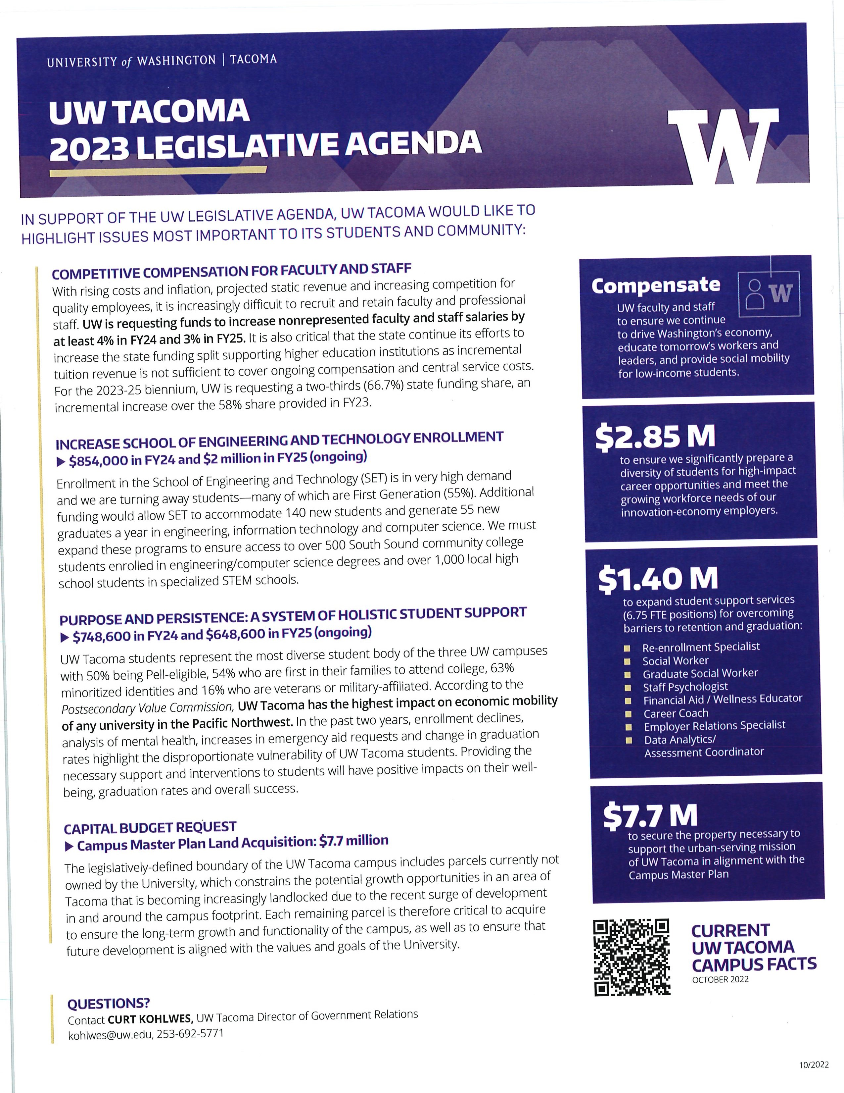

Appendix B: Elsevier resources from Annie Downey

Elsevier Update

What:
• Our current Elsevier package costs ~$2.6 million/year; UW's negotiating team is aiming for a ~$650K cut for FY23-24.
• Librarians have identified ~500 journal titles for which we'll maintain immediate access, prioritizing clinical care journals. These titles comprise ~90% of all use.
• All other titles (~2000) will be accessible via interlibrary loan and/or are Open Access.
• New one-year contract will start January 2023; negotiations will be scheduled again for FY24-25.

Why:
• Seeking to re-balance our monographs and serials expenditures
• Allocate more resources toward other, sustainable digital collections/projects
• Match last year's Wiley cut of 20%
• UW Principles in Licensing & Class C resolution passed by Faculty Senate in support of those principles

UWT Approach:
• Due to very short turnaround time, librarians reviewed the title list https://docs.google.com/spreadsheets/d/1sQr_NGd1QbVIsn-9tIFlOBQX-FUcjBfV/edit#gid=1895620006
• UWT Librarians will focus on:
o Helping faculty mitigate the impact
  - Communicating updates to faculty
o Identifying challenges and possible titles to add during the 2023 calendar year

