Academic Planning Policy Draft

Strategic Plan Statement for Academic Plan: “A roadmap of the academic programs and courses we need to meet our community’s and students’ needs and to grow our programs to an enrollment of 10,000 students”
Vision: We will align our academic plan with global needs and ongoing development in the Puget Sound area and beyond by clarifying campus strengths, student needs, community conditions, and regional opportunities. We aim to be transparent, collaborative, value-driven, and nimble as we embark on academic planning and consult with faculty and campus stakeholders to grow sustainably and efficiently. We see our current budget constraints and enrollment challenges as an opportunity to reinvigorate our academic programs to continue to position us as a leader of higher education.
Goals:
- Shared definition of current regional development needs and global conditions, to originate new program proposals and identify priorities for investment and implementation, based on empirical research and supported by policy process and resource allocation models.
- A streamlined Planning Notice of Intent (PNOI or program creation template) and process flowchart and recommendations for tracking proposals
- An assessment of the current state of data for planning and what the future state needs to be for data in order to become information for invigorating our programs. This includes new tools to streamline data collection
- Shared criteria to identify and prioritize relationships between programs on campuses, with proximity to external partners to invigorate programs and support sustainability of full range of offerings
- Provide a unit/school level directive to guide the program invigoration process with clear deadlines and process
- Coordinate with campus planning groups for alignment with strategic planning, student success initiative, strategic enrollment planning, and campus climate implementation
Taskforce Work Timeline for Academic Plan:
Autumn 2022: Present previous academic plan and feedback at Fall retreat, Academic Plan Taskforce Formation, Review and analyze documents from previous academic plan, explore what data is possible to inform our decisions, brainstorm approaches to the creation of the new academic plan, universal framework proposal
Winter 2023: Questionnaire for invigorating programs, explore the opportunities for internal and external data, Brainstorm the use of universal framework and integration with the academic plan, timeline for implementation of Academic plan, Draft academic plan presentation and brainstorming session for all faculty
Winter/Spring 2023: Listening sessions for process, budget, and flow documents for interested faculty/deans/curriculum coordinators/APCC members, incorporate feedback from brainstorming session and listening sessions held for academic plan, provide draft to Executive council for approval, provide data requests to external firm in preparation for new program growth
Winter 2023-Spring 2023: Process document review and revisions by office of Academic Affairs and APCC:
- Review process documentation for undergraduate programs including process flowchart, process steps, stakeholder list, stakeholder feedback form, Planning Notice of Intent (PNOI) form, and full proposal guidelines. Consider how the process may be streamlined and refined to increase efficiency, clarify roles within the process, and highlight when decisions are being made and by whom.
- For graduate proposals, check with the Graduate School’s Office of Academic Affairs and Planning regarding graduate program and certificate flowcharts to see where revisions may be allowable within their process. Draft revisions in conjunction with the Graduate School.
- Share proposed draft process documents with various campus stakeholders including deans, school directors of operations, academic support staff, and curriculum coordinators. Provide the opportunity for feedback via listening sessions with the campus groups. (Note: some parts of the processes are controlled by the UW Curriculum Office or the Graduate School. These will be noted accordingly on the flowcharts as items that cannot be revised.)
- Taking into consideration feedback received, revise documents as needed.

Academic Plan Timeline:
The Academic Plan Cycle will be 3 years where new proposals can be submitted only in the winter quarter of each year.
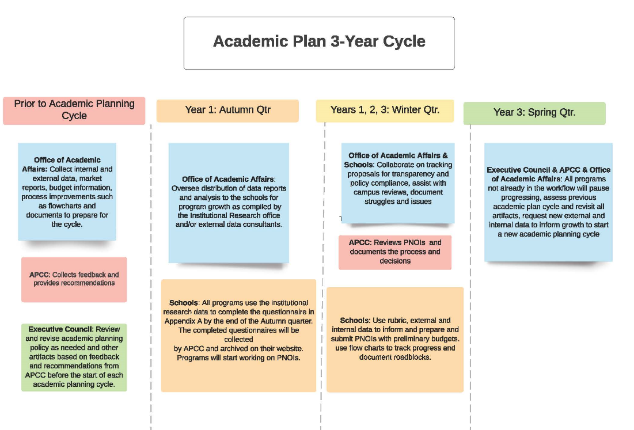

Prior to the Academic Planning Cycle:
Office of Academic Affairs: Collect internal and external data, market reports, budget information, process improvements such as flowcharts and documents to prepare for the cycle.
APCC: Collects feedback and provides recommendations.
Executive Council: Review and revise academic planning policy as needed and other artifacts based on feedback and recommendations from APCC before the start of each academic planning cycle.
Autumn of Year 1:
Schools: All programs use the institutional research data to complete the questionnaire in Appendix A by the end of the autumn quarter. The completed questionnaires will be collected by APCC and archived on their website. Programs will start working on PNOIs.
Office of Academic Affairs: Oversee distribution of data reports and analysis to the schools for program growth as compiled by the Institutional Research office and/or external data consultants.
Winter of Years 1, 2, 3:
We envision that the program invigoration questionnaire and internal/external data will result in innovative ideas and solutions to propose changes or new programs that align with the academic plan framework proposed in Appendix B to support our strategic plan and campus climate implementation.
Schools: Use rubric, external and internal data to inform and prepare and submit PNOIs with preliminary budgets. Use flow charts to track progress and document roadblocks.
APCC: Reviews PNOIs and documents the process and decisions.
Office of Academic Affairs & Schools: Collaborate on tracking proposals for transparency and policy compliance, assist with campus reviews, document struggles and issues.
Spring of Year 3:
Executive Council & APCC & Office of Academic Affairs: All programs not already in the workflow will pause progressing, assess previous academic plan cycle and revisit all artifacts, request new external and internal data to inform growth to start a new academic planning cycle.
Appendix A
UW Tacoma Questionnaire for Invigorating Academics
* Required
As a campus, we will take this opportunity to examine our programs and use the data provided by Institutional research to make curricular or strategic decisions to invigorate each program within our schools. The goal is to reflect collectively on what is working well, what can be improved, and what can we learn from each other to move forward on our strategic plan. The deadline to complete this questionnaire is the end of autumn quarter 2023.
Please engage as many faculty and staff members as possible when completing this questionnaire to get multiple inputs and viewpoints to invigorate our curriculum. There are questions for information sharing across campus to learn from each other.
Please complete one questionnaire for each program or CIP Code.
Degree Program: *
School or Program: *
Contact Person: *
Contact E-mail: *
Internal and Community Demand
- How do you interact or interface with community technical colleges (CTCs) or high schools within your program? How do you communicate about your major to potential students, including how they will find belonging and post-graduation opportunities?
- Do you engage with community partners? How do you engage with them?

Program Quality
Prior to answering these questions, please examine the data provided for your program. 7-year enrollment in the program, courses, student demographics, course modalities, etc.
- Is your program separately accredited? Which accreditation body is used? What is the term for this? What are some accreditation requirements that restrict you in making decisions?
- Are there multiple options or tracks or pathways in the program? Do all options, tracks, or pathways support adequate enrollment? Are the pathways clear and transparent to students?
- Is there a minor for this program? Are there opportunities to create a new minor?
- Are there hybrid and online options currently available for your program or courses in the program? What is the rationale for these options?
- Given the student demographics, describe the opportunities for invigorating the quality of the program with respect to this (revisit any areas in the program)?
- Given the data for course level enrollment, are there opportunities to optimize the offerings?
- How do you assess whether students are meeting the learning objectives of your program? How do you track graduates and their post-graduation pathways? Do you adapt your program as a result of your assessment process?
- Are course caps appropriate to the goals of the curriculum? Are there places they could be bigger or smaller? Are classes filling? Are students able to take required classes in a timely way to move towards graduation?
- Does your curriculum support students in general education, such as through offering Area of Inquiry, writing, or diversity courses? Does your curriculum support students beyond your major, or pre-major students?

Human, Physical and Technical Resources
Prior to answering these questions, please examine the data provided for your program. 7-year faculty and staff, lab, technical resources allocated to your program, etc.
- Given the data provided, are there opportunities to reassess the resources available? Are there resource needs that aren’t met? Is there an opportunity to collaborate with other programs to optimize the resources available?
- How is marketing and recruiting done?

Future Potential for the Program
- What are some opportunities for future potential? Are there opportunities for attracting working professionals or providing professional development?
- Could the program benefit from a minor offering or restructuring of the options, certificates, or pathways?
- Could the program benefit from an online option?

Student Enrollment, Retention and Engagement
- What are some student retention and support mechanisms for your program?
- How do students receive assistance with their work? (i.e., tutoring, mentoring, advising)
- Are there any Registered Student Organizations (RSOs) that the students have from this program or school? How active are these RSOs?
- What are some enrollment strategies or plans used? Do you have staffing support for enrollment?
- What High Impact Practices, such as independent research, global learning, community engaged learning, learning communities, and internships, do you support for students in your majors? (For more information about HIPs, see: https://www.aacu.org/trending-topics/high-impact). How do you ensure that access to HIPs is equitable in your program?
- Do you offer Study abroad programs?
- Is there an internship option and is it required? How are internships managed or how do students find internships?
- Do you engage with community partners?

School or Division Level
- Do you collaborate with other programs in school or division?
- Are there opportunities for collaboration or sharing of resources (optional)?

Interdisciplinary Exploration
- Do you collaborate with other programs in other schools?
- Are there opportunities for collaboration or sharing of resources (optional)?

Appendix B
ALIGNING EXPANSION, ASSETS, AND RESOURCES: A SHARED FACULTY FRAMEWORK

- ESTABLISH A SHARED GOAL BASED UPON RECOGNITION OF A CHALLENGE AND OPPORTUNITY
UWT Shared Goal: Campus expansion aligned with urban-serving mission
- Faculty definition and understanding of this goal: “Expand access to higher education in an environment where every student has the opportunity to succeed; Foster scholarship, research and creativity to address the challenging problems of our time and place; Partner and collaborate for common good; Catalyze the economic, social and cultural vitality of the region with an understanding of our student demographics.”
- For the purposes of academic planning and program growth within the university, the shared goal is defined through the following four areas of focus, in alignment with the campus mission, values, and strategic plan:
  - Workforce Development
  - Civil Rights and Climate
  - Community Health Stability
  - Cultural Vitality
Four areas of focus are described in more detail below, including connections to Strategic Planning goals and faculty-led, student-focused pedagogy; community-engaged, issue-based research; and program development that will integrate these for the benefit of UWT stakeholder communities.

- ASSESS OVERALL PERFORMANCE RELATIVE TO SHARED GOAL
Performance Relative to Goal at the Campus Level (Aggregated):
- WORKFORCE DEVELOPMENT - From the outset, the UWT campus has been working to serve the human capital needs of the region and the state. This means preparing students for jobs and careers that contribute to mutual wellbeing of residents, households, businesses, and communities through sustainable workforce development, in line with the goals of the Washington State Legislature, the UW Board of Regents, and our public and private champions and supporters.

- CIVIL RIGHTS AND CLIMATE: UWT shares the commitment of public research universities to further an agenda of rights-based education and training to all students, upholding the highest standards of accountability and continuous learning in our institutions and governing arrangements. An institutional climate of safety, non-discrimination, and equal protection is at the center of our approach to global climate change, one of many scientific challenges that we face as a research and teaching community, and equal protection is at the center of our approach to global climate change, one of many scientific challenges that we face as a research and teaching community.

- COMMUNITY HEALTH STABILITY: UWT is uniquely poised to engage in teaching, research, and community invested services that require an interdisciplinary approach to the social determinants of health. These include shelter, nutrition, education, environmental conditions, access to healthcare, and social support systems to enable individuals and communities to maintain healthy relationships and strong place-based connection

- CULTURAL VITALITY: UWT contributes to a culture of learning, tolerance, entrepreneurship, and creativity, on our campus, throughout our region, and around the world. Practices of access-based learning, community service, and anti-racist, engaged pedagogy reinforce the cultural strengths of our diverse region, including creative and performing arts, sport and recreation, and place-based innovation and community development initiatives

- OTHER? Is there an additional area of focus that is needed to fully define and actualize our urban-serving mission?
*these focus areas have been developed through faculty process and analysis of our existing strengths and stated mission; they are linked to our Strategic Planning goals, in the next step*

- RECOGNIZE PERFORMANCE of UNITS WITH RESPECT TO THE SHARED GOAL
Performance Relative to Shared Goal at the Sub-Campus Level (Disaggregated)
Sub-Campus Measures of Goal Performance: Linked to Strategic Planning Goals/Metrics
- WORKFORCE - Local Economic Conditions and Workforce readiness, employment statistics for UWT graduates.
- Increase recruitment, enrollment, retention, and graduation rates with a focus on closing equity gaps. (GOAL 1)
- Enhance the economic vitality of the region. (GOAL 4)
- Foster a climate of creativity, entrepreneurship and innovation. (GOAL 7)

- CLIMATE and CIVIL RIGHTS – Hospitability of institutional and environmental climates, including climate change science, effects, design and evaluation of interventions.
- Increase recruitment, enrollment, retention, and graduation rates with a focus on closing equity gaps. (GOAL 1)
- Strengthen collaborative community partnerships with an emphasis on diverse communities. (GOAL 3)
- Cultivate an accessible, equitable, respectful and inclusive campus culture. (GOAL 8)

- COMMUNITY HEALTH STABLITY: Cultivation of systems to promote place-connected social and environmental health.
- Enhance student well-being. (GOAL 2)
- Strengthen collaborative community partnerships with an emphasis on diverse communities. (GOAL 3)
- Intentionally create spaces, programs and activities that encourage engagement with our campus. (GOAL 10)

- CULTURAL VITALITY: Engagement across the region and investment in local community groups and regional affinity organizations, throughout our curricula, research, and service.
- Become a national leader in community-engaged research, scholarship and teaching. (GOAL 5)
- Integrate high-impact practices for students into our scholarly work. (GOAL 6)
- Foster a climate of creativity, entrepreneurship and innovation. (GOAL 7)
MISSING CONNECTIONS TO STRATEGIC PLANNING GOALS:
GOAL 9: Attract, engage and retain a diverse community of students, faculty and staff.
GOAL 11: Prioritize financial stability and sustainability.
*Can we educate ourselves, to make these Strategic Planning Goals be part of everything that we do at UWT?
- ASSESS AND UNDERSTAND THE STRUCTURES THAT SUPPORT OR IMPEDE UNITS RELATIVE TO THE SHARED GOAL.

- DEVELOP AND IMPLEMENT STRATEGIES FOR EACH UNIT TO PROGRESS THE SHARED GOAL.

^{[1]} One framework to guide equity-based policy and decision-making, developed by john a. powell and policy leaders at the Haas Institute at UC Berkeley, is Targeted Universalism: https://belonging.berkeley.edu/targeted-universalism Other frameworks follow similar tenets, where shared values and identified goals, organize the collection and analysis of data
^{[2]} S

^{[1]} One framework to guide equity-based policy and decision-making, developed by john a. powell and policy leaders at the Haas Institute at UC Berkeley, is Targeted Universalism: https://belonging.berkeley.edu/targeted-universalism Other frameworks follow similar tenets, where shared values and identified goals, organize the collection and analysis of data
See: Vision, Mission, Values and Strategic Priorities of UW Tacoma, University of Washington Tacoma Strategic Plan, 2022-2027, (p. 6), University of Washington Tacoma Strategic Plan, 2022-2027.

