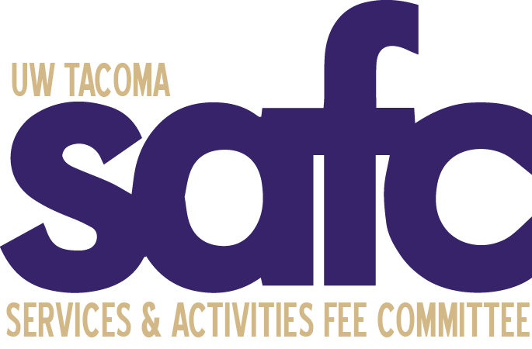
Services and Activities Fee Committee (SAFC)
Tuesday, January 24, 2023
4:00pm - 5:00pm
JOY 201
Zoom | Dial in: Dial in: (253) 215-8782, Meeting ID: 952 2161 9879

MEETING MINUTES 05

Attendance:

Voting Members  An Le Dang - Present  Patrick Sullivan - Present  Ngoan Huynh – Present  Ramon Hermerlein – Present  Administrative | Ex-Officio Members  Bernard Anderson - Present  Jan Rutledge - Present  Faculty (TBD) -  Sean Schmidt - Present  Jasmine Davis - Present  Kelly A. Tyrrell - Absent  Guests  - Ben

The meeting was called to order by Patrick at 4:05 pm.

A land acknowledgement was given by Patrick.

Roll Call is documented above.

Approval of Agenda
An moved to approve the 1/24/2023 agenda. Ngoan seconded. The motion passed unanimously.

Approval of Minutes
An moved to approve the minutes of the 1-17-2023 meeting. Ngoan seconded. The motion was passed unanimously.

Open Public Forum
- Ben – first quarter at UWT

Old Business
- $1.781 million in the short-term contingency
- Fall Special Allocations
  - Total request $197,637
  - Keep in mind the reoccurring positions that are being requested through the Fall Special Allocation as student enrollments are going down.
  - CEI Request
    - $22,275 total request for Tribal Liaison.
    - Most of the items that are being requested are one-time funding.
- Stipends has been started

New Business
- Send reminder that the deadline for Annual Allocation proposals is approaching

Announcements

Adjournment
An moved to adjourn the meeting at 4:42pm. Ramon seconded. The motion was passed unanimously. The meeting ended at 4:42pm.

