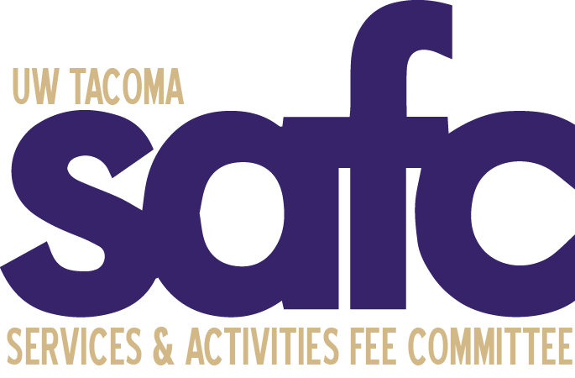
Services and Activities Fee Committee (SAFC)
Tuesday, January 31, 2023
4:00pm - 5:00pm
UWY 307
Zoom | Dial in: Dial in: (253) 215-8782, Meeting ID: 952 2161 9879

MEETING MINUTES 06

Attendance:

Voting Members  An Le Dang - Absent  Patrick Sullivan - Present  Ngoan Huynh – Present  Ramon Hermerlein – Absent  Kiang Le – Present  Taylor Cole-McIntosh - Present  Administrative | Ex-Officio Members  Bernard Anderson - Present  Jan Rutledge - Absent  Faculty (TBD) -  Sean Schmidt - Present  Jasmine Davis – Absent  Kelly A. Tyrrell - Absent  Guests

The meeting was called to order by Patrick at 4:06 pm.

A land acknowledgement was given by Patrick.

Roll Call is documented above.

Approval of Agenda
Taylor moved to approve the 1/31/2023 agenda. Ngoan seconded. The motion passed unanimously.

Approval of Minutes
Kiang moved to approve the minutes of the 1/24/23 meeting. Taylor seconded. The motion was passed unanimously.

Open Public Forum
- Committee members shared highs and lows

Old Business
- $1.781 million in the short-term contingency
- Fall Special Allocations
  - Total request $197,637
  - Keep in mind the reoccurring positions that are being requested through the Fall Special Allocation as student enrollments are going down.
  - CEI Request
    - $22,275 total request for Tribal Liaison.
    - Most of the items that are being requested are one-time funding.
- Stipends has been started
- Reminder
- Faculty Ex-officio member still needed. Patrick will reach out.

New Business

Announcements

Adjournment
Taylor moved to adjourn the meeting at 4:34pm. Ngoan seconded. The motion was passed unanimously. The meeting ended at 4:35.

