Faculty Assembly Executive Council (EC)
Meeting Minutes
Monday, 2/27/2023, 12:30 p.m. – 1:20 p.m.
GWP 320/ Zoom

Present: Chair Menaka Abraham, Vice Chair Huatong Sun, APCC Chair Julie Masura, FAC Chair Sharon Laing, Kathy Beaudoin, Andrea Hill, Barb Toews, Robin Evans-Agnew, Ruben Casas, Rupinder Jindal, Julie Eaton, Jenny Xiao, Margaret Griesse, Erika Bailey, Anne Taufen , Zhiquan (Andy) Shu, Jim West Excused: Monika Sobolewska Absent: Jai’Shon Berry (ASUWT Representative), APT Chair Jim Thatcher, Alex Miller Guests: Bonnie Becker, Mentha Hynes-Wilson (Vice Chancellor for Student Affairs) Program Coordinator Andrew Seibert

- Land Acknowledgement, Consent to Agenda, Meeting Minutes, Permission to Record, Announcements
- The agenda was approved. Permission to record the meeting was granted for minutes purposes only. The members reviewed the minutes from January 23, 2023, and January 31, 2023. Minutes were approved as written
- Announcements from Chair
  - A nomination email was sent out to all full-time faculty to serve a two-year term on the Faculty Senate. Four faculty members expressed interest in serving
  - Academic planning taskforce members are planning to meet on Friday, March 3rd. Their goal is to work on the next draft to get to Executive Council next quarter
  - Provost search feedback collected from faculty has been provided to the faculty senate chair
  - EVCAA listening session had good attendance. The chair provided the discussion topics:
    - Faculty support in teaching and scholarship
    - Workload equity
    - Supporting faculty’s productivity within the schools
    - Providing support for librarians
    - Formation of schools and growth resulting in issues relating to faculty hiring
    - How services differ within each school
  - Chair provided an update on the upcoming events
    - March 10: DEI professional development
    - March 17: EC meeting attendees are as followed;
      - Cheryl Greengrove, Associate Vice Chancellor for Research
      - Susan Wagshul-Golden, Campus Safety & Security
      - Sylvia James, Vice Chancellor for Finance & Administration
      - Providing updates: EVCAA Andy Harris
      - Providing updates: Chancellor Sheila Edwards Lange
- Student Affairs updates by Mentha Hynes-Wilson, Vice Chancellor for Student Affairs
  - Vice Chancellor for Student Affairs Mentha Hynes-Wilson provided the following information
    - Introduced EC members to the Student Affairs team via their website, and their organization chart
    - Provided the following resources:
      - Bias Incident Reporting
      - Care Team
        - Purple sheet on supporting students in distress (See appendix A)
        - Care team is responsive regarding students who are in distress and help students succeed and thrive
      - Recommended to forward students to the HuskiesCare link which can help students in a variety of categories such as housing, food, mental health, and basic needs
      - Director of Campus Safety and Security will speak at the March 17, 2023 EC meeting
    - Video on emergency preparedness was shown
      - An EC representative brought up a concern about some of the older spaces having outdated locking mechanisms and recommended having a video on how to lock newer spaces. Vice Chancellor for Student Affairs recommended to bring this concern to the Director for Campus Safety & Security
- Discussion on EC Rep’s Roles & Responsibilities (See appendix B)
  - Chair went over the roles and responsibilities of the Executive Council. See appendix for the original draft that was made by 2020-2021 chair, Sarah Hampson. Chair recommended to share this with new Executive Council members next academic year, and shared with current EC representatives as a reminder of the role of a representative
- Adjournment
  - The meeting was adjourned at 1:20 p.m.
    - Next meeting: March 17, 2023, 1:00 to 3:00, GWP 320

Appendix A: Students in distress PDF

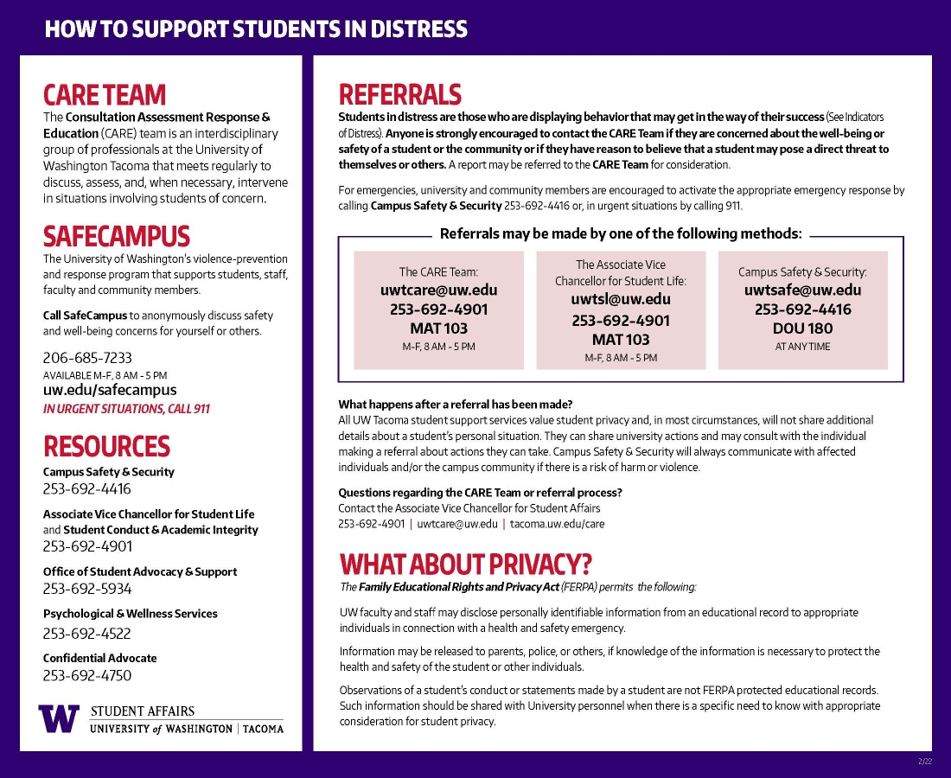
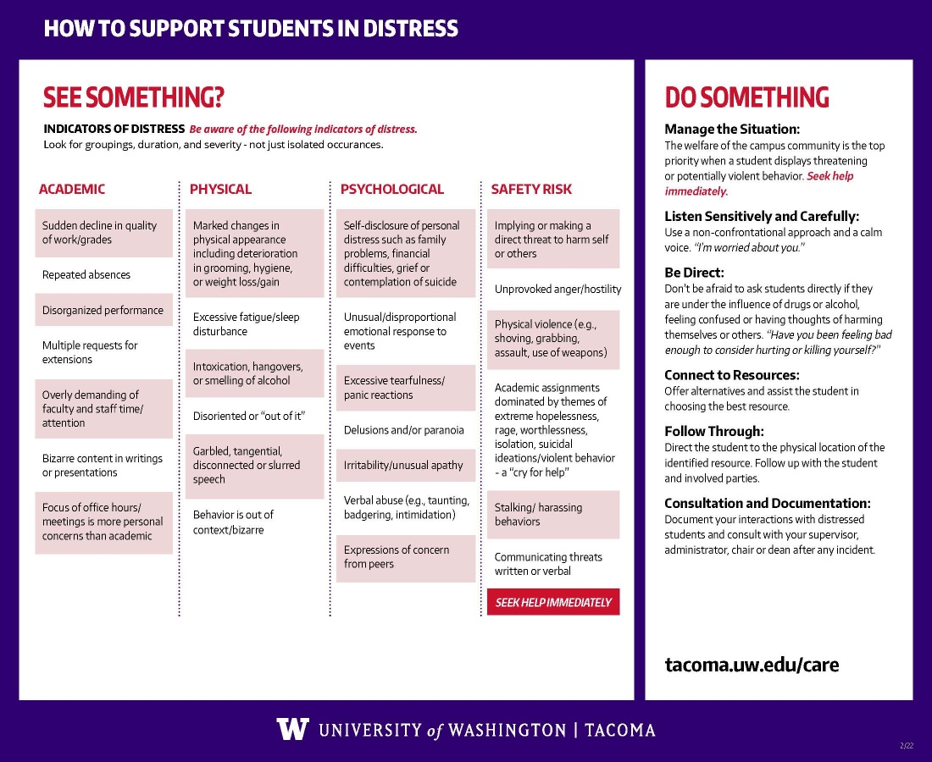

Appendix B: Executive Council roles and responsibilities

EC Member’s Roles and Responsibilities
Originally drafted by Sarah Hampson, FA Chair 2020-21
Membership and duties of the Executive Council are formally outlined determined by the UW Tacoma Faculty Assembly By-Laws in Article V Section I. The following represents a list of institutionalized expectations of the behaviors and practices of members of the Executive Council. You are expected to:
- Read the by-laws pertaining to the Executive Council at the beginning of each new year of service.
- Attending all meetings of the Executive Council either in-person or remotely. If you cannot attend a meeting, please notify the Chair and the FA Coordinator ahead of time. More than one unexcused absence from the EC during a quarter may prompt the Chair to notify your school’s Faculty Council of your attendance record.
- Prepare for EC meetings by reading the materials that are sent one week in advance by the coordinator to all members. You may also frequently be asked to collect information or feedback from your faculty ahead of a meeting.
- Represent your school on EC and to be the voice of your faculty in that important space. This may include summarizing and representing voices and feedback with which you personally do not agree.
- Communicate the work of EC on a regular basis to the faculty in your school. You may do this in a variety of ways, but some that have been done effectively in the past include verbal updates at faculty meetings and/or regular email summaries of EC “key topics”.
- Coordinate regularly and clearly with the other representatives from your school (if applicable) to ensure that your responsibilities are shared, and that your school is well informed of the work of EC.

