Faculty Assembly Executive Council (EC)
Meeting Minutes
Friday, 03/17/2023, 1:15p.m. – 3:00 p.m.
GWP 320/ Zoom

Present: EVCAA Andy Harris, Vice Chair Huatong Sun, APCC Chair Julie Masura, FAC Chair Sharon Laing, Kathy Beaudoin, Andrea Hill, Anne Taufen, Robin Evans-Agnew, Ruben Casas, Rupinder Jindal, Julie Eaton, Jenny Xiao, Margaret Griesse, Erika Bailey, Zhiquan (Andy) Shu, Jim West, Excused: Chair Menaka Abraham, Monika Sobolewska, Barb Toews Absent: Alex Miller, Jai’Shon Berry Guests: Christine Stevens(Representing APT), Susan Wagshul-Golden (Director of Campus Safety & Security), Cheryl Greengrove (Associate Vice Chancellor for Research), Sylvia James (Vice Chancellor for Finance & Administration) Program Coordinator: Andrew Seibert

- Land Acknowledgement, Consent to Agenda, Meeting Minutes, Permission to Record, Approval of Meeting Minutes from 2/27
The meeting started at 1:15pm. Permission to record the meeting was granted for minutes purposes only. The approval of the meeting minutes has been tabled to the next meeting on March 27, 2023.
- Presentation by Director of Campus Safety & Security, Susan B. Wagshul-Golden
- Please see Appendix A for the presentation.
- A safety briefing resource document was provided. This document was referenced during discussion and was given to the Chancellor’s Cabinet as a resource. See Appendix B for the resources.
- Several members expressed concerns about security in the classroom and locking doors, glass in buildings and doors, and recommended that more training materials and videos be provided.
- The Vice Chair of Faculty Assembly recommended sending any questions and they will pass them on to the Director of Campus Safety & Security.
- Presentation by Dr. Cheryl Greengrove, Associate Vice Chancellor for Research
  - Please see Appendix C for the presentation.
  - The Vice Chair of Faculty Assembly recommended sending any questions to them, and they will pass them on to the Associate Vice Chancellor for Research.
- Chancellor/Executive Vice Chancellor for Academic Affairs (EVCAA)/ASUWT President Report
  - EVCAA Dr. Andy Harris had the following to report:
    - Specific updates from Chancellor Lange:
    - There is no update to the concealed carry request from the EC meeting on January 2023 where the Chancellor provided the following update: “The Chancellor notified the Executive Council on the topic of prohibiting firearms on campus. A UW Tacoma student is currently challenging this prohibition. There is a process that is typically done if a student needs something for their safety, however, it was mentioned that allowing firearms for safety was rare. Currently, no one has permission to have weapons on campus. At this time, the Chancellor was unsure whether this will move forward but will keep the Executive Council up to date on this directive.”. The beginning stages of faculty workload resolution is underway. Data is being gathered and Dr. Sharon Laing will be working with the Office of Academic Affairs to lead the service audit and the discussion of faculty equity across the campus.
    - The Academic Planning workgroup is waiting on a request for proposal on the Lightcast software.
    - Discussion of budget reduction in the units happened in each unit and EVCAA is pleased with the discussions from unit deans and directors.
- Meet with Vice Chancellor for Finance & Administration Sylvia James
  - Sylvia James, Vice Chancellor for Finance & Administration introduced herself to the executive council and gave her background around Finance and Administration.
  - Sylvia described her goals around transparency around the budget, such as being invited to more meetings Faculty Assembly holds and having a transparent calendar, so that deadlines are visible.
- Adjournment
  - The meeting was adjourned at 3:00p.m.
    - Next meeting: March 27, 2023, 12:30 to 1:20.
      - GWP 320.

Appendix A: Presentation from Susan Wagshul-Golden

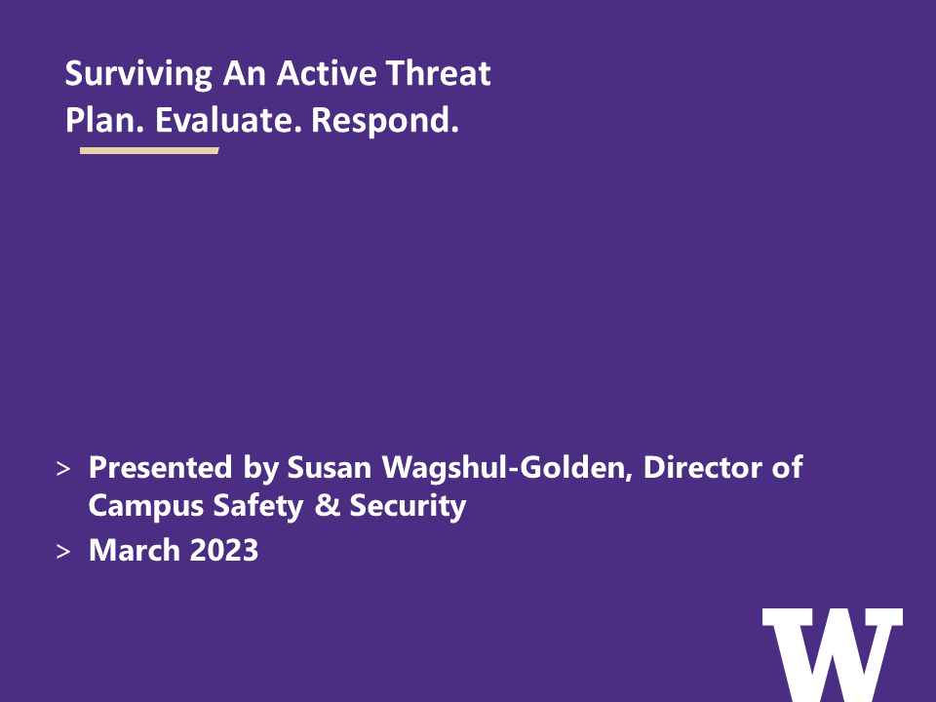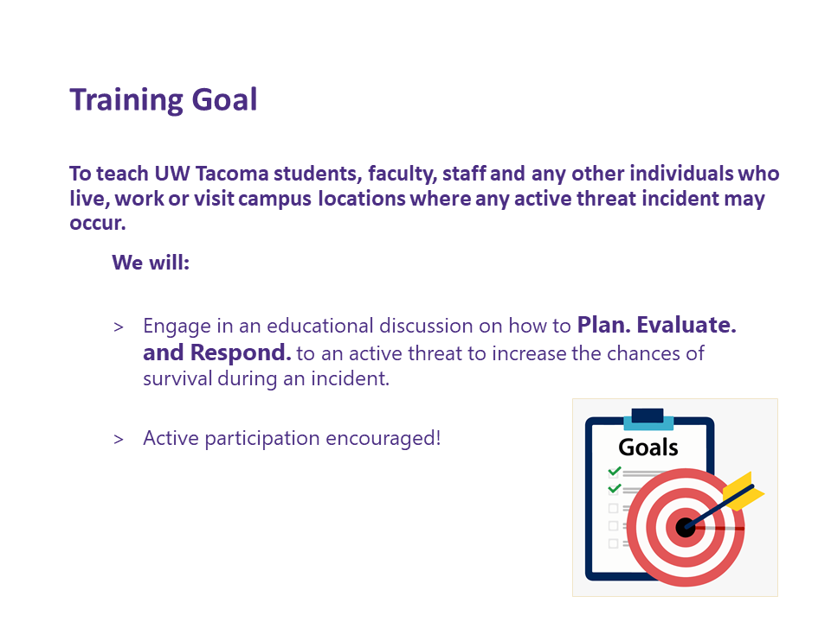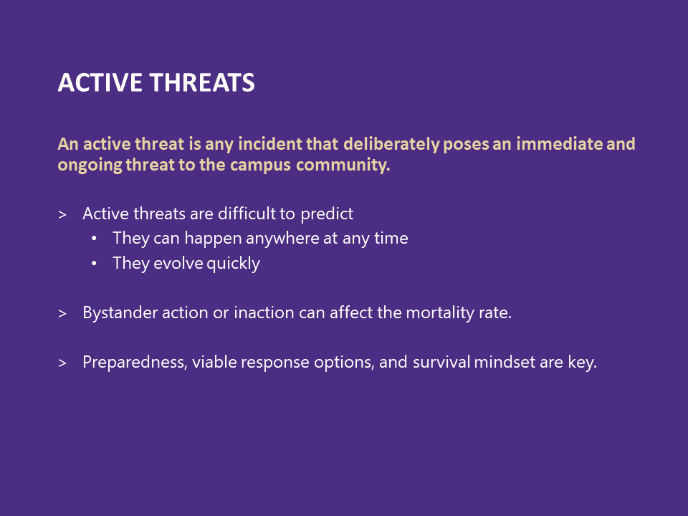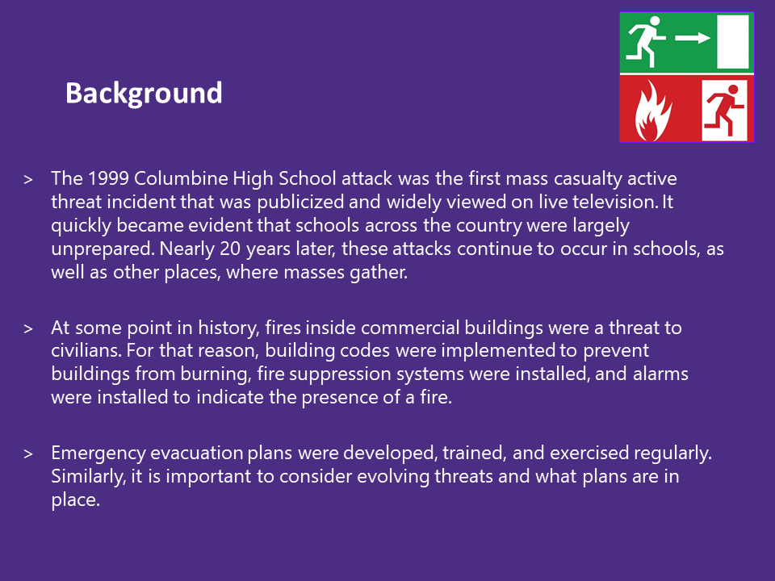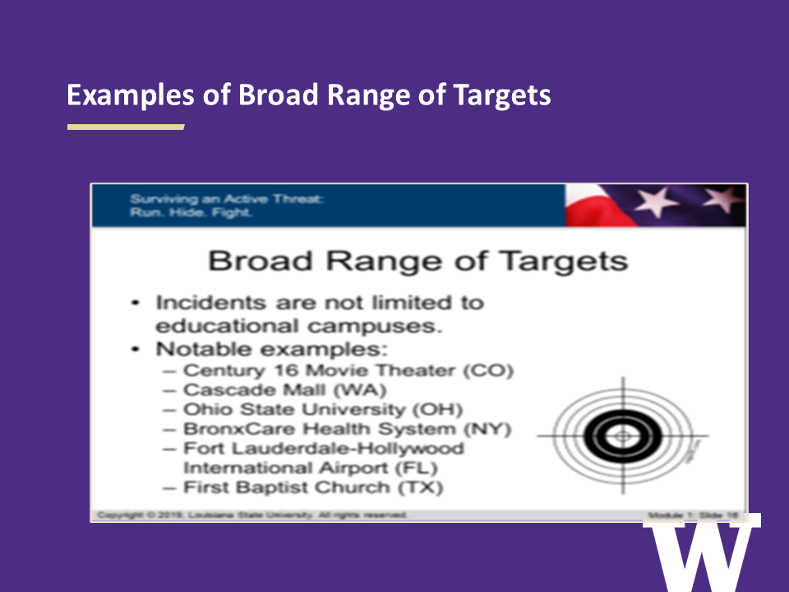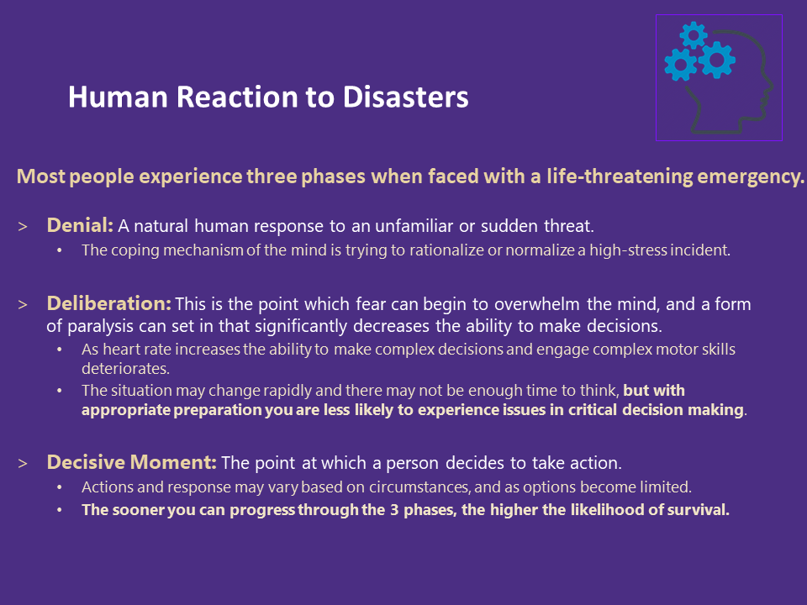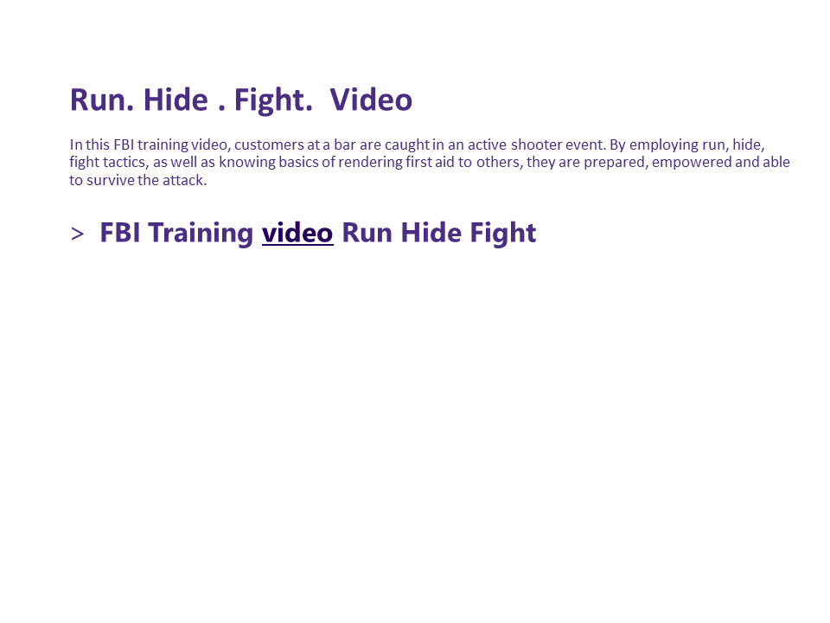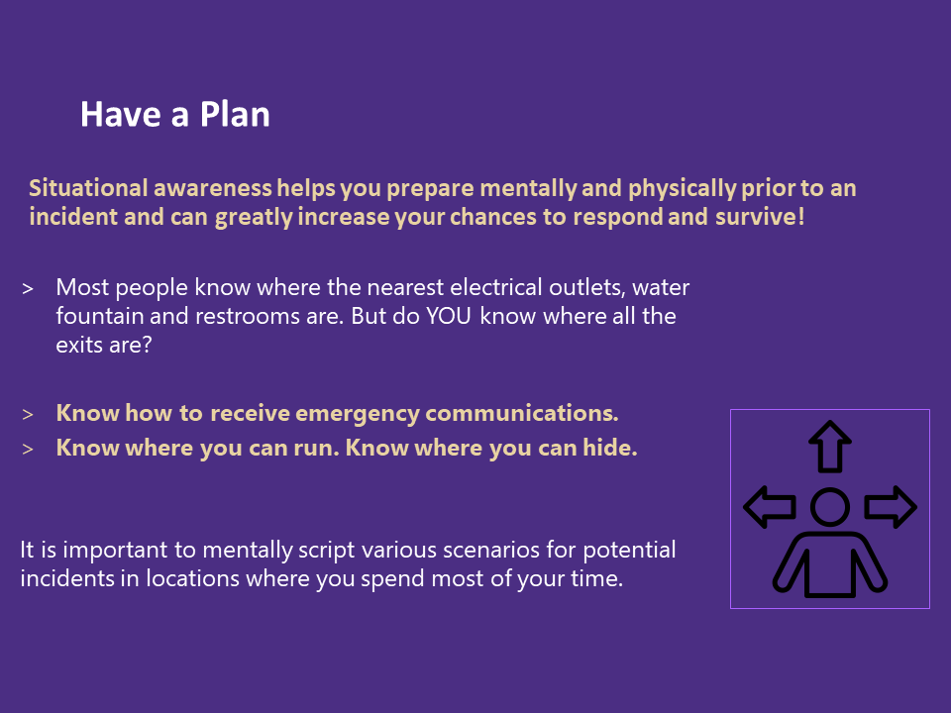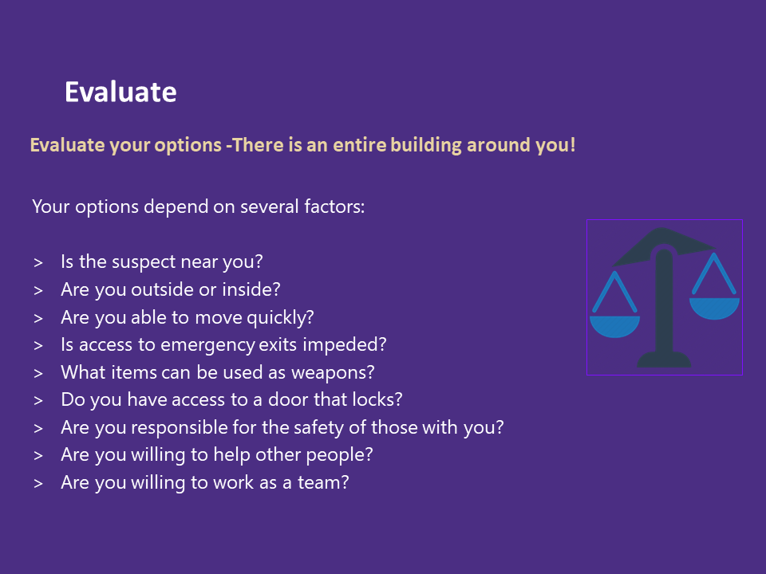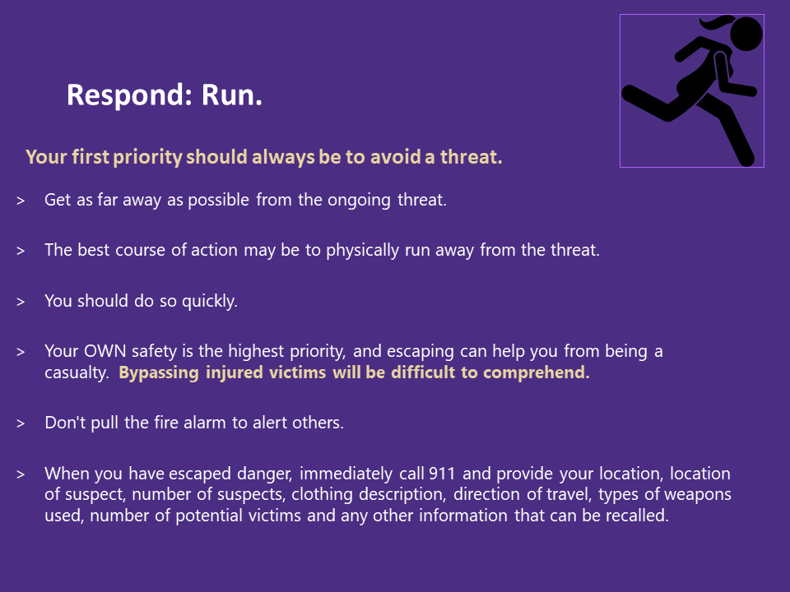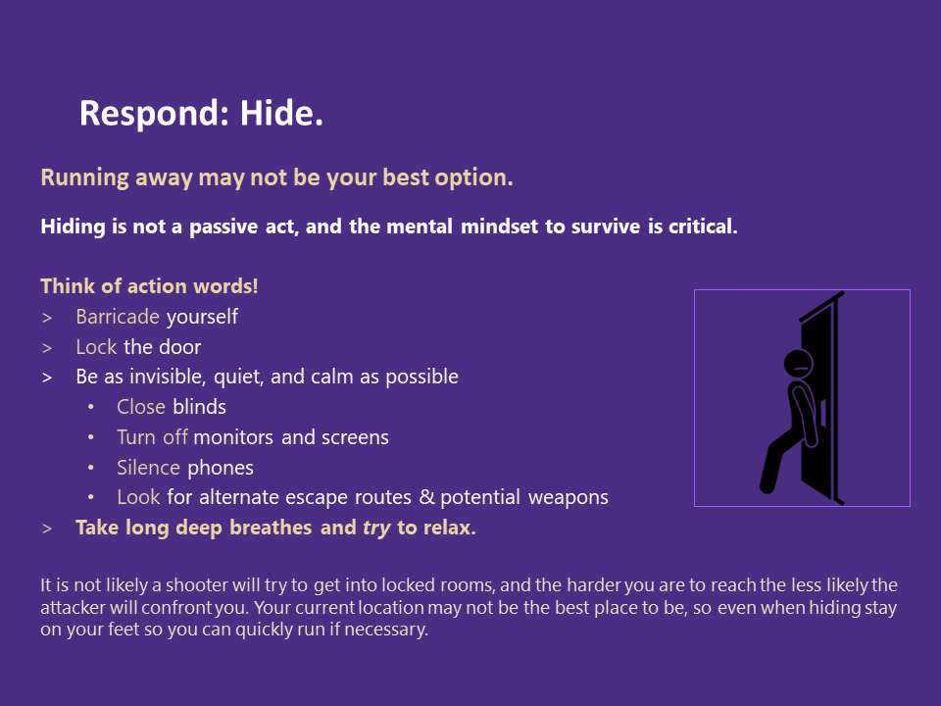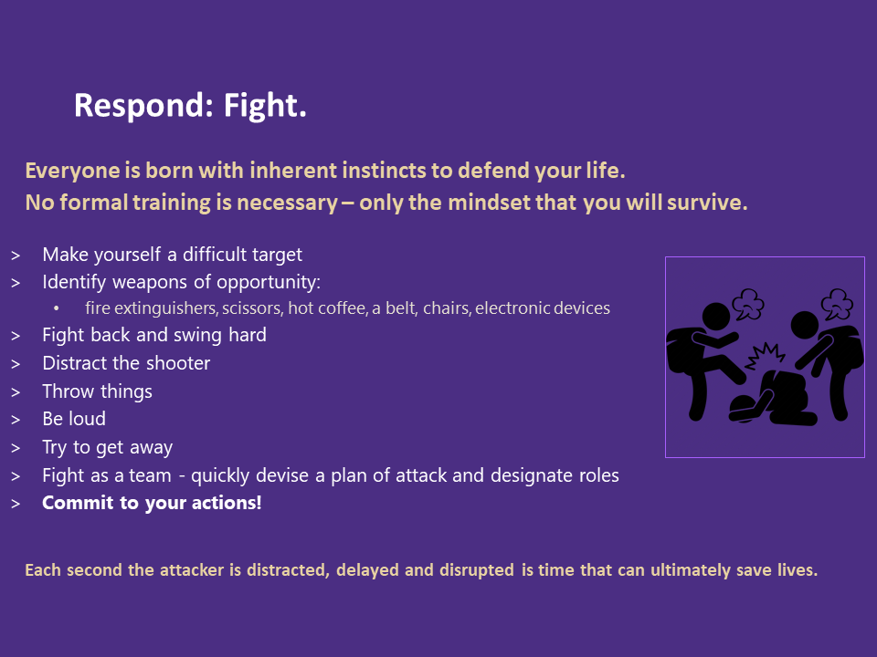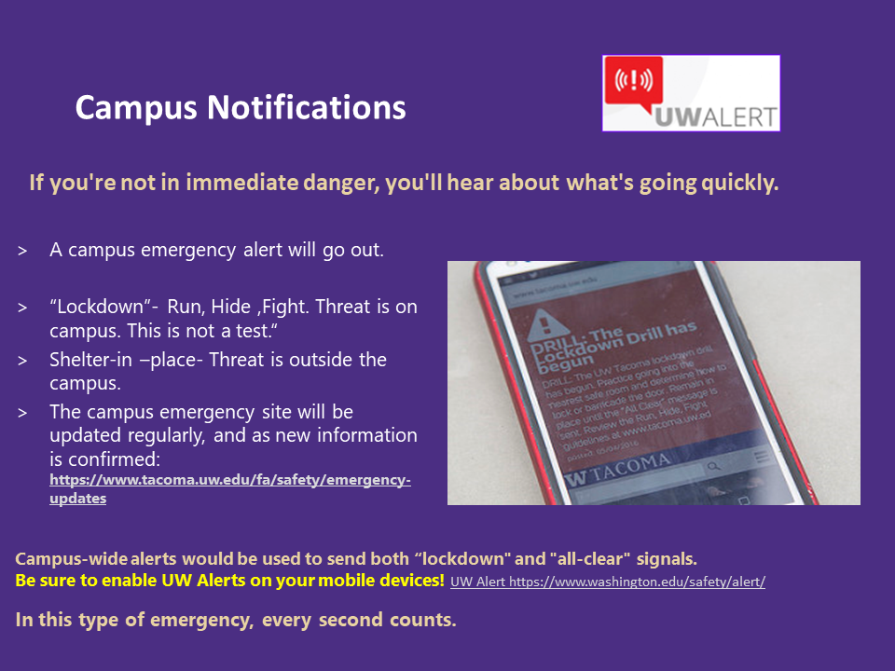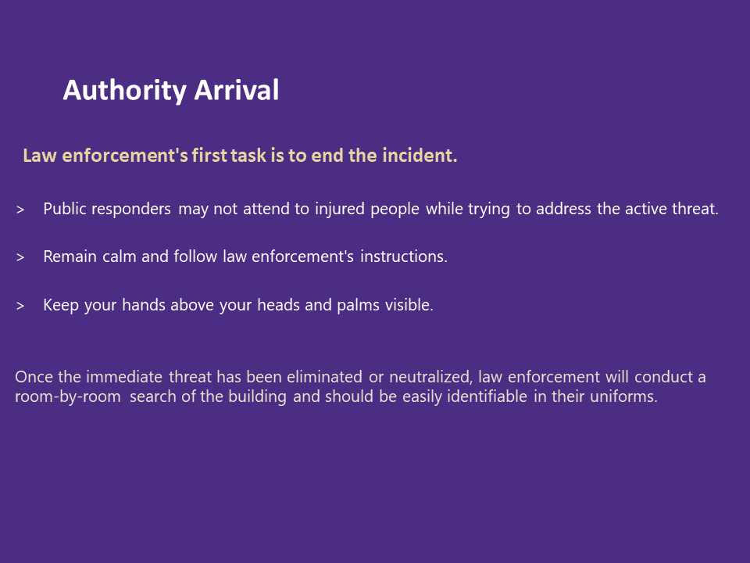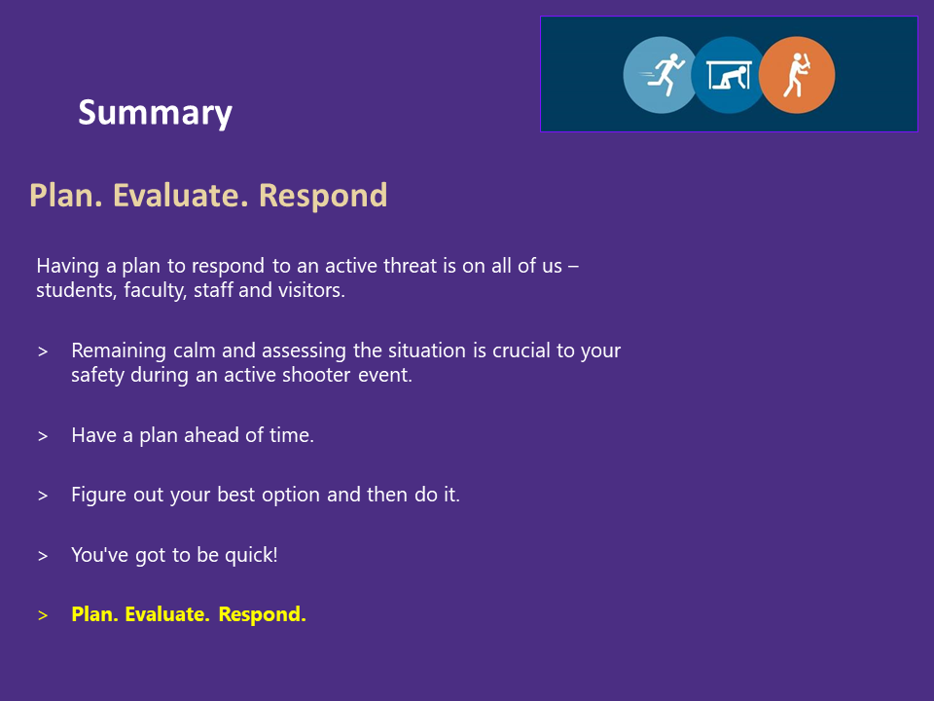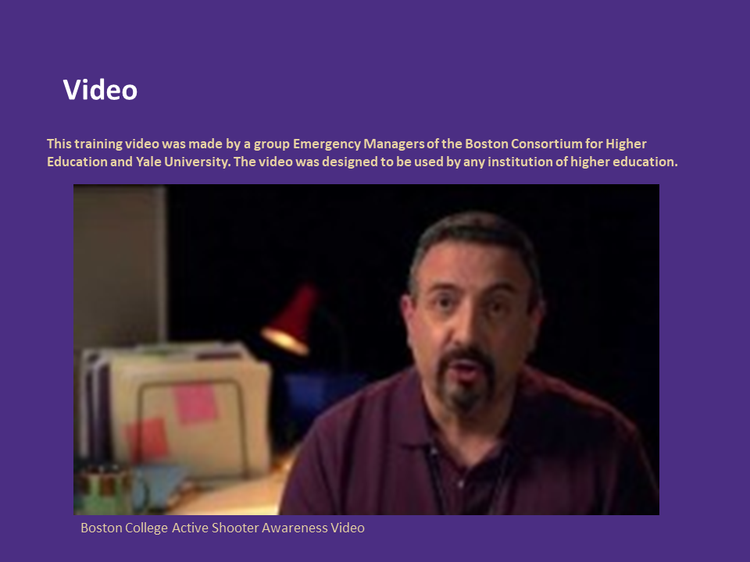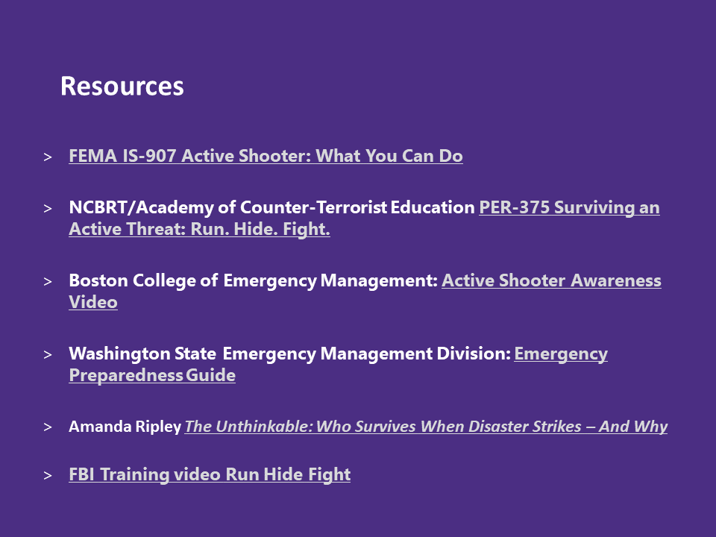

Appendix B: Safety Briefing UW Tacoma meeting and events

Safety Briefing
At UW Tacoma we take safety seriously. At the beginning of meetings or events, a safety briefing should be conducted to acquaint all attendees with their current location and ensure everyone knows how to respond in case of an emergency. You may tailor this script to your audience. If you have any questions, contact Susan Wagshul-Golden, Director of Campus Safety 253-692-4425 or swg5@uw.edu

You are currently located in Building _____Room_____

If you have a cell phone, call 911 for fire or police and 253-692-4416 for campus security. If there is a campus phone in hallway or office, point out the phone location and advise dialing 911 for fire or police and #333 for campus security.

In the event of an emergency, please exit out_____ and _____doors. Once outside, proceed to _____, the gathering location for this building.

In case of an earthquake, get under a table or other stable object, cover your head and hold until you receive an all clear. At that point, proceed outside to the gathering location for this building mentioned above.

In case of a small fire, extinguishers are located ___________. A first aid kit is located __________.

In case of a medical emergency, call 911 operator and give details to the dispatcher. The nearest AED kit is located_____________.

In event of an active threat situation, escape if you feel it is safe to do so. When you are safe call or text 911. If not, stay in place (securing doors, closing windows and blinds, turning off lights, computers, silence mobile phones and barricading if possible) until an all-clear is received from law enforcement, fire/rescue or campus security.

Resources:

UW Alert Signup:
http://www.uw.edu/safety/alert/
Violence Prevention and Response virtual training sign up:
https://www.washington.edu/safecampus/training-options/
UW Tacoma Campus Safety & Security emergency procedures guide:
https://www.tacoma.uw.edu/fa/safety/are-you-ready-resource-guide
Stop the Bleed Training classes:
https://www.stopthebleed.org/training/
Campus Evacuation Map: https://www.tacoma.uw.edu/fa/safety/emergency-evacuation

Appendix C: Presentation of Dr. Cheryl Greengrove
