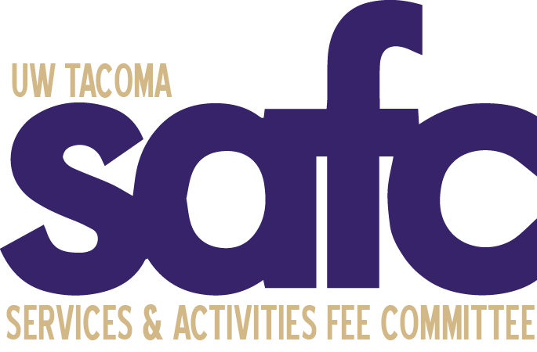

Services and Activities Fee Committee (SAFC)
Tuesday, March 14, 2023
4:00pm - 5:00pm
University Y 307
Zoom | Dial in: Dial in: (253) 215-8782, Meeting ID: 952 2161 9879

AGENDA 12

- Call to Order

- Land Acknowledgment

- Roll Call & Guest Introductions

- Approval of Agenda

- Approval of Minutes

- Open Public Forum

- Old Business

- New Business

- Announcements

- Adjournment

