Faculty Assembly Executive Council (EC)
Meeting Minutes
Friday, 04/07/2023, 1:00 p.m. – 3:00 p.m.
GWP 320/ Zoom

Present: Chair Menaka Abraham, Vice Chair Huatong Sun, APCC Chair Julie Masura, Kathy Beaudoin, Monika Sobolewska, Zhiquan (Andy) Shu, Barb Toews, Andrea Hill, Robin Evans-Agnew, Rupinder Jindal, Anne Taufen, Mary Hanneman, Julia Eaton, Jenny Xiao, Margaret Griesse, Ruben Casas, Erika Bailey, Jim West Excused: FAC Chair Sharon Laing, APT Chair Jim Thatcher, Alex Miller Absent: Jai’Shon Berry Program Coordinator: Andrew Seibert

- Land Acknowledgement, Consent to Agenda, Meeting Minutes, Permission to Record, Approval of Meeting Minutes from 3/27:
The meeting was called to order at 1:00pm. Permission to record the meeting was granted for minutes purposes. There were a few minor typos in section 2 of the March 27th minutes that were corrected. The minutes were approved with the edits.
- Announcements:
  - Faculty Assembly Vice Chair Nominations:
    - Two nominees have accepted the nomination to run for Vice Chair. We will send another notice to all faculty for nominations.
  - Provost’s future of Teaching & Learning:
    - A meeting request has been sent out to the faculty at-large regarding the future of teaching and learning. UW Tacoma representation consists of Darcy Janzen, Libi Sundermann, and Lisa Hoffman. This session will be on April 26, 2023, from 12:30 to 1:20 on Zoom.
  - Class B Legislation: Curriculum Governance:
    - The Chair of Faculty Assembly is still taking feedback on this Class B Legislation. Some current feedback that was made was concerns involving faculty workload. This will be sent to the Senate Executive Committee on May 1st. This was widely circulated through Tri-campus committees, and UW Bothell’s and Tacoma’s Curriculum Committees.
  - Spring Quarter/Faculty Assembly Luncheon:
    - The Chair and Vice Chair met with the Program Coordinator and have decided to cancel the Spring Quarter all faculty meeting. The Faculty Assembly will hold an appreciation lunch at the June 2nd meeting for members of the standing and adhoc committees.
  - School level Hybrid/Distance Learning policy drafts:
    - The Executive Council has been tasked to provide the draft or finalized policies from their schools at the April 24th meeting.
  - Other announcements:
    - Dr. Fred Nafukho, Vice Provost for Academic Personnel is still accepting feedback on the Appointment, Promotion, and Tenure processes. The chair has said that the feedback can be brought back as an EC action item to collect from all units.
    - Reminder:
      - The Executive Council Meeting falls under Open Public Meeting Act (OPMA) as it serves as the decision-making body, and conversations over emails could potentially break the Open Public Meeting Act. Please be mindful when sending emails through the listserv.
- Draft Resolution to Address the Safety and Security of instruction and faculty:
- No action was taken on this draft resolution, as some faculty were not ready to vote. The chair recommends adding any language within the document to vote to approve during the April 24th meeting.
  - This is a resolution request which was made at the last EC meeting over some student threats to faculty. This draft is expected to be finalized at the next meeting.
- Some recommendations:
  - Specific requests in resolution:
    - Address culture and climate of UW Tacoma.
    - Have financial renovation requests later in the resolution.
  - Suggestions for future drill communications:
    - Include language on how to help disabled faculty, staff, and students.
    - State clearly whether the drill is optional or mandatory.
    - Request to have additional psychological services available for students during and after the drill (Whether it is a drill or not).
    - Have a standardized message or template to share with the students for the drills.
  - Address the instruction spaces where locking or securing the location may not be possible.
    - Examples given: Glass spaces in MDS, TPS.
- Draft Academic Plan (See Appendix A)
- The Executive Council reviewed the second draft of the Academic Plan and discussed the document changes, and the draft can be found in the appendix.
  - The chair is looking for two faculty members, a data fellow and a non-data fellow from each school.
  - EC members raised concern about how to balance between the data and campus visions during the academic planning process.
  - The chair requested to gather feedback from the units. This will be voted on at the May 8th meeting.
- Best Practices Document Proposal
  - The Vice Chair of Faculty Assembly raised a question regarding best practices for chair and vice chair. The Executive Council asked the Vice Chair to create a draft of this, so they could better understand the request.
- Adjournment
- The meeting was adjourned at 2:40p.m.
  - Next meeting: April 24, 2023, 12:30 to 1:20. GWP 320.

Appendix A: Draft Academic Plan
Academic Planning Policy Draft (Version 2)
Revised March 30th 2023

Strategic Plan Statement for Academic Plan: “A roadmap of the academic programs and courses we need to meet our community’s and students’ needs and to grow our programs to an enrollment of 10,000 students”
Vision: We will align our academic plan with global needs and ongoing development in the Puget Sound area and beyond by clarifying campus strengths, student needs, community conditions, and regional opportunities. We aim to be transparent, collaborative, value-driven, and nimble as we embark on academic planning and consult with faculty and campus stakeholders to grow sustainably and efficiently. We see our current budget constraints and enrollment challenges as an opportunity to reinvigorate our academic programs to continue to position us as a leader of higher education.
Goals:
- Shared definition of current regional development needs and global conditions, to originate new program proposals and identify priorities for investment and implementation, based on empirical research and supported by policy process and resource allocation models.
- A streamlined Planning Notice of Intent (PNOI or program creation template) and process flowchart and recommendations for tracking proposals
- An assessment of the current state of data for planning and what the future state needs to be for data in order to become information for invigorating our programs. This includes new tools to streamline data collection
- Shared criteria to identify and prioritize relationships between programs on campuses, with proximity to external partners to invigorate programs and support sustainability of full range of offerings
- Provide a unit/school level directive to guide the program invigoration process with clear deadlines and process
- Coordinate with campus planning groups for alignment with strategic planning, student success initiative, strategic enrollment planning, and campus climate implementation
Taskforce Work Timeline for Academic Plan:
Autumn 2022: Present previous academic plan and feedback at Fall retreat, Academic Plan Taskforce Formation, Review and analyze documents from previous academic plan, explore what data is possible to inform our decisions, brainstorm approaches to the creation of the new academic plan, universal framework proposal
Winter 2023: Questionnaire for invigorating programs, explore the opportunities for internal and external data, Brainstorm the use of universal framework and integration with the academic plan, timeline for implementation of Academic plan, Draft academic plan presentation and brainstorming session for all faculty
Winter/Spring 2023: Listening sessions for process, budget, and flow documents for interested faculty/deans/curriculum coordinators/APCC members, incorporate feedback from brainstorming session and listening sessions held for academic plan, provide draft to Executive council for approval, provide data requests to external firm in preparation for new program growth
Winter 2023-Spring 2023: Process document review and revisions by office of Academic Affairs and APCC:
- Review process documentation for undergraduate programs including process flowchart, process steps, stakeholder list, stakeholder feedback form, Planning Notice of Intent (PNOI) form, and full proposal guidelines. Consider how the process may be streamlined and refined to increase efficiency, clarify roles within the process, and highlight when decisions are being made and by whom.
- For graduate proposals, check with the Graduate School’s Office of Academic Affairs and Planning regarding graduate program and certificate flowcharts to see where revisions may be allowable within their process. Draft revisions in conjunction with the Graduate School.
- Share proposed draft process documents with various campus stakeholders including deans, school directors of operations, academic support staff, and curriculum coordinators. Provide the opportunity for feedback via listening sessions with the campus groups. (Note: some parts of the processes are controlled by the UW Curriculum Office or the Graduate School. These will be noted accordingly on the flowcharts as items that cannot be revised.)
- Taking into consideration feedback received, revise documents as needed.

Academic Plan Timeline:
The Academic Plan Cycle will be 3 years where new proposals can be submitted only in the Winter quarter of each year.
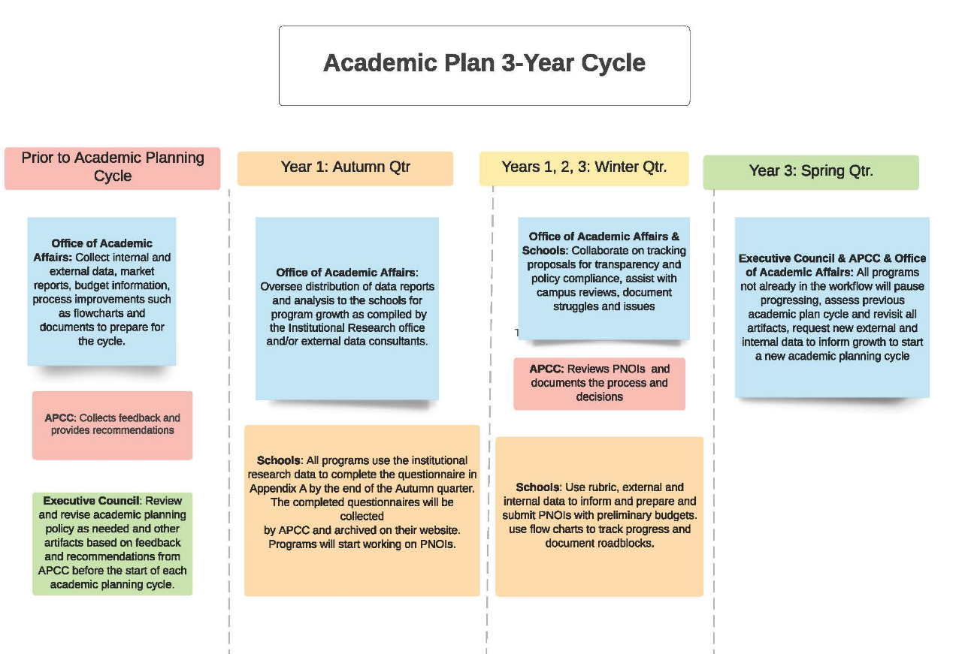

Prior to the Academic Planning Cycle:
Office of Academic Affairs: Collect internal and external data, market reports, budget information, process improvements such as flowcharts and documents to prepare for the cycle.
APCC: Collects feedback and provides recommendations.
Executive Council: Review and revise academic planning policy as needed and other artifacts based on feedback and recommendations from APCC before the start of each academic planning cycle. The appendices can be modified with a Class C resolution.
Autumn of Year 1:
Schools: All programs use the institutional research data to complete the questionnaire in Appendix A by the end of the Autumn quarter. The completed questionnaires will be collected by APCC and archived on their website. Programs will start working on PNOIs.
Office of Academic Affairs: Oversee distribution of data reports and analysis to the schools for program growth as compiled by the Institutional Research office and/or external data consultants.
Winter of Years 1, 2, 3:
We envision that the program invigoration questionnaire and internal/external data will result in innovative ideas and solutions to propose changes or new programs that align with the academic plan framework proposed in Appendix B to support our strategic plan and campus climate implementation.
Schools: Use rubric, external and internal data to inform and prepare and submit PNOIs with preliminary budgets. use flow charts to track progress and document roadblocks.
APCC: Reviews PNOIs and documents the process and decisions.
Office of Academic Affairs & Schools: Collaborate on tracking proposals for transparency and policy compliance, assist with campus reviews, document struggles and issues.
Spring of Year 3:
Executive Council & APCC & Office of Academic Affairs: All programs not already in the workflow will pause progressing, assess previous academic plan cycle and revisit all artifacts, request new external and internal data to inform growth to start a new academic planning cycle.
Appendix A: UW Tacoma Questionnaire for Invigorating Academics (Revised March 2023)
* Required
As a campus, we will take this opportunity to examine our programs and use the data provided by Institutional research to make curricular or strategic decisions to invigorate each program within our schools. The goal is to reflect collectively on what is working well, what can be improved, and what can we learn from each other to move forward on our strategic plan. The deadline to complete this questionnaire is the end of autumn quarter of the academic planning cycle year 1.
Please engage as many faculty and staff members as possible when completing this questionnaire to get multiple inputs and viewpoints to invigorate our curriculum. There are questions for information sharing across campus to learn from each other.
Please complete one questionnaire for each program or CIP Code.
Degree Program: *
School or Program: *
Contact Person: *
Contact E-mail: *
Internal and Community Demand
- How do you engage with community partners?
- How do you communicate about your major to potential students, including how they will find belonging and post-graduation opportunities?
- How do you interact or interface with community technical colleges (CTCs) or high schools within your program?
Program Quality
Prior to answering these questions, please examine the data provided for your program. 7-year enrollment in the program, courses, student demographics, course modalities, etc.
- How is your program accredited? Which accreditation body(bodies) is(are) used? Are there accreditation requirements that influence program decisions?
- Are there multiple options or tracks or pathways in the program? Do all options, tracks, or pathways support adequate enrollment? Are the pathways clear and transparent to students?
- Is (Are) there (a) minor(s) for this program? Are there opportunities to create a new minor?
- Are there hybrid and online options currently available for your program or courses in the program? What is the rationale for these options?
- Given the student demographics, describe the opportunities for invigorating the quality of the program with respect to this (revisit any areas in the program)?
- Given the data for course level enrollment, are there opportunities to optimize the offerings?
- How do you assess whether students are meeting the learning objectives of your program? How do you track graduates and their post-graduation pathways? Do you adapt your program as a result of your assessment process?
- Are course caps appropriate to the goals of the curriculum? Are there places they could be bigger or smaller? Are classes filling? Are students able to take required classes in a timely way to move towards graduation?
- Does your curriculum support students in general education, such as through offering Area of Inquiry, writing, or diversity courses? Does your curriculum support students beyond your major, or pre-major students?
Human, Physical and Technical Resources
Prior to answering these questions, please examine the data provided for your program. 7-year faculty and staff, lab, technical resources allocated to your program, etc.
- Given the data provided, are there opportunities to reassess the resources available? Are there resource needs that aren’t met? Is there an opportunity to collaborate with other programs to optimize the resources available?
- How is marketing and recruiting done?
Future Potential for the Program
- What are some opportunities for future potential? Are there opportunities for attracting working professionals or providing professional development?
- Could the program benefit from a minor offering or restructuring of the options, certificates, or pathways?
- Could the program benefit from an online option?
Student Enrollment, Retention and Engagement
- What are some enrollment strategies or plans used? Do you have staffing support for enrollment?
- What are your student retention and support mechanisms for your program?
- How do students receive assistance with their academics (i.e., tutoring, mentoring, advising)? How are the academic services such as Academic advising, libraries, Teaching & learning Center, Technology support utilized to support academic success??
- Are there any Registered Student Organizations (RSOs) associated with this program or school? How active are these RSOs? What support is given to these organizations?
- What High Impact Practices, such as independent research, global learning, community engaged learning, learning communities, and internships, do you support for students in your majors? (For more information about HIPs, see: https://www.aacu.org/trending-topics/high-impact). How do you ensure that access to HIPs is equitable in your program?
- Do you offer Study abroad programs?
- How are internships managed or how do students find internships? Are internships scaffolded throughout your curriculum? If yes, explain.
Faculty and Staff Recruitment and Retention
- What is your plan to recruit and retain BIPOC faculty and staff?
- What is your program's support and retention plan?
School or Division Level
- How would you describe the culture of your School or Division?
- Do you collaborate with other programs in school or division?
- Are there opportunities for collaboration or sharing of resources (optional)
Interdisciplinary Exploration
- Do you collaborate with other programs in other schools?
- Are there opportunities for collaboration or sharing of resources (optional)?

Appendix B: 3-STEP ALIGNMENT FRAMEWORK ¹

STEP ONE: Establish and define shared UWT goal.
GOAL: UW Campus Expansion Aligned with Urban-Serving Mission²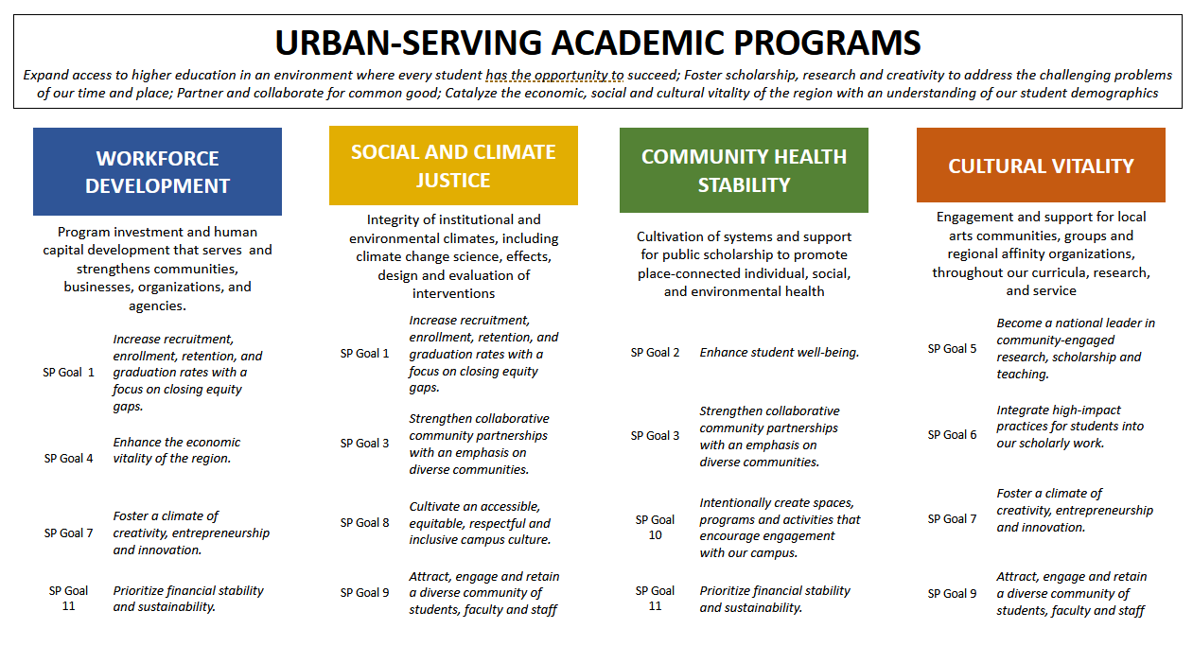

STEP TWO: Assess performance relative to shared goal.

MEASURE AND EVALUTE: Apply campus strategic plan metrics at the campus level (aggregated) and at the unit level (disaggregated) to assess goal performance and identify gaps.

- WORKFORCE DEVELOPMENT - Serve residents, households, businesses, and communities with human capital investment through UWT programs.
- Increase recruitment, enrollment, retention, and graduation rates with a focus on closing equity gaps (GOAL 1)
- Enhance the economic vitality of the region (GOAL 4)
- Foster a climate of creativity, entrepreneurship, and innovation (GOAL 7)

- SOCIAL AND CLIMATE JUSTICE: Integrity of institutional and environmental climates, including safety, non-discrimination, and equal protection; as well as climate change science, effects, design, and evaluation of interventions.
- Increase recruitment, enrollment, retention, and graduation rates with a focus on closing equity gaps (GOAL 1)
- Strengthen collaborative community partnerships with an emphasis on diverse communities (GOAL 3)
- Cultivate an accessible, equitable, respectful, and inclusive campus culture (GOAL 8)
- Attract, engage, and retain a diverse community of students, faculty, and staff (GOAL 9)

- COMMUNITY HEALTH STABILITY: Cultivation of systems and support for public scholarship to promote place-connected individual, social, and environmental health.
- Enhance student well-being. (GOAL 2)
- Strengthen collaborative community partnerships with an emphasis on diverse communities. (GOAL 3)
- Intentionally create spaces, programs and activities that encourage engagement with our campus. (GOAL 10)

- CULTURAL VITALITY: Engagement across the region, support for cultures of learning, local arts communities, and investment in local community groups and regional affinity organizations throughout our curricula, research, and service.
- Become a national leader in community-engaged research, scholarship, and teaching. (GOAL 5)
- Integrate high-impact practices for students into our scholarly work (GOAL 6)
- Foster a climate of creativity, entrepreneurship, and innovation (GOAL 7)
- Attract, engage, and retain a diverse community of students, faculty, and staff (GOAL 9)

STEP THREE: Design interventions to further shared goal
ENGAGE AND PROGRESS: Where gaps exist, how may they be engaged and addressed? (e.g., budget tools)
- IDENTIFY STRUCTURES: Recognize mechanisms that support or impede units relative to the shared goal.

- IMPLEMENT STRATEGIES: Develop mechanisms to progress the shared goal.
^{[1]} [1] One framework to guide equity-based policy and decision-making, developed by john a. powell and policy leaders at the Haas Institute at UC Berkeley, is Targeted Universalism: https://belonging.berkeley.edu/targeted-universalism Other frameworks follow similar tenets, where shared values and identified goals, organize the collection and analysis of data
^{[1]} See: Vision, Mission, Values and Strategic Priorities of UW Tacoma, University of Washington Tacoma Strategic Plan, 2022-2027, (p. 6), University of Washington Tacoma Strategic Plan, 2022-2027.

