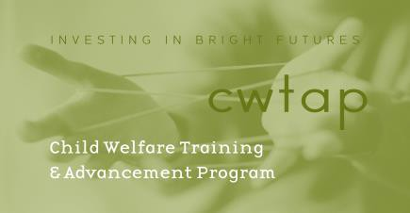

Mandated Reporting Expectations

I understand the Child Welfare Training and Advancement Program (CWTAP) is intended for those who are seeking an MSW with a focus on working with children, youth and families served within the Washington State public child welfare system.

Under RCW 26.44.030, the state statute regarding mandated reporting laws, students are not considered mandated reporters in their capacity as students. However, as a MSW student I understand I must comply with the following additional requirements:

- I understand as a student within the MSW program that during my practicum at the Department of Children, Youth and Families (DCYF) I am obligated to report suspected child abuse or neglect to my Agency Field Instructor (AFI) or Faculty Field Instructor (FFI) (EWU), or Field Instructor (FI) (UW/UWT).

- If I am a mandated reporter because of some other role I have, such as a social worker, teacher or medical professional, then I will report suspected child abuse or neglect pursuant to the requirements that apply to those roles.

- As a CWTAP DCYF employee student, I must follow the mandated reporting rules of DCYF.

- In my role as a non DCYF employee student, any suspected child abuse or neglect must be reported immediately to my AFI or FFI (EWU), or FI (UW/UWT). The AFI, FFI or FI may have me make a call to intake under their supervision as a learning activity of the practicum. If my AFI, FFI, or FI are not available I will immediately bring it to the unit supervisor, or another supervisor or manager in my office.

I understand and agree to abide by the expectations as set forth above.

Applicant Signature Date

Mandated Reporting Expectations Revised 6/6/2019

