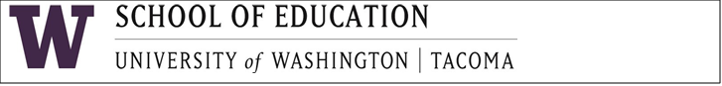
UWT Project TELL EQUITY Grant
Family Project: Videotape an Interview with a ML Community Member

The University of Washington-Tacoma invites your participation in the Family Project—Videotape an Interview with a ML Community Member. This project is part of the UWT Project TELL-EQUITY Grant in partnership with Federal Way School District, Puyallup School District, and Warden School District. The project’s purpose is to increase public awareness about the benefits of fluency in more than one language as well as to show the coordination of language development between home and school.

Description of Project:
Project includes middle school students with the help of their parents interviewing a community member to discuss the positive life outcomes and societal impact of their rich linguistic capacity. The videos of these interviews will be posted on the Project TELL-EQUITY’s webpage allowing the public to view.

- Select a community member to be videotaped.
- Determine date/time/place.
- Prepare questions for the 10-15-minute interview. Possible questions may include:
  - Tell us a little bit about yourself such as your name, position, education.
  - Share with us your ethnic group/community you identify with.
  - Share an experience that launched you on your career path.
  - Where are you from?
  - What languages are you fluent in?
  - Tell us some of the benefits of being multilingual.
  - What was it like to attend school in your country versus in the U.S.?
  - What challenges did you face?
  - What were some of your hopes and dreams as a child?
  - Who inspires you? Who do you admire? Why?
  - What advice do you have for others, like me, who have a similar cultural background?
  - Is there anything else you would like to share?
- Suggested tools/device for videotaping are: Smart phone with camera app for video recording and a tripod
- Upon completion of this project, submit your videotape to grant coordinator, Karlyn Davis-Welton.

