Faculty Assembly Executive Council (EC)
Meeting Minutes
Monday, 05/8/2023, 12:30 p.m. – 1:20 p.m.
GWP 320/ Zoom

Present: Chair Menaka Abraham, Vice Chair Huatong Sun, APCC Chair Julie Masura, APT Chair Jim Thatcher, FAC Chair Sharon Laing, EVCAA Andy Harris, Kathy Beaudoin, Monika Sobolewska, Jim West, Zhiquan (Andy) Shu, Barb Toews, Andrea Hill, Robin Evans-Agnew, Anne Taufen, Mary Hanneman, Julia Eaton, Jenny Xiao, Alex Miller, Ruben Casas, Erika Bailey. Excused: Rupinder Jindal, Margaret Griesse Guests: Sarah Davies Breen (Academic HR). Program Coordinator: Andrew Seibert

- Land Acknowledgement, Consent to Agenda, Meeting Minutes, Permission to Record, Approval of Meeting Minutes from 04/24/2023
The meeting was called to order at 12:30 p.m. Agenda was consented as- presented. Permission to record the meeting was granted for minutes purposes only. The meeting minutes from April 24th were reviewed and approved as written.
- Announcements
- The vote for the Faculty Resolution on the Safety and Security of Instruction and Faculty on the Tacoma Campus is open and closes tomorrow, May 9, 2023.
- An email from Faculty Senate was distributed regarding a faculty liaison position from Tacoma campus. The chair asked representatives to nominate or self-nominate to advocate for faculty on Tacoma campus.
- There is currently one nomination for Vice Chair of Faculty Assembly and waiting for confirmation from the faculty member.
- There is still time to RSVP for the June 2nd Faculty Assembly Appreciation Luncheon. If you have not done so, please see the email and meeting request that was sent out by the Faculty Assembly Program Coordinator.
- The first of the four APT Workshops will be held this week. Please see emails from Chair of APT if you are interested in attending. These workshops will be recorded and will be posted on the Appointment, Promotion, and Tenure Committee website.
- Reminder: Please send Hybrid/DL policies to the APCC Chair, and Faculty Assembly Chair and Vice Chair and copy the Program Coordinator to finalize for the next Academic year.
- The Vice Chair of Faculty Assembly notified the Executive Council on a discussion happening in Faculty Council on Tri-Campus Policy around course evaluations on all three campuses. Please see the following URL for the Office of Educational Assessment for the resource that was provided around FAQs for course evaluations (https://www.washington.edu/assessment/course-evaluations/course-eval-faq/ . The Vice Chair is soliciting feedback to submit to FCTCP next week.
- The Faculty Affairs Committee Chair met with the EVCAA and Director of Faculty Affairs and Academic HR on April 10, and came up with a self-assessment tool for Faculty workload. These criteria were outlined and will be reviewed by Academic HR. Afterwards, Faculty Council and deans will be contacted to distribute the self-assessment tool for Faculty to complete. Upon completion, Schools will obtain concrete data on where they are in terms of needed support, or where restructuring might be needed.
- Academic Planning Policy: Discussion and Vote
- The chair presented the final draft of the Academic Planning Policy and thanked the Academic Planning taskforce for their work. For the most up to date version, please see appendix for final planning policy.
  - A motion was made to approve the Academic Planning document. So moved by Robin Evans-Agnew and seconded by Julie Masura.
    - Discussion
      - A faculty member expressed concern about moving to a 3-year academic plan versus the 5-year plan implemented in 2018.
      - EC members appreciated the inclusivity of the faculty at-large on the Tacoma campus for this Academic planning policy document.
    - Vote: 18 yes, 0 no, 0 abstentions
- Adjournment
- The meeting was adjourned at 1:20p.m.
  - Next meeting: TBD, GWP 320.

Appendix A: Academic Planning Policy

Academic Planning Policy
Approved By Executive Council of Faculty Assembly on May 8th 2023
University of Washington Tacoma

2022-2027 Strategic Plan Statement for Academic Plan: “A roadmap of the academic programs and courses we need to meet our community’s and students’ needs and to grow our programs to an enrollment of 10,000 students” [1]

Purpose: We will align our academic plan with global needs and ongoing development in the Puget Sound area and beyond by clarifying campus strengths, student needs, community conditions, and regional opportunities. We aim to be transparent, collaborative, value-driven, and nimble as we embark on academic planning and consult with faculty and campus stakeholders to grow sustainably and efficiently. We see our current budget constraints and enrollment challenges as an opportunity to reinvigorate our academic programs to continue to position us as a leader of higher education.

Goals:
- Shared definition of current regional development needs and global conditions, to originate new program proposals and identify priorities for investment and implementation, based on empirical research and supported by policy process and resource allocation models.
- A streamlined Planning Notice of Intent (PNOI or program creation template) and process flowchart and recommendations for tracking proposals
- An assessment of the current state of data for planning and what the future state needs to be for data in order to become information for invigorating our programs. This includes new tools to streamline data collection
- Shared criteria to identify and prioritize relationships between programs on campuses, with proximity to external partners to invigorate programs and support sustainability of full range of offerings
- Provide a unit/school level guidance to guide the program invigoration process with clear deadlines
- Coordinate with campus planning groups for alignment with strategic planning, student success initiative, strategic enrollment planning, and campus climate implementation

1 https://www.tacoma.uw.edu/chancellor/strategic-planning

Taskforce Work Timeline for Academic Plan:
Autumn 2022: Present previous academic plan and feedback at Fall retreat, Academic Plan Taskforce Formation, review and analyze documents from previous academic plan, explore what data is possible to inform our decisions, brainstorm approaches to the creation of the new academic plan, universal framework proposal
Winter 2023: Questionnaire for invigorating programs, explore the opportunities for internal and external data, brainstorm the use of universal framework and integration with the academic plan, timeline for implementation of Academic plan, draft academic plan presentation and brainstorming session for all faculty
Winter/Spring 2023: Listening sessions for process, budget, and flow documents for interested faculty/deans/curriculum coordinators/APCC members, incorporate feedback from brainstorming session and listening sessions held for academic plan, provide draft to Executive council for approval, provide data requests to external firm in preparation for new program growth
Winter 2023-Spring 2023: Process document review and revisions by office of Academic Affairs and APCC:
- Review process documentation for undergraduate programs including process flowchart, process steps, stakeholder list, stakeholder feedback form, Planning Notice of Intent (PNOI) form, and full proposal guidelines. Consider how the process may be streamlined and refined to increase efficiency, clarify roles within the process, and highlight when decisions are being made and by whom.
- For graduate proposals, check with the Graduate School’s Office of Academic Affairs and Planning regarding graduate program and certificate flowcharts to see where revisions may be allowable within their process. Draft revisions in conjunction with the Graduate School.
- Share proposed draft process documents with various campus stakeholders including deans, school directors of operations, academic support staff, and curriculum coordinators. Provide the opportunity for feedback via listening sessions with the campus groups. (Note: some parts of the processes are controlled by the UW Curriculum Office or the Graduate School. These will be noted accordingly on the flowcharts as items that cannot be revised.)
- Taking into consideration feedback received, revise documents as needed.

Academic Plan Timeline:
The Academic Plan Cycle will be 3 years, new proposals can be submitted only in the Winter quarter of
each year and the cycle will repeat every 3 years.
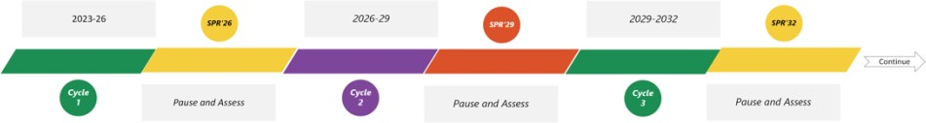

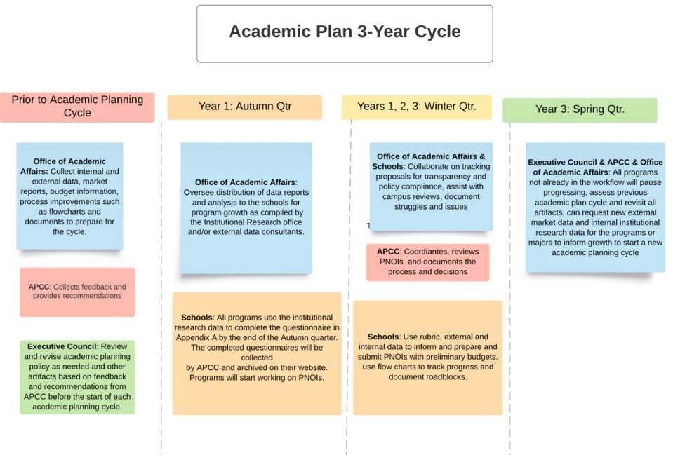

Prior to the Academic Planning Cycle:
Office of Academic Affairs: Collect internal and external data, market reports, budget information, process improvements such as flowcharts and documents to prepare for the cycle.
APCC: Collects feedback and provides recommendations.
Executive Council: Review and revise academic planning policy as needed and other artifacts based on feedback and recommendations from APCC before the start of each academic planning cycle. The appendices can be modified with a Class C resolution without revising the policy.

Autumn of Year 1:
Schools: All programs use the institutional research data to complete the questionnaire in Appendix A by the end of the Autumn quarter. The completed questionnaires will be collected by APCC and archived on their website. Programs will start working on PNOIs.

Office of Academic Affairs: Oversee distribution of data reports and analysis to the schools for program growth as compiled by the Institutional Research office and/or external data consultants.

Winter of Years 1, 2, 3:

We envision that the program invigoration questionnaire and internal/external data will result in innovative ideas and solutions to propose changes or new programs that align with the academic plan framework proposed in Appendix B to support our strategic plan and campus climate implementation.

Schools: Use rubric, external and internal data to inform and prepare and submit PNOIs with preliminary budgets. Use flow charts to track progress and document roadblocks.
APCC: Coordinates, reviews PNOIs and documents the process and decisions.

Office of Academic Affairs & Schools: Collaborate on tracking proposals for transparency and policy compliance, assist with campus reviews, document struggles and issues.

Spring of Year 3:

Executive Council & APCC & Office of Academic Affairs: All programs not already in the workflow will pause progressing, assess previous academic plan cycle and revisit all artifacts, can request new external market data and internal institutional research data for the programs or majors to inform growth to start a new academic planning cycle.

Appendix A: UW Tacoma Questionnaire for Invigorating Academic Programs (Revised April 2023)
* Required
As a campus, we will take this opportunity to examine our programs and use the data provided by Institutional research to make curricular or strategic decisions to invigorate each program within our schools. The goal is to reflect collectively on what is working well, what can be improved, where we may need to re/invest our limited resources, and what can we learn from each other to move forward on our strategic plan. The deadline to complete this questionnaire is the end of autumn quarter of the academic planning cycle year 1.
Please engage as many faculty and staff members as possible when completing this questionnaire to get multiple inputs and viewpoints to invigorate our curriculum. There are questions for information sharing across campus to learn from each other. Please indicate N/A if the question doesn’t apply to your program or major.

Please complete one questionnaire for each program or CIP Code.
Degree Program: * School or Program: * Contact Person: * Contact E-mail: *

Internal and Community Demand
- Do you engage with diverse community partners to determine demand and needs?
- Do you communicate about your major or program to current or potential students, including their needs, interests, and post-graduation opportunities?
- Do you interact or interface with community technical colleges (CTCs) or high schools within your program?

Program Quality

Prior to answering these questions, please examine the data provided for your program. 7-year enrollment in the program, courses, student demographics, course modalities, etc.
- Is your program accredited? Which accreditation body(bodies) is(are) used? Are there accreditation requirements that influence program decisions?
- Are there multiple options or tracks or pathways in the program? Do all options, tracks, or pathways support adequate enrollment? Are the pathways clear and transparent to students?
- Is (Are) there (a) minor(s) for this program? Are there opportunities to create a new minor?
- Are there hybrid and online options currently available for your program or courses in the program? What is the rationale for these options?
- Given the student demographics, describe the opportunities for invigorating the quality of the program with respect to this (revisit any areas in the program)?
- Given the data for course level enrollment, are there opportunities to optimize the offerings?
- Do you assess whether students are meeting the learning objectives of your program? Do you track graduates and their post-graduation pathways? Do you adapt your program as a result of your assessment process? Please explain.

- Are course caps appropriate to the goals of the curriculum? Are there places they could be bigger or smaller? Are classes filling? Are students able to take required classes in a timely manner to move towards graduation? Please explain.
- (Undergraduate programs or majors) Does your curriculum support students in undergraduate general education, in the areas of inquiry, writing, or diversity courses? Does your curriculum support students beyond your major, or pre-major students? Please explain.
- How does your program support students beyond graduation?

Human, Physical and Technical Resources
Prior to answering these questions, please examine the data provided for your program. 7-year faculty and staff, lab, technical resources allocated to your program, etc.
- Given the data provided, are there opportunities to reassess the resources available? Are there resource needs that aren’t met? Is there an opportunity to collaborate with other programs to optimize the resources available? Please explain.
- Is marketing and recruiting done? If yes, please provide information.

Future Potential for the Program
- What are some opportunities for future potential? Are there opportunities for attracting working professionals or providing professional development?
- Could the program benefit from a minor offering or restructuring of the options, certificates, or pathways? Please elaborate.
- Could the program benefit from an online option? Please elaborate.

Student Enrollment, Retention, Well-being, and Engagement
- What are some enrollment strategies or plans used? Do you believe you have adequate staffing support for enrollment?
- Are there any student retention, well-being, and support mechanisms for your program? Please explain.
- Do students receive assistance with their academics (i.e., tutoring, mentoring, advising)? How are the academic services such as Academic advising, libraries, Teaching & learning Center, Technology support utilized to support academic success??
- How are students engaged within the program or major? Are there any Registered Student Organizations (RSOs) associated with this program or school? How active are these RSOs? What support is given to these organizations?
- What High Impact Practices, such as independent research, global learning, community engaged learning, learning communities, and internships, do you support for students in your majors or programs? (For more information about HIPs, see: https://www.aacu.org/trending-topics/high- impact). How do you ensure that access to HIPs is equitable in your program?
- Do you offer Study abroad programs? Why do or don’t you offer these programs?
- If applicable, how are internships managed or how do students find internships? Are internships scaffolded throughout your curriculum? If yes, explain.

Faculty and Staff Recruitment and Retention
- What is your plan to recruit and retain diverse faculty and staff?
- What is your program's support and retention plan?

School or Division Level
- Describe the program or division or school’s climate. What is currently being done and what could be done to improve the climate?
- To what extent is scholarship supported within the program or division or school?
- Do you collaborate with other programs in school or division?

- Describe any opportunities for collaboration or sharing of resources.

Interdisciplinary Exploration
- How do you collaborate with other programs in other schools? Please comment on what resources and barriers exist for collaboration?
- Describe any opportunities for interdisciplinary collaboration or sharing of resources.

Appendix B: 3-STEP ALIGNMENT FRAMEWORK 1

STEP ONE: Establish and define shared UWT goal.
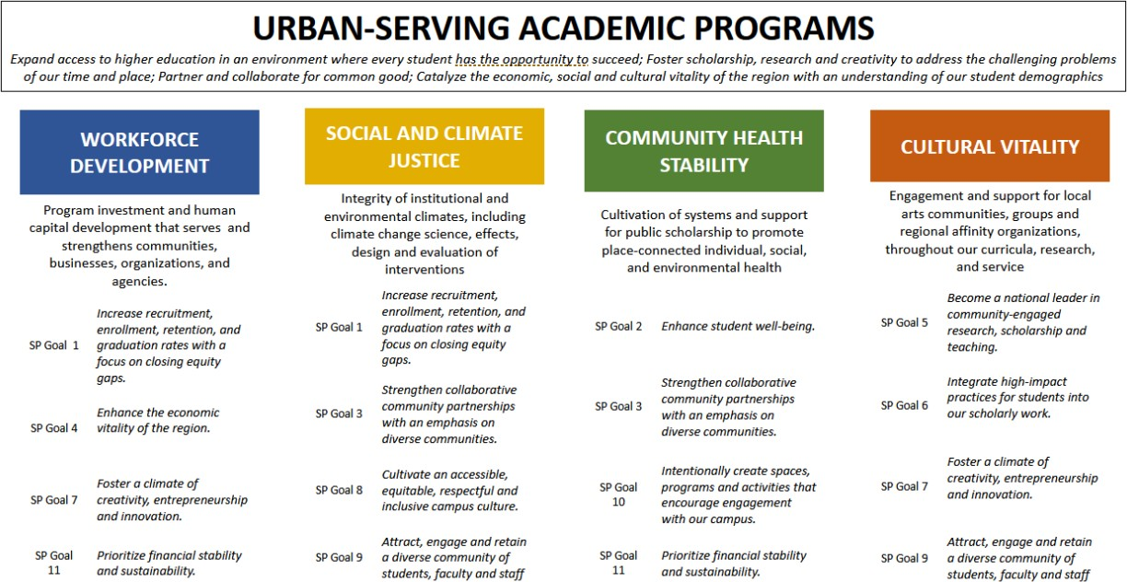
GOAL: UW Campus Expansion Aligned with Urban-Serving Mission2

STEP TWO: Assess performance relative to shared goal.

MEASURE AND EVALUTE: Apply campus strategic plan metrics at the campus level (aggregated) and at the unit level (disaggregated) to assess goal performance and identify gaps.

- WORKFORCE DEVELOPMENT - Serve residents, households, businesses, and communities with human capital investment through UWT programs.
  - Increase recruitment, enrollment, retention, and graduation rates with a focus on closing equity gaps (GOAL 1)
  - Enhance the economic vitality of the region (GOAL 4)
  - Foster a climate of creativity, entrepreneurship, and innovation (GOAL 7)

- SOCIAL AND CLIMATE JUSTICE: Integrity of institutional and environmental climates, including safety, non-discrimination, and equal protection; as well as climate change science, effects, design, and evaluation of interventions.
  - Increase recruitment, enrollment, retention, and graduation rates with a focus on closing equity gaps (GOAL 1)

  - Strengthen collaborative community partnerships with an emphasis on diverse communities (GOAL 3)
  - Cultivate an accessible, equitable, respectful, and inclusive campus culture (GOAL 8)
  - Attract, engage, and retain a diverse community of students, faculty, and staff (GOAL 9)

- COMMUNITY HEALTH STABILITY: Cultivation of systems and support for public scholarship to promote place-connected individual, social, and environmental health.
  - Enhance student well-being. (GOAL 2)
  - Strengthen collaborative community partnerships with an emphasis on diverse communities. (GOAL 3)
  - Intentionally create spaces, programs and activities that encourage engagement with our campus. (GOAL 10)

- CULTURAL VITALITY: Engagement across the region, support for cultures of learning, local arts communities, and investment in local community groups and regional affinity organizations throughout our curricula, research, and service.
  - Become a national leader in community-engaged research, scholarship, and teaching. (GOAL 5)
  - Integrate high-impact practices for students into our scholarly work (GOAL 6)
  - Foster a climate of creativity, entrepreneurship, and innovation (GOAL 7)
  - Attract, engage, and retain a diverse community of students, faculty, and staff (GOAL 9)

STEP THREE: Design interventions to further shared goal
ENGAGE AND PROGRESS: Where gaps exist, how may they be engaged and addressed? (e.g., budget tools)
- IDENTIFY STRUCTURES: Recognize mechanisms that support or impede units relative to the shared goal.

- IMPLEMENT STRATEGIES: Develop mechanisms to progress the shared goal.

[1] [1] One framework to guide equity-based policy and decision-making, developed by john a. powell and policy leaders at the Haas Institute at UC Berkeley, is Targeted Universalism: https://belonging.berkeley.edu/targeted-universalism Other frameworks follow similar tenets, where shared values and identified goals, organize the collection and analysis of data
[1] See: Vision, Mission, Values and Strategic Priorities of UW Tacoma, University of Washington Tacoma Strategic Plan, 2022- 2027, (p. 6), University of Washington Tacoma Strategic Plan, 2022-2027.

