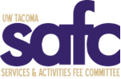

Services and Activities Fee Committee (SAFC)
Tuesday, December, 2023
4:00pm
University Y 307

Zoom Link: https://washington.zoom.us/j/96170927759

AGENDA 05

- Call to Order

- Land Acknowledgement

- Safety Briefing

- Roll Call & Guest Introductions

- Approval of Agenda

- Approval of Minutes

- Open Public Forum

- Old Business

- New Business

- Announcements

- Adjournment

