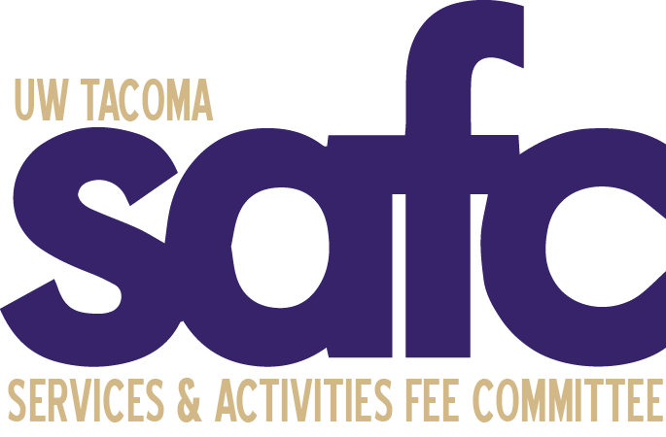
Services and Activities Fee Committee (SAFC)
Thursday, November 16, 2023
12:30pm
UWY 307

MEETING MINUTES 02

Attendance:

Voting Members  Alex Alvarado – Absent  Eli Feleke - Present  Ngoan Huynh – Present  Lizzy McLam - Present  Navneet Singh - Present  Ryan Wicklund - Present  Karalea Zuber - Present  Administrative | Ex-Officio Members  Bernard Anderson – Present  Mike Russell – Present  Sean Schmidt – Present  Alicia Whitten – Absent  Kelly A. Tyrrell – Absent  Guests  - Brittany Mai

The meeting was called to order by Ngoan at 12:36pm.

A land acknowledgement was given by Ngoan.

An introductory safety briefing was given by Ngoan.

Roll Call is documented above.

Approval of Agenda. Karalea moved to approve the agenda. Eli seconded. The motion Passed unanimously

Approval of Minutes. Eli moved to approve the minutes of the 11/9/23 meeting. Karalea seconded. The motion passed unanimously.

Open Public Forum
- None

Old Business
- Elections: A draft of the Vice Chair job description will be sent to the committee. Ngoan
- Special Allocations. The summary of proposals was shared with the committee. The group decided to begin reviewing special allocations to see if some of the proposers will be invited to attend a future meeting.

New Business
- Discussing the inquiry from Global Affairs, reallocating funds from student positions to fund a staff position who will be supervising the program. Further discussion will be held on Tuesday. Note: SAFC funds operate on a “temporary basis”
- Annual Budget Request Process posted December 1st. Discussion for annual allocations will be held after deadline
- Conflict of Interest formal guidelines for Committee members, members who may have a conflict of interest are advised to abstain from voting matters

Announcements
- Future weather conditions rescheduling future meetings via zoom?
- Replacement husky cards are temporarily not available due to new equipment changes
- November 17th Creative Writing Mixer Hosted by Tahoma West- Lizzy

Adjournment

- Karalea moved to adjourn the meeting at 1:28pm. Eli seconded the motion. The motion passed unanimously.

