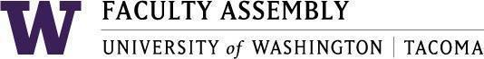

Agenda
Faculty Affairs Committee Meeting
December 11, 2023 / 12:30pm-1:20 p.m.
Zoom

- Recording Permissions/Consent [2 mins]
- Non-Tenure Track Faculty Forum [15 mins]
- Updates
- Supporting NTTF (pay discrepancies) – WSU Salary Equity Results
(How can FAC support efforts?)
- AY 2022-2023 priorities and status updates [25 mins]
- UWT Equity-Minded Faculty Workload Initiative – Status Report
- International Faculty Support – Status Report
- New Items [5 mins]

Join Zoom Meeting
https://washington.zoom.us/j/96609919459

Dial by your location
+1 253 215 8782 US (Tacoma)
+1 206 337 9723 US (Seattle)
Meeting ID: 966 0991 9459

