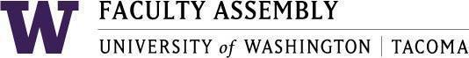

Agenda
Faculty Affairs Committee Meeting
January 22, 2024 / 12:30pm-1:20 p.m.
Zoom

- Recording Permissions/Consent [2 mins]
- Non-Tenure Track Faculty Forum [15 mins]
- Updates
- Supporting NTTF (pay discrepancies) – Discussion
- AY 2022-2023 priorities and status updates [25 mins]
- UWT Equity-Minded Faculty Workload Initiative
  - Update (Self-assessments received? Self-assessments outstanding? Next steps?)
  - Faculty Assembly Winter Quarter: Round-Table Discussion
  - Status of making unit-level data available to all campus
  - Status of outreach to Seattle and Bothell campuses
  - Status of Schools tracking their hours spent on self-assessment of equity workload
- International Faculty Support (report attached)
  - Next steps on supporting International Faculty?
- New Items? [5 mins]

Join Zoom Meeting
https://washington.zoom.us/j/96609919459

Dial by your location
+1 253 215 8782 US (Tacoma)
+1 206 337 9723 US (Seattle)
Meeting ID: 966 0991 9459

