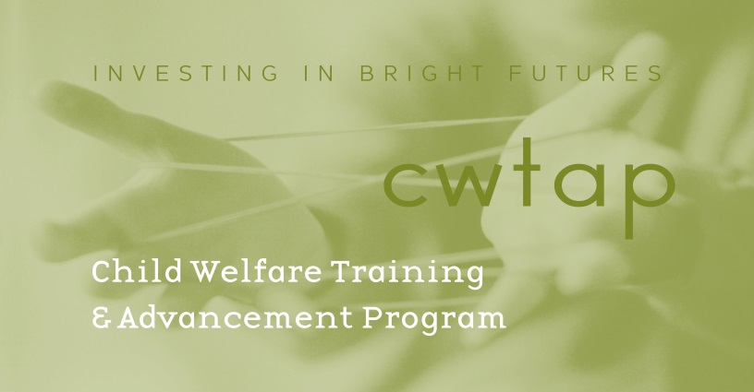

Child Welfare Training and Advancement Program (CWTAP)
BASW Student Application Form
Date: Click or tap to enter a date.
Last name: Click or tap here to enter text. First name: Click or tap here to enter text.
Address: Click or tap here to enter text. City/State: Click or tap here to enter text. Zip Code: Click or tap here to enter text.
Cell # (include area code): Click or tap here to enter text. Work # (include area code): Click or tap here to enter text.
Email (Primary): Click or tap here to enter text. Email (Alternate): Click or tap here to enter text.
Anticipated Graduation: Click or tap here to enter text.
Emergency Contact Information – Someone who doesn’t reside with you. Name /Phone number(s): Click or tap here to enter text.
Relationship: Choose an item. Type here: Click or tap here to enter text.
Are you a current DCYF Child Welfare Program employee? Choose an item.
If yes - Office/Program (CPS/FAR etc.): Click or tap here to enter text.
Supervisor name/number: Click or tap here to enter text.
Your work cell # (include area code): Click or tap here to enter text.
Your DCYF email: Click or tap here to enter text.

