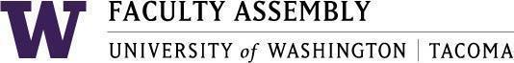

Agenda
Faculty Affairs Committee Meeting
March 4, 2024 / 12:30pm-1:20 p.m.
Zoom

- Recording Permissions/Consent [2 mins]
- Non-Tenure Track Faculty Forum [15 mins]
- Updates
- Supporting NTTF (incorporating NTTF strong voices in faculty workload data collection)
- Additional topics
- AY 2022-2023 priorities and status updates [25 mins]
- UWT Equity-Minded Faculty Workload Initiative
  - Reporting on meeting with Council of Deans
  - Reporting on meeting with Sarah Davies- Breen and AHR staff who will be evaluating the data (data evaluation has begun!)
  - Next steps after data analysis – reporting out to Schools and tracking workload activities.
- International Faculty Support: International Faculty Leadership Panel
  - Seattle’s engagement in supporting International Faculty
- Communication with Ursula Owen (International Scholars Operation Manager)
- Shared report with her – substantial interest shown. Will share report with leaders in Seattle.
  - A reminder of the International Faculty Leadership Forum scheduled for March 5 at 12:30 pm in Milgard Room 110.
  - Please try to attend!

Join Zoom Meeting
https://washington.zoom.us/j/96609919459

Dial by your location
+1 253 215 8782 US (Tacoma)

