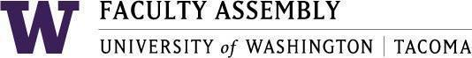

Agenda
Faculty Affairs Committee Meeting
April 15, 2024 / 12:30pm-1:20 p.m.
Zoom

- Recording Permissions/Consent [2 mins]
- Non-Tenure Track Faculty Forum [15 mins]
- Updates
- AY 2022-2023 priorities and status updates [25 mins]
- UWT Equity-Minded Faculty Workload Initiative
  - Data analysis status – School-level data and Faculty-level data
  - Additional request to Schools (due date – week of April 17)
  - Plans for communicating with Schools (Expected to occur in May)
- Communicate findings
- Suggest recommendations based on findings and Schools’ priorities
- Suggest periodic reporting out by Schools
- Suggest follow-up faculty-level assessment within 6 mos to 12 mos.
  - FA request a report out at May 5 meeting (will need to report an abbreviated version due to requirement of presenting to Schools first)
- International Faculty Support: International Faculty Leadership Panel
  - No new updates

Join Zoom Meeting
https://washington.zoom.us/j/96609919459

Dial by your location
+1 253 215 8782 US (Tacoma)

