4/5/2024

The Office of Research has released a new Principal Investigator Dashboard in Workday.

The Principal Investigator (PI) Dashboard displays grant data, which is tailored to the PI, who is logged into Workday. This gives PIs a central place to find grant-related content that is specific to them.

This dashboard splits data across six tabs—My Sponsored Grants, My Awards, My Stand Alone Grants, My Gifts, Grant Staffing, and Additional Resources—which are explained in more detail in the following sections.

* **My Sponsored Grants Tab**

This tab displays a snapshot of the Sponsored Grants associated with the PI, and allows the user to drill into additional detail, if needed.

* **My Awards Tab**

This tab displays a snapshot of the awards associated with the PI, and allows the user to drill into additional detail, if needed.

* **My Stand Alone Grants Tab**

This tab displays a snapshot of the stand-alone grants associated with the PI, and allows the user to drill into additional detail, if needed.

**My Gifts Tab**

This tab displays gifts, but unlike the other tabs, the gits that display are not specific to the PI. This tab also allows the user to drill into additional detail, if needed.

* **Grant Staffing Tab**

This tab displays the staff working on grants associated with the PI, and allows the user to drill into additional detail, if needed.

* **Additional Resources**

This tab links out to helpful resources for the PI, including reports (Workday, research, and legacy), tasks, and other external resources.

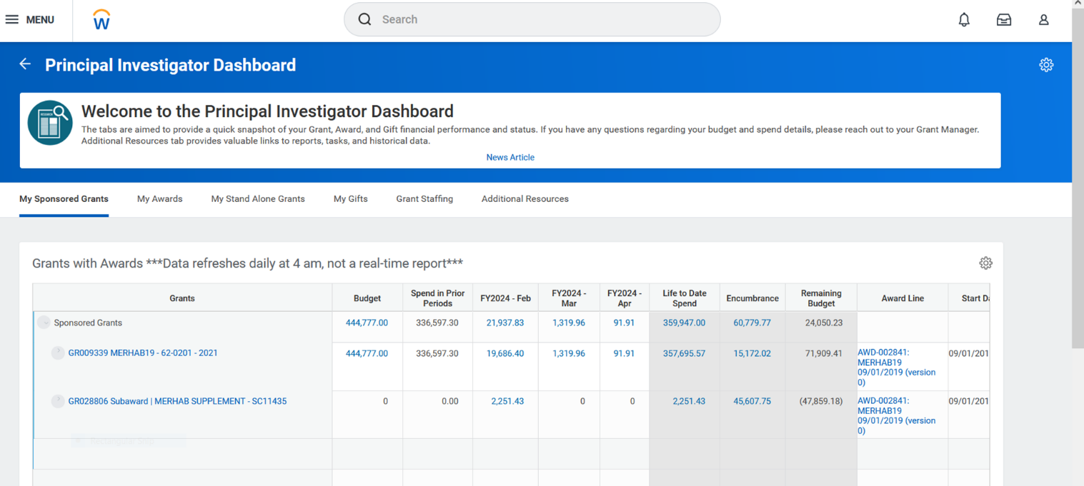

ACCESS

1. Login to Workday
2. Select **MENU** button

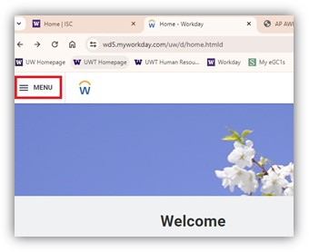

1. Select **+** **Add Apps** button

1. In search box type **Principal Investigator Dashboard**

1. Select **+** button

1. Select **<- Back to Menu** button

1. Select **Principal Investigator Dashboard**

Assembled by Marlyn Del Cid UWT Office of Research