4/5/2024 - Quick Guide for Workday Grant Report R1234
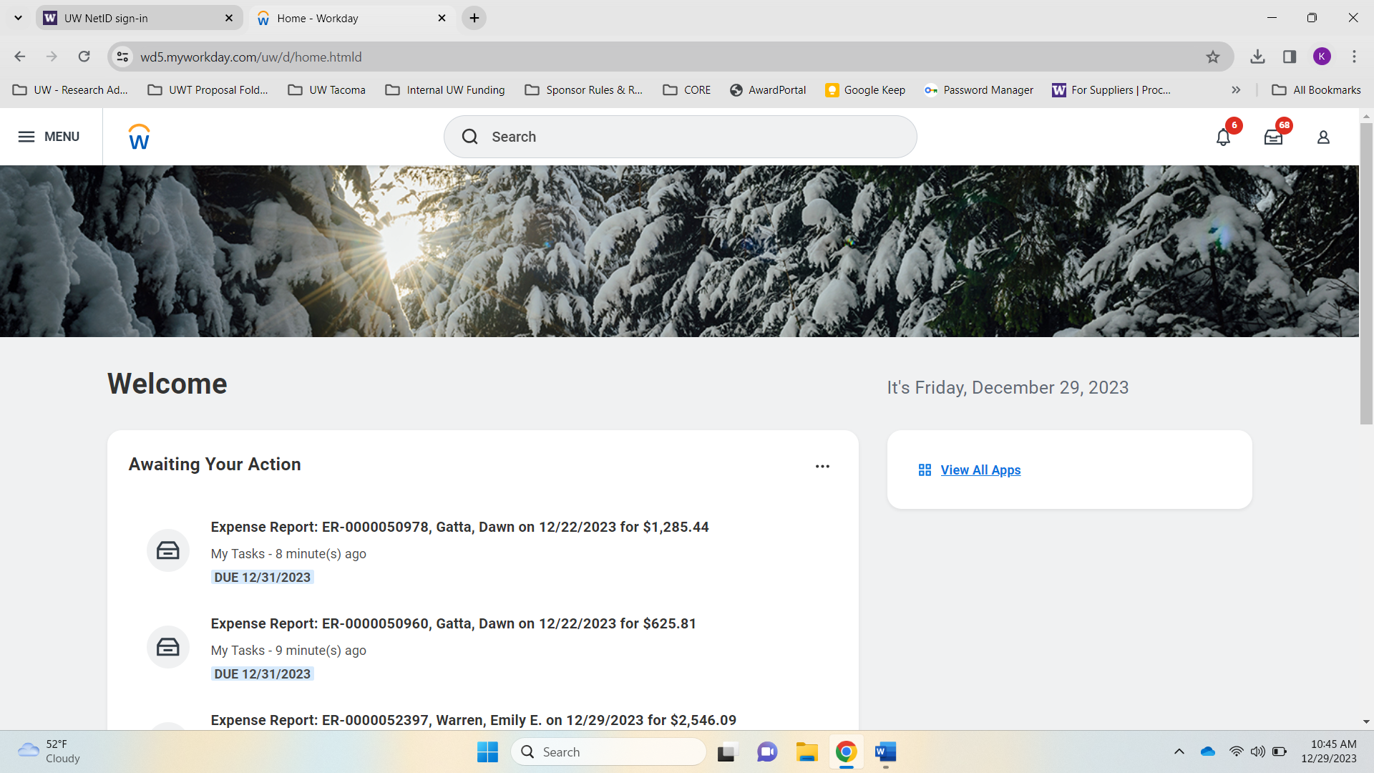
- Start in Workday

- Go to Menu (on top left)
- Go to Apps; then at bottom click + Add Apps
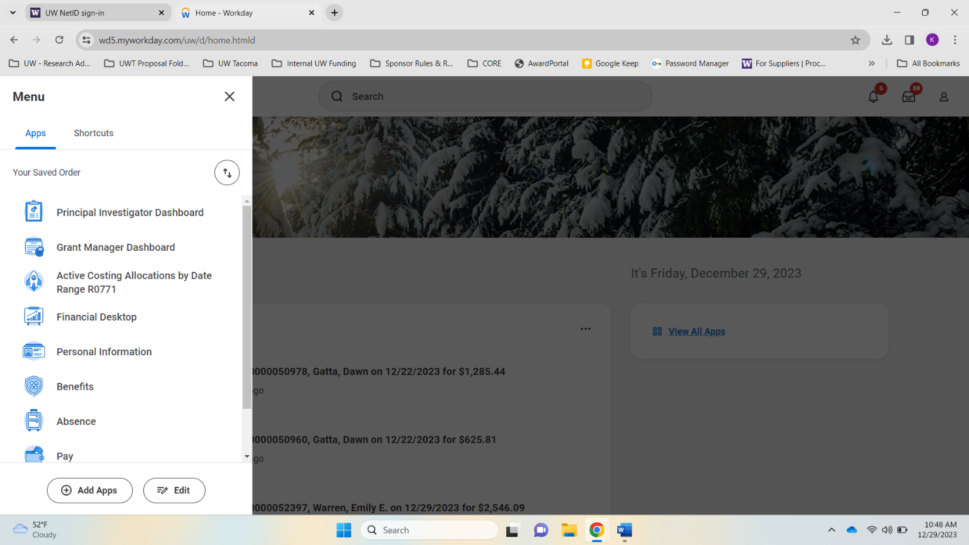
- [Add] Principal Investigator Dashboard
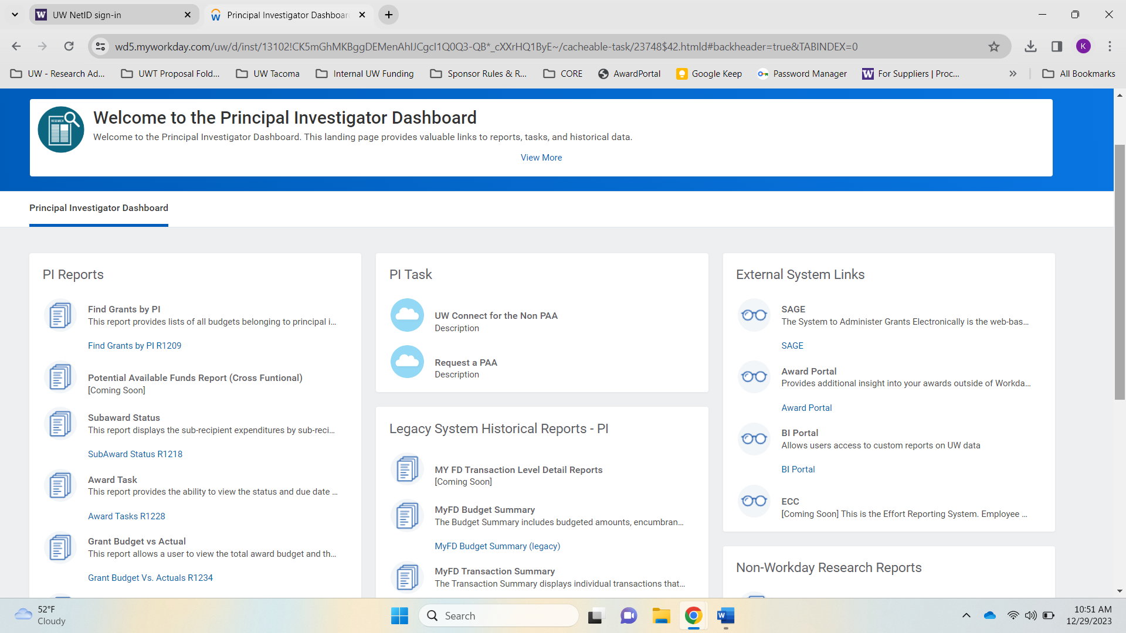
- Click Principal Investigator Dashboard

- Under PI Reports, click Grant Budget vs. Actuals R1234
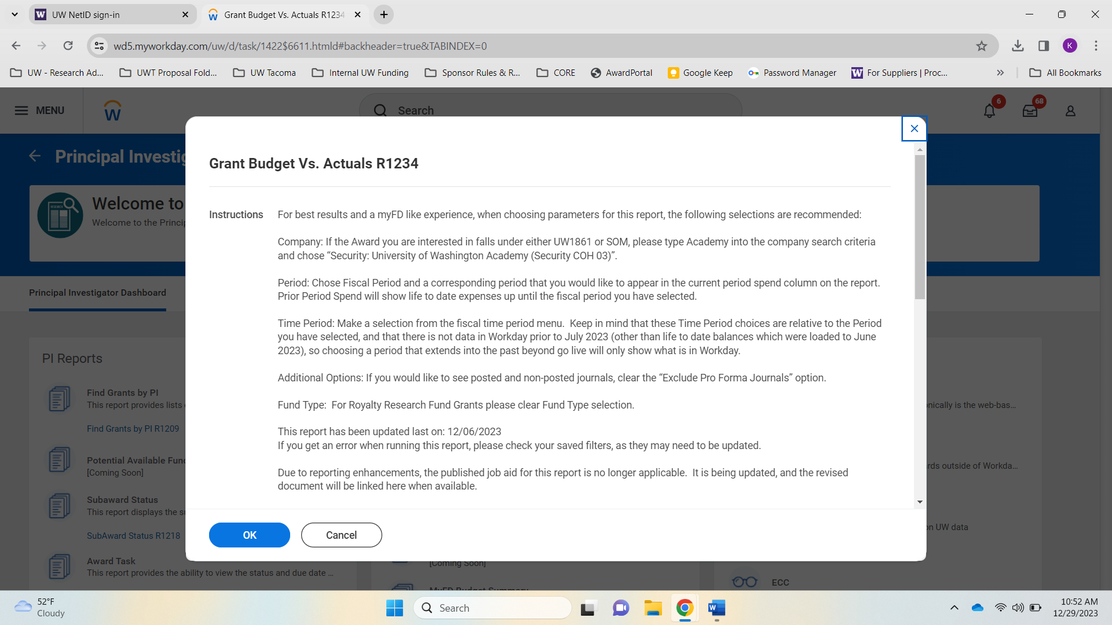
- In this window popup, scroll down to see filters

- Filters:
  - COMPANY: Company Hierarchy>Security University of Washington Academy
  - AWARD: Type in AWD-020765 [tab out]
  - PERIOD: Current and Prior Periods>FY2024-DEC (or most recent closed month)
  - TIME PERIOD: Award Time Period>Award Life to Date
  - GRANT: GR042426
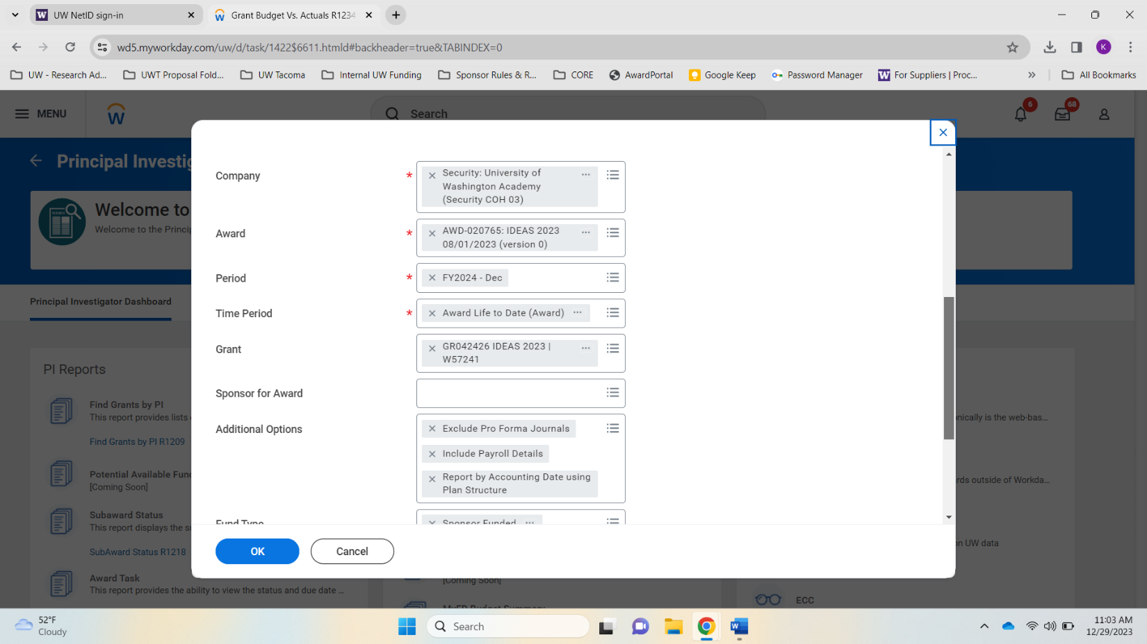
BEFORE HITTING OK, scroll down and choose SAVE FILTER. Name and Save it for next time!
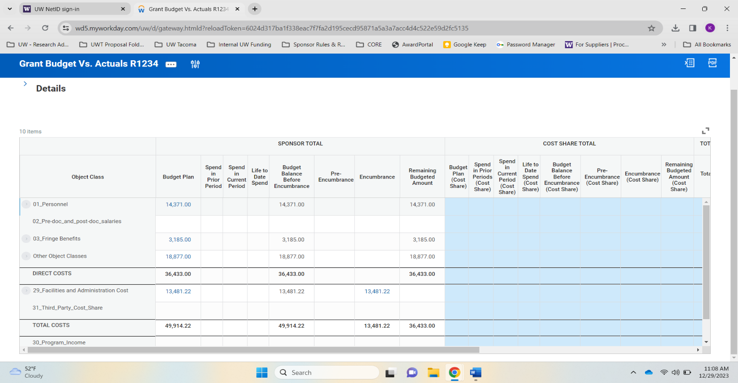
- Click OK – here is your budget update:
- You can scroll down and to the right to see the full sheet
- Hover over any number in blue and click down arrow>View Details
- Once you start spending, your totals will turn blue so you can see details in those as well.
- You can export any of these specific items or the full sheet from here into Excel and then sort your columns, etc.

Assembled by Karen Urlie UWT Office of Research

